Key Points for Infinite Campus Transition
How To Run Ad Hoc Reports to Locate Students - Detention
January 2015

The purpose of this running this report is to locate students in their sixth period class in order to efficiently assign detention for behavior events. This report may be modified to gather data for daily, monthly, or quarterly behavior events.

- Select <Ad Hoc Reporting> in the navigation menu on the left side of the screen.
- Select “Data Export.”
- Open the Ad Hoc Reporting folder and select the report titled, “Student Locator/Detention - period 6.” (*Note: This report can also be found in the “Secretary/Office Professional” folder so office staff can assist in running the report.)
- Select an Export Format, then click “Export.”

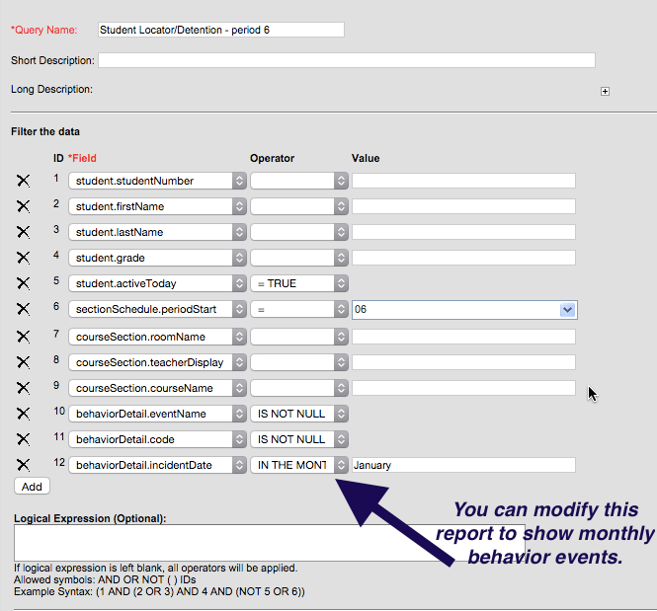
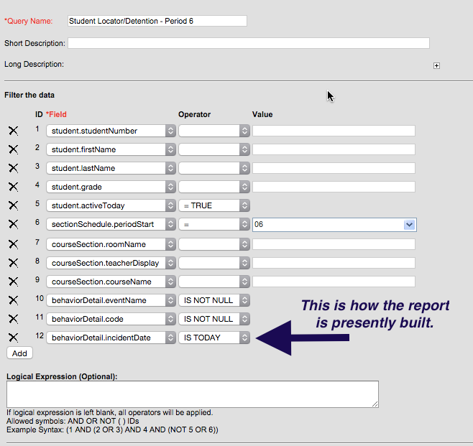
*The report is presently built to run reports based on today’s date. If you would like to change the date and/or frequency of the report, see below for instructions. You can change the “sectionSchedule.periodStart” so the report will list students’ 4th period class, for instance, if you pick up students for lunch detention. REMEMBER: Before you make any modifications to a report, COPY THE REPORT to your own user account and make changes there. Otherwise, you are changing the report for everyone else who uses it!

