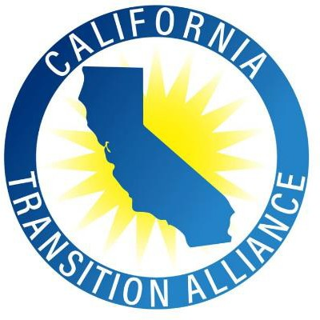
Save the Dates
March 7-9, 2022

California’s Institute on Secondary Transition

Bridge to the Future V
(Registration Information Forthcoming)

Spanning the Transition Landscape:
The Times They Are A-Changin’

www.catransitionalliance.org

Target Audience
All Pre-K through age 22 educators, administrators, families and community stakeholders committed to ensuring ALL students are prepared for competitive, integrated and family-sustaining employment. ALL means ALL.

Institute Partners
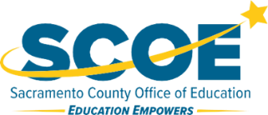
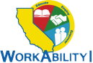 Sacramento County SELPA
