START EARLY, START STRONG!

We’re expanding Transitional Kindergarten for our youngest scholars.
Now offering full- and half-day options for our families, we’ve also added new locations to make 2022-2023 Transitional Kindergarten offerings more accessible to everyone in our Sac City Unified community.
- Curriculum incorporates age-appropriate play-based and project-based learning models with social-emotional learning, physical health and identity development
- Creates inclusive classrooms designed to ensure that the developmental needs of all students are met
- Supports multilingual learners to encourage primary language development while learning new vocabulary
- Expanded learning and nutrition services available to provide students with up to 9 hours of free, quality care while assisting working families*

SEE THE REVERSE SIDE FOR DETAILS AND VISIT SCUSD.EDU/TK-ONLINE-REG TO APPLY ONLINE.
*May be subject to income requirements.

2022-2023 TRANSITIONAL KINDERGARTEN
Free public education for young scholars who turn five between September 2, 2022 through February 2, 2023.*
Transitional Kindergarten is optional and provides students with an additional year of preparation, so they enter kindergarten with stronger academic, social, and emotional skills needed for future success in school.

HALF-DAY TK
- A. M. Winn Public Waldorf – AM and PM classes
- Alice Birney Public Waldorf – AM and PM classes
- H. W. Harkness – AM class
- Hubert Bancroft – AM class
- John Sloat – AM class
- Leonardo da Vinci – AM class
- Pacific – AM class
- Tahoe – AM class
- Theodore Judah – AM class
- Washington – AM class

FULL-DAY TK
- Edward Kemble
- Ethel Phillips
- Earl Warren
- Isador Cohen
- John Bidwell
- Mark Twain
- Martin Luther King, Jr.
- Parkway
- Susan B. Anthony

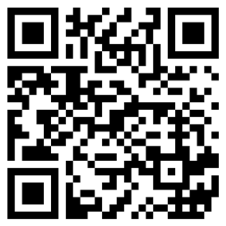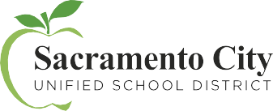

CHECK OUT SCUSD.EDU/TRANSITIONAL-KINDERGARTEN
TO DISCOVER ALL THE WAYS TO ENROLL AND LEARN MORE.
*May be subject to income requirements.

