Smarter Balanced Assessment Consortium Digital Library

Brief User Guide

About the Digital Library
Smarter Balanced has developed the Digital Library and populated it with instructional and professional learning resources to help educators tailor Common Core instruction to students’ needs using the formative assessment process. Access to the Digital Library by California educators has been paid for by the State of California. Contents of the Digital Library have been thoroughly vetted by select educators prior to posting. For more information about the review process, select the Quality Criteria for the Digital Library link at http://www.cde.ca.gov/ta/tg/sa/index.asp .
Note that the Digital Library is not an assessment or item bank or a learning management system where educators can register for training or receive credit by completing specific online courses. Given its proprietary content, the Digital Library is not intended to serve the general public, and proper login credentials will be required to access its contents. The purpose of this user guide is to orient you to the Digital Library so that you may quickly explore its potential. Tutorials are available for further reference and a Help Guide is embedded in the Digital Library.

Accessing the Digital Library
Access to the Digital Library will be granted to teachers and educators through their respective educational agency or school district. In the fall the Digital Library is fully operational and additional content will been added. To access the Digital Library, go to https://www.smarterbalancedlibrary.org and enter your username (email address) and password. You will be required to change your password and set up your user profile.

Using the Digital Library
The Digital Library contains instructional and professional learning resources, along with forums that educators may use to discuss resources. A screenshot of the Digital Library is shown in Figure 1.
To find resources, select the Digital Library Resources tab and select one or many of the filters listed below. You may apply, edit, and reset filters at any time. You may sort by newest, most used, or highest rated. After browsing a specific resource, users may click on the Reviews tab to collaborate with other users regarding implementation or to write a review of the resource. All communications via the SBAC Digital Library are associated with the email address used to log in, and are regarded as public comments. Category filters include:
- Subject
- Grade
- Attribute of Formative Assessment Process
- Media Type
- Resource Type
- Intended End users
- Intended Student Population
- Educational Use
- Smarter Balanced Keywords
- Geographic Setting
- Common Core State Standards

To find on-line forums in which to converse with other educators about resources, select the Forums tab and utilize a similar set of filters and sorting criteria to narrow or refine your choices.
Figure 1. Resource and Forum Selection Screen.
Areas personalized for your use.
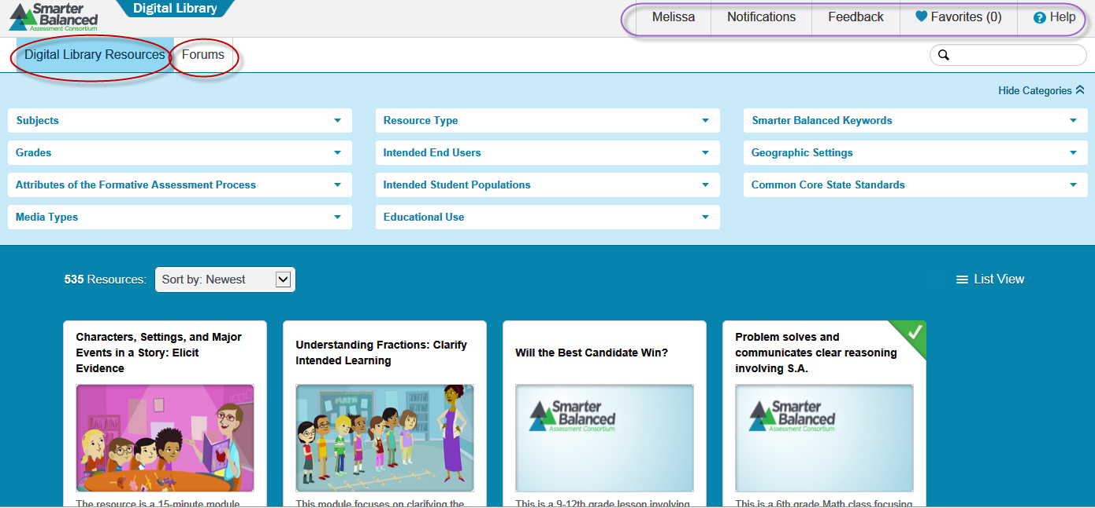
Once you make your selection, click on the title to access the resource. The resource will include title, author, summary, subject, intended audience, learning goals and information about how it connects to assessments and standards (Figure 2.). It will also provide further links to additional related information. To download the resource, click on the green download button.
Figure 2. Resource Information Sample
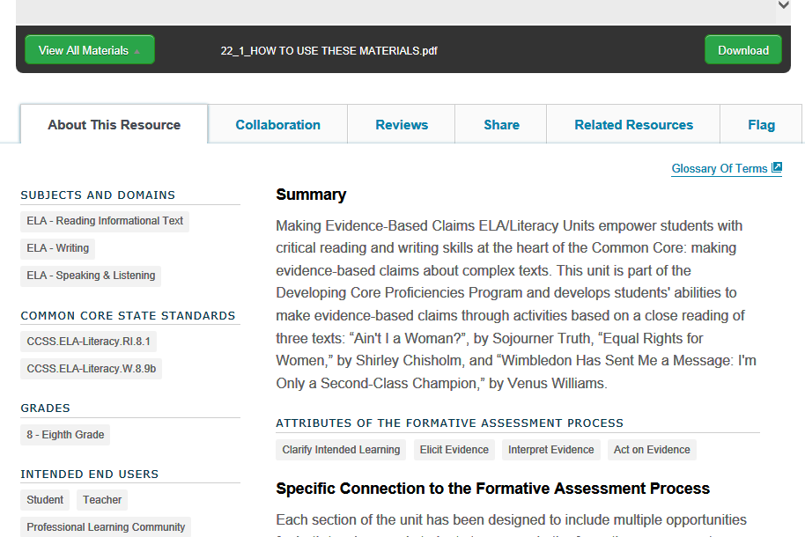
To exit the Digital Library, simply click on your name in the top bar and select Logout.
Courtesy of Sacramento County Office of Education

This guide was adapted from the help guide embedded in the library.

