 | Human Resource Services
 | Resignation and Retirement

Site / Department Checklist of
Items to be Returned / Notifications
Note: Ensure that employee fills out and submits the following forms: (1) PSL-F008 (Resignation/Retirement) and (2) PSL-F196 (Exit Interview Questionnaire).

Departing Employee Name:

 | □ Keys | Date Collected:
 | □ Keys | Notes:
 | □ Badge (Security Services)  School Mail Box 823  Phone: 643-7449  Fax: 643-9451 | Date Collected:
 |  | Date Security Services Notified:
 |  | Notes:
 | □ Telephone Services:  Re: Cell Phone & Directory  Phone: 643-7429  Fax: 643-9452 | Date Technology Svcs Notified:
 |  | Notes:
 | □ Laptop Computer or  Other Electronic Device  Fax to: 643-9452;  Questions: 643-9445 | Date Collected:
 |  | Date Technology Svcs Notified:
 |  | Notes:
 | □ Books (Site/Department) | Date Collected:
 | □ Books (Site/Department) | Notes:
 | □ Supplies (Site/Department) | Date Collected:
 | □ Supplies (Site/Department) | Notes:
 | □ Other District Property | Date Collected:
 | □ Other District Property | Notes:
 | □ Bistro Account Balance Due (Serna Center) | Date Collected:
 | □ Bistro Account Balance Due (Serna Center) | Notes:
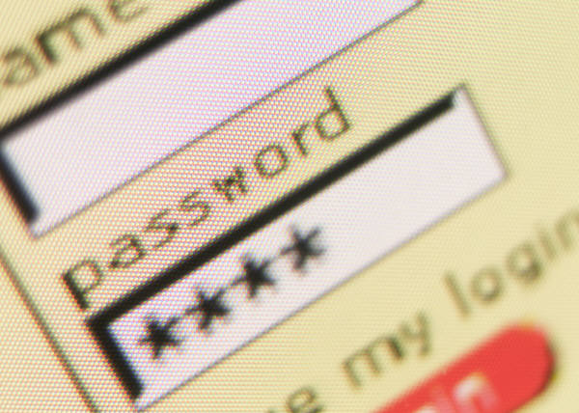 | □ Technology Services  (Remove Employee From  District Network Access,  i.e., Escape, Outlook,  Zangle) Fax to: 643-9452;  Questions: 643-9445 | Date Completed INF-F001 Request for Access to Network Services and Email Form to Remove Access:
 |  | Date Form Faxed to Techn Svcs:
 |  | Notes:
Completed by: □ Office Manager___________ OR □ Human Resource Analyst ___________

