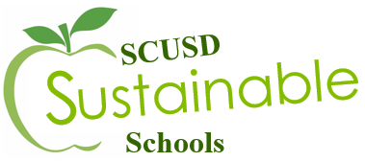

Participation Agreement
Form
Schools can participate in the Sustainable Schools Initiative in two different ways: guided or unguided. Guided participation will follow along with the Project Green format with a scheduled theme, timeline of events and one-on-one mentoring. Unguided participation is at the school’s leisure but the school must assign a Lead Sustainability Advisor and report annually on their accomplishments by updating their Sustainable Schools Profile. See the chart below for details. Boxes with a check indicate they are included with the corresponding style of participation.

 | Guided (Project Green) | Unguided
Topic | District Chooses | School Chooses
Timeline | X
Curriculum | X | X
Mentorship | X
Professional Development | X | X
Collaboration Workshop(s) | X
Project Funding | X
Sustainable School Profile | X | X

Lead Sustainability Advisor’s Name: Lead Advisor’s Email:

School Representing:

Check one of the following boxes to indicate your school’s participation.

Guided Participation (Project Green): Unguided Participation:

If guided participation, please fill out the following Project Green Participation Form.

Project Green 2018
Participation Agreement
Due: Friday, October 13, 2017

Project Green 2018 will focus on waste and recycling in our schools by initiating food waste recycling in the cafeterias and increasing recycling in our classrooms. This year’s program will provide a hands-on learning opportunity for students and NGSS professional development opportunities for advisors as we continue our collaborate approach to sustainability education.

Project Green Schools will participate in workshops throughout the school year so it is suggested that multiple advisors from one school participate in order to create collaboration across the school.

List any additional Sustainability Advisors for your school. A minimum of two is preferred.
Name: Email:
1.
2.
3.
4.

Provide a summary of the students who will be participating. (Grade, group, # of students, etc.)

Has your school participated in Project Green prior to this school year? If so, check the corresponding box for each year your school has participated.

- Project Green 2011-2012
- Project Green 2012-2013
- Project Green 2013-2014
- Project Green 2014-2015
- Project Green 2015-2016 (Water)
- Project Green 2016-2017 (Energy)

Principal Approval:
 | Signature of Principal |  | Date

If you have any questions regarding this form, or Project Green, please contact
Rachel King at rachel-king@scusd.edu

