Lesson Plan: Grades K-2 (Session 1, Oct. 2013)
Unit Title:  Operations and Algebraic Thinking  Lesson: Number Tiles | Approx. time:  60 Minutes | CCSS-M Standards:  Gr.2 OA.2 Fluently add and subtract within 20 using mental strategies. By end of Grade 2, know from memory all sums of two one-digit numbers.
A. Focus and Coherence  Students will know…  - The order of addends may be changed and the result will not change.  - Mental math strategies may be used to solve problems involving numbers.  - Problems involving numbers may be simplified using the commutative, associative, and identity properties. (Students are not expected to learn the terms, just the principles.)  Students will be able to…  - use addition and subtraction strategies in order to fluently add and subtract within 20 (count all, count on, count back, near doubles, make 10 etc.)  - internalize facts and develop fluency by repeatedly using strategies that make sense to them.  Student prior knowledge:  - Putting together, take apart problems.  Which math concepts will this lesson lead to?  Addition and Subtraction |  | B. Evidence of Math Practices  What will students produce when they are making sense, persevering, attending to precision and/or modeling, in relation to the focus of the lesson?  SMP 1. Make sense of problems and persevere in solving them. Students have multiple opportunities to develop strategies for mental math addition and subtraction.  SMP 3. Construct viable arguments and critique the reasoning of others. Students develop strategies for solving the problem. They will also share and defend their thinking.  SMP 6. Attend to precision. Mathematically proficient students in Second Grade are precise in their communication and calculations. Students in Second Grade communicate clearly, using grade-level appropriate vocabulary accurately as well as giving precise explanations and reasoning regarding their process of finding solutions.  SMP 8. Look for and express regularity in repeated reasoning. Students look for shortcuts in addition and subtraction mental math strategies.
Essential Question(s)
- What strategies will help me add multiple numbers quickly and accurately?
- How will I know when I have found all possible solutions?

Formative Assessments
- What addition and subtraction strategies (outlined above) are the students using?
- Are they applying their understanding of turn around facts and to find more solutions?

Anticipated Student Preconceptions/Misconceptions
- Students may have difficulty with the two-step nature of the number sentence.
- Some students may still approach this addition/subtraction problem as a counting problem.
- Some students may not have experience with the relevant vocabulary (count all, count on, count back, near doubles, make 10, etc)

Materials/Resources
- Interactive Whiteboard/Projector or Whiteboard
- Number Tiles

C. Rigor: Conceptual Understanding, Procedural Skills and Fluency, and Application
What are the learning experiences that provide for rigor? What are the learning experiences that provide for evidence of the Math Practices? (Detailed Lesson Plan)

Engage– Grid Mental Math (10 minutes)
Use the grid to have students perform mental mathematics. The teacher can choose to use the numbers across a row, down a column or diagonally. You could use the grid to have students mentally calculate; Doubles, Near Doubles, et. Today students will use the grid to find combinations that make 10. 5 minutes to find combinations and 5 minutes to share different solutions.

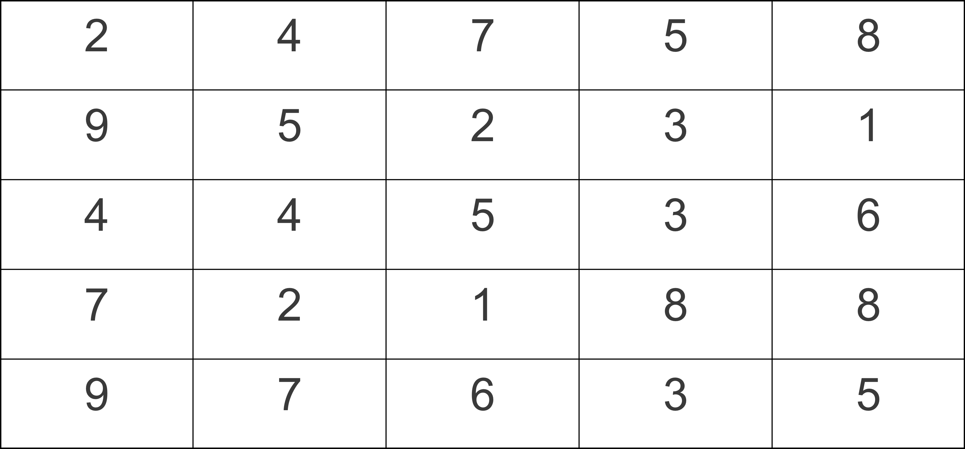

Questions
- What numbers in the grid can you see that make 10?
- Are the students only giving solutions with two addends? Can you find solutions that have more than two addends?
- Could you find solutions that use other operations other than addition?

Main Activity –Number Tiles
Resources
Each student to have the 6 tiles (cut into squares) at the end of the lesson plan, math notebook to record solutions and a pencil.

Launch
Building on the idea of mixed operations number sentences we explored in the warm up have students consider the equation below.

______ + ______ - ______ = ______

Using only the numbers 3, 4, 5, 6 and 7 can you make the following equation true?

Allow students time to use the problem solving strategy trial and error to find a solution. When some students have found a solution share these with the class. Pose the questions; do you think there are other solutions? How many solutions do you think there might be for this problem?

Explore
Once the students have been engaged in the task and the class has started to find multiple solutions (these should be shared on chart paper or an interactive whiteboard etc) stop the investigation and begin to look at strategies that students are using. In this section we are looking to move students away from the problem solving strategy ‘trial and error’ to ‘look for a pattern’. Question; can we find other solution by looking at the answers we already have? (some students may identify turn around facts, associative property). Look for whether the students have applied this mathematical understanding to this task. Model on chart paper how to organize this thinking.

Deepen the Investigation
Once we have explored how we can turn one answer into multiple solutions, ask:
1. How many solutions do you think there might be? and;
2. How do you know when you have found them all?

Encourage students to think and organize their work in a systematic way.

Closure – Rocket Writing
What did you do in math today?
Students prepare answers for this question for parents focusing on the mathematical concepts studied, they are not to write a summary of the lesson – we were all there we don’t want it recounted. What were the concepts/strategies we explored today in math? Students are to write a response to this prompt with the intention of preparing an answer for an adult at home.

Next time I would…
Based on todays lesson, ask the students to identify something they would attempt if they had similar problem.
Suggested Homework/Independent Practice-

Resources

3 | 4 | 5 | 6 | 7
= | - | +

