MAKE CONNECTIONS
Copernicus (Planets revolve around the sun)  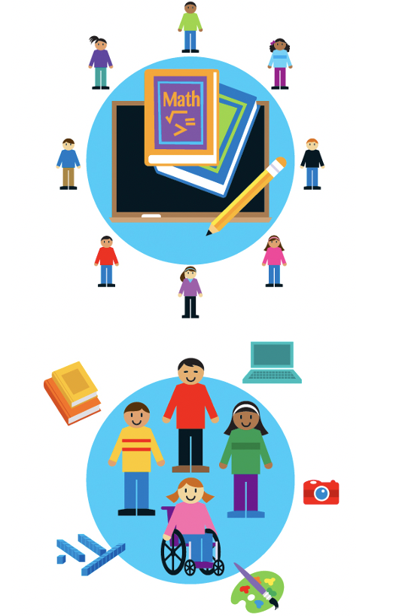 |  | UDL Lesson Design (Student focus)
LESSON DESIGN, VOCABULARY, SEQUENCE
1. Goal (Objective) – |  | 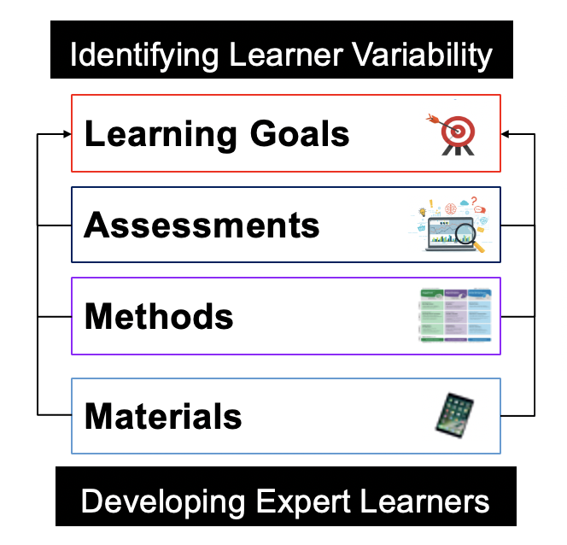  Why is this planning sequence important?
2. Assessment –

3. Methods –

4. Materials –

CONTENT VS. METHOD
Definition  Content -  Method – | Example  Content -  Method – | Verb  Content -  Method – | Advantages/Limits  Content -  Method –
IDENTIFYING POTENTIAL BARRIERS
(Refer to Module #1 Learner Variability and Identity)
List Learner Variability/Identities in Your Class/Caseload (Choose a specific subject/activity) |  | For each identity, assign  a potential barrier and solution
Learner Variability/Identity and Subject |  | Barrier to Learning | Solution
1.

2.

3.

4.

5.

6.

7.

8.

