What is your “Why”? |  | How do you define inclusion?
The Evolution of Inclusion Video
Notes
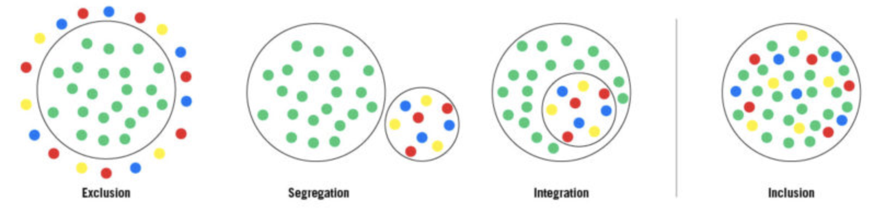

How is inclusion defined in SCUSD? |  | What would doing better look like?
GROUNDING US IN LANGUAGE
Equitable education is defined as the educational policies, practices, and programs necessary to: (a) eliminate educational barriers based on gender, race/ethnicity, national origin, color, disability, age, or other protected group status; and (b) provide equal educational opportunities and ensure that historically underserved or underrepresented populations meet the same rigorous standards for academic performance expected of all children and youth.
How is the above research related to learner variability/identity from Module #1?

Who Do We Value Video
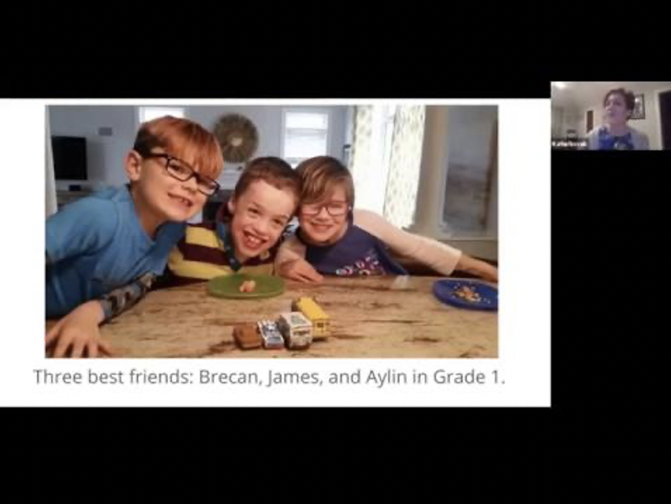
Notes
- Do you agree/disagree with Katie Novak’s perspective?
- What do Brecan, James and Aylin have to offer each other?
- Who is valued in our education system? Who isn’t?

College, Career, and Civic Life Readiness  In my opinion, the #1 quality of a student who  is college, career and civic life ready is  ______________________________ because  _____________________________________  _____________________________________  ____________________________________. |  | EXPERT LEARNER (The Goal of UDL)  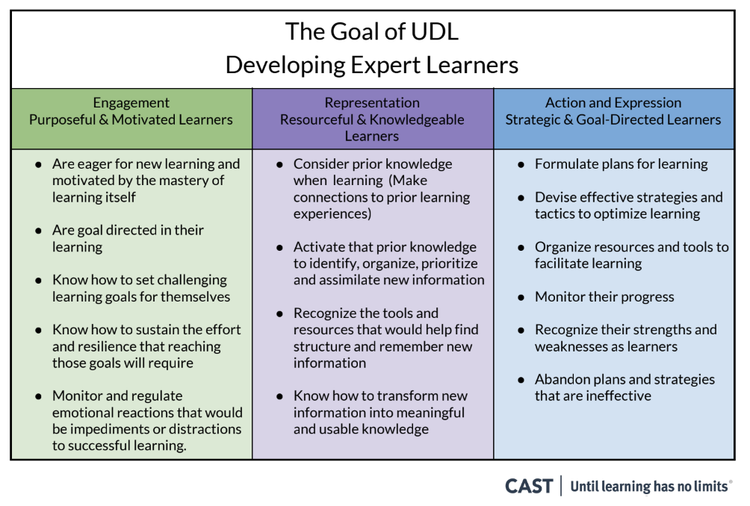
Can you locate an approximation of the “quality” you chose in the Expert Learner chart on the right? An “expert learner’ isn’t a student who receives “A’s” or “B’s”, but a student who knows themselves as a learner, understands how they learn best, and are motivated, resourceful, and goal directed.
List similarities and difference between UDL and Differentiated Instruction below
UDL | Differentiated Instruction
Explain how providing multiple means of access (choice) allows for the development of expert learners:
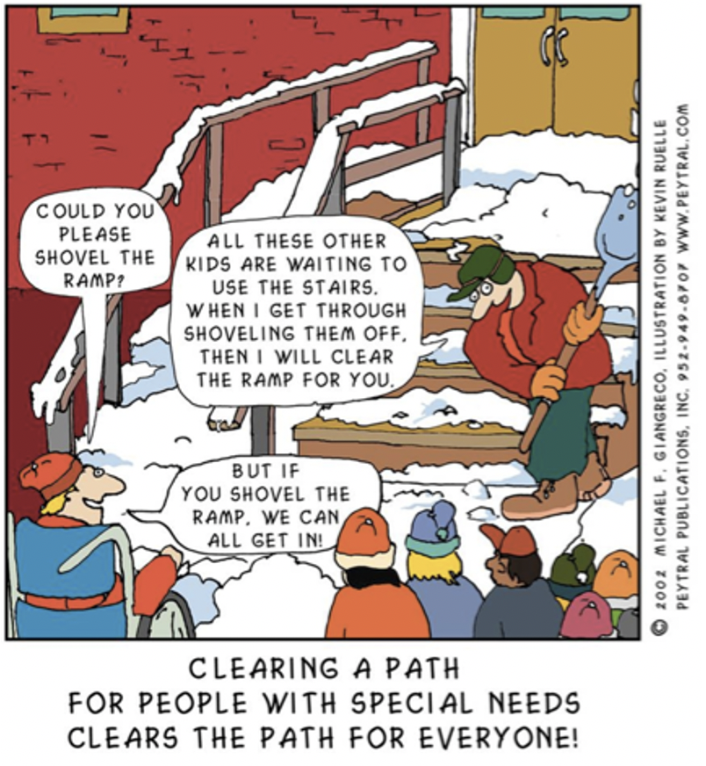

Engagement Notes:

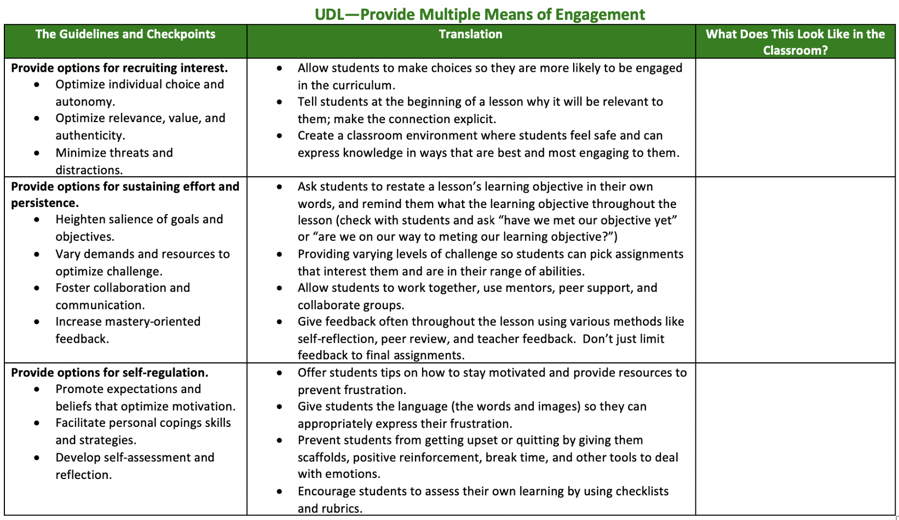

What is one area of providing multiple means of engagement (listed above) you’d like to explore/improve upon?
Use your Padlet for resources: https://padlet.com/SIP_Grant/SCUSD

Representation Notes:

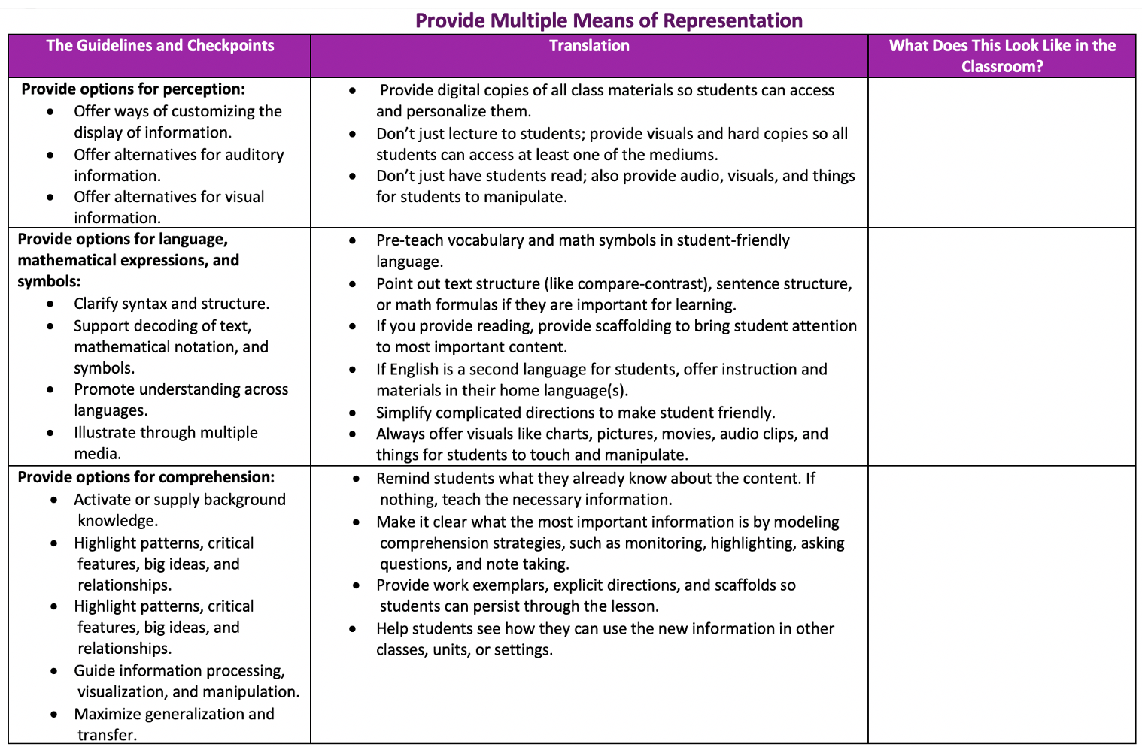

What is one area of providing multiple means of represent (listed above) you’d like to explore/ improve upon?
Use your Padlet for resources: https://padlet.com/SIP_Grant/SCUSD

Action/Expression Notes:

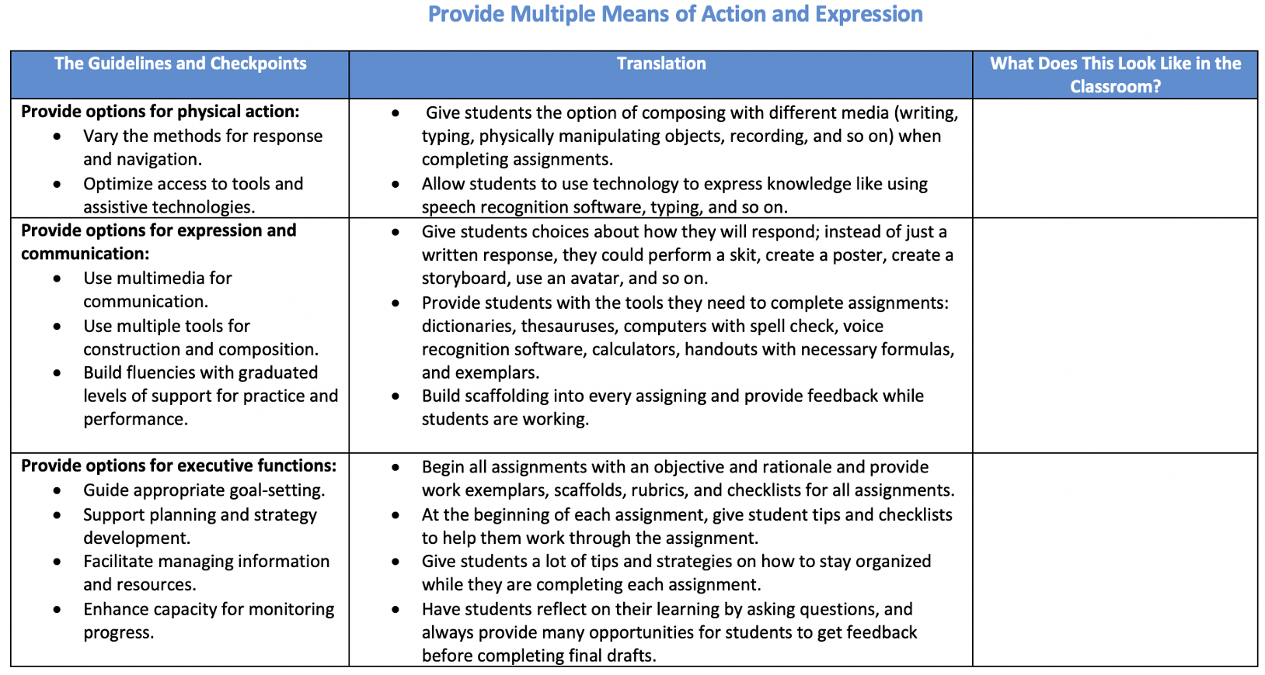

What is one area of providing multiple means of action/expression (listed above) you’d like to explore/improve upon?
Use your Padlet for resources: https://padlet.com/SIP_Grant/SCUSD

ALIKE Video
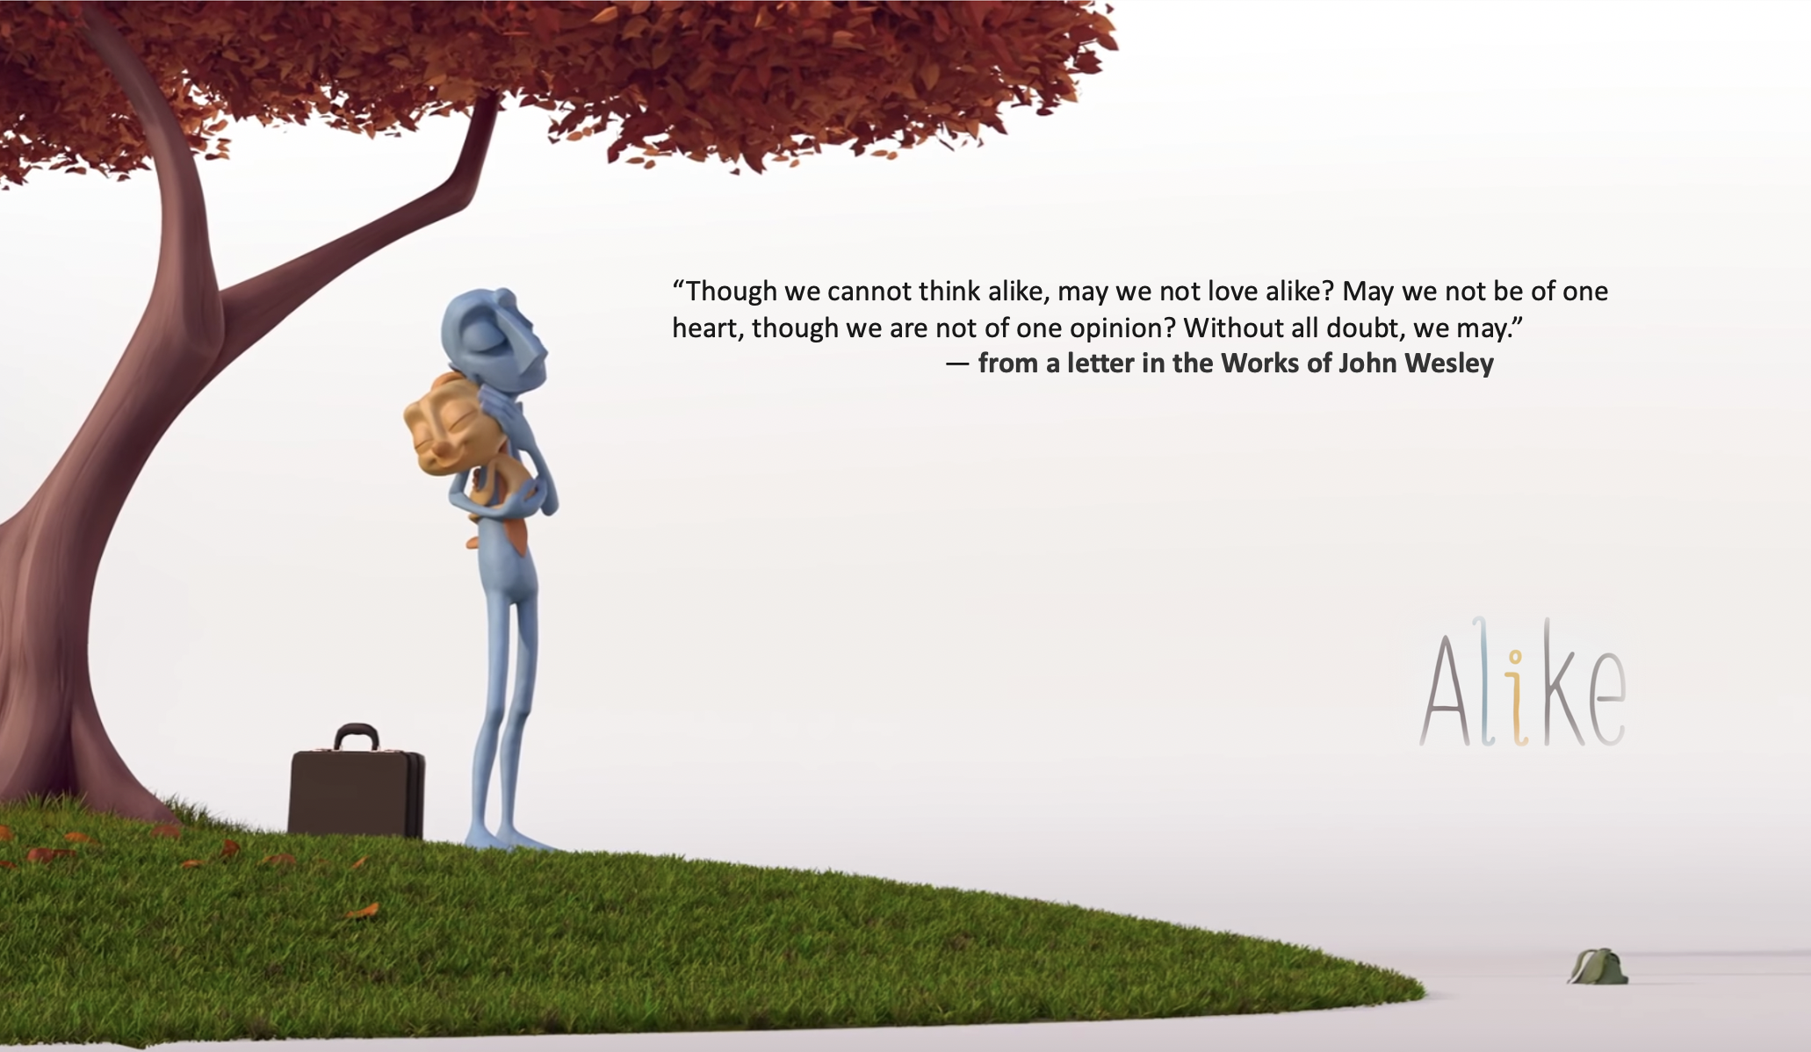
Notes

- Initial thoughts?

- How is the ALIKE video related to the “Factories of Education”
article from Module #1?

- Are there opportunities in today’s educational design to offer multiple means of engagement, representations of information, and demonstration of understanding (action/expression) that honors the variability of learner in our system?

