
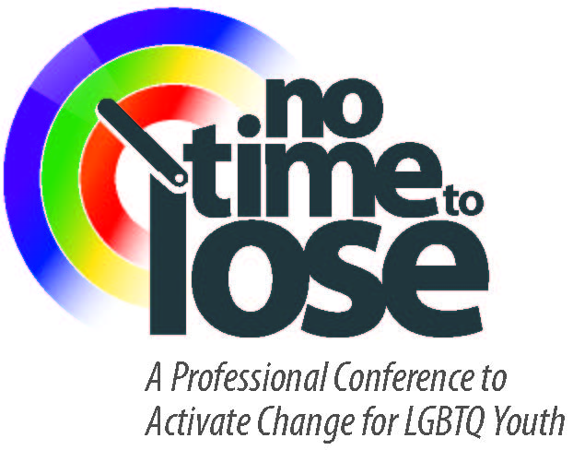
NO TIME TO LOSE:
A Professional Conference
to Activate Change for LGBTQ Youth

April 27th 2011
8am-4:30pm
SCUSD Serna Center

AGENDA

Time | Topic | Presenter
8:00 | Breakfast and Check-in  Resource Tables and Book Fair (all day)
8:30 | Welcome | Isaac Gardon  SCUSD Board of Education  Student Board Member
8:40 | Introduction | Lawrence Shweky  Coordinator, SCUSD Integrated  Support Services
8:45 | Keynote Address  Gender, Bullying, and Harassment:  Strategies to End Sexism and Homophobia in Schools | Dr. Elizabeth Meyer  Professor, School of Education  Cal Poly, San Luis Obispo
10:15 | Break
10:30 | New Visions  Creating a Responsive System for LGBTQ Youth:  School and Community Perspectives | Jerry Peterson  Facilitator, Contra Costa LGBTQ Youth Advocacy Collaborative,  Rainbow Community Center
11:45 | Lunch
12:15 | Youth Panel | Gay-Straight Alliance Club Leaders
1:00 | Workshops – Session 1 | See Detail on Next Page
2:30 | Break
2:45 | Workshops – Session 2 | See Detail on Next Page
4:15 | Closing, Evaluation, Raffles | Lawrence Shweky  Coordinator, SCUSD Integrated  Support Services
4:30 | Adjourn
WORKSHOP DETAIL

A | SESSION A (1:00-2:30) | PRESENTER(S) | ROOM
1 | What Do I Say When?  Proactive Ways to Prevent Negative Interactions in Schools | Dr. Elizabeth Meyer  Professor, School of Education  Cal Poly, San Luis Obispo | Tennessee
2 | Working Effectively with LGBTQ Youth Involved with the Child Welfare System | Robert Woronoff, MS  Project Director, Putting Pride Into Practice  Family Builders, Oakland, CA | Pennsylvania
3 | Clinical Issues in Counseling LGBTQ Youth and Families | Nichole Wofford, MFT, MSW  Emily Herr, Intern  SCUSD Connect Center | Michigan
4 | Legal Issues That Affect LGBTQ Youth and Families | Amy Williams, Managing Attorney  Legal Services of Northern California’s Health Unit | Indiana
5 | Early Intervention in School Systems to Prevent LGBT Health Disparities | Edward J. Callahan, Ph.D  School of Medicine  University of California, Davis | Parent Center

B | SESSION B (2:45-4:15) | PRESENTER(S) | ROOM
6 | Strategies for Creating an Inclusive and LGBT-Friendly Classroom | Julie Snider, Teacher and GSA Advisor  Terri Wollack, Teacher  Rosemont High School | Pennsylvania
7 | Legislative Issues that Affect LGBTQ Youth and Families | Wendy Hill, Senior Legislative Assistant  Assembly member Tom Ammiano | Tennessee
8 | ABCs of STDs for LGBTs | Emily R. Tsuchida, RN, MSN, FNP  Nursing Manager, CARES | Parent Center
9 | Understanding the Needs of  Transgender Youth and Families | Ben Hudson, Executive Director  Rachael Hudson, Operations Manager  Gender Health Center, Sacramento, CA | Michigan
10 | The FAIR Act: Classroom Resources for Teaching LGBT History | Angela Luna, Teacher and Author  Melissa Bryden, Teacher  San Juan Unified School District | Indiana


CONFERENCE RESOURCES
No Time to Lose is a “green” conference and we are seeking to be as paper-free and waste-free as possible. All conference resources, including powerpoint presentations and reading lists, will be available on the SCUSD website following the conference.


MAKE A DONATION
Services for LGBTQ students at SCUSD are funded completely through individual
contributions and grants. Please consider making a donation to support LGBTQ services by
sending a check to SCUSD LGBTQ Services, 5735 47th Avenue, Sacramento, CA 95824.

