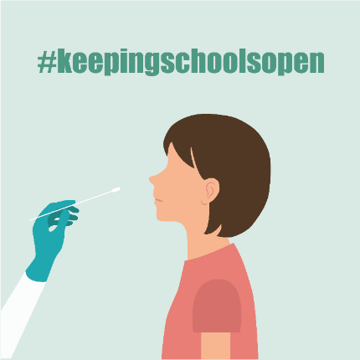
Kauj Ruam 1: Cov khoom siv los mus kuaj:
- Ib pob khoom uas muaj 2 qhov khoom kuaj hu ua iHealth COVID-19 Antigen Rapid Tests thiab muaj cov lus qhia tias yuav siv li cas
- Ib yam khoom siv uas ua nkag tau mus rau hauv internet los mus muab qhov tias kuaj pom zoo li cas xa mus rau koj lub tsev kawm ntawv nyob ntawm qhov link uas koj lub tsev kawm ntawv muab rau koj (Yog tias koj tsis muaj ib yam khoom siv uas nkag tau mus rau hauv internet los sis tsis muaj internet, hu rau Primary ntawm (650) 275-5419.

Kauj Ruam 2: Kuaj koj tus me nyuam (los sis kuaj koj tus kheej yog tias koj yog ib tus neeg ua haujlwm hauv tsev kawm ntawv)
TSIS MUAJ TSOS MOB LOD? Cov me nyuam kawm ntawv thiab cov neeg ua hauj lwm hauv tsev kawm uas yeej TSIS MUAJ ib yam tsos mob ntawm tus kab mob COVID-19 thiab yeej TSIS TAU mus nyob ze ib co neeg uas lawv paub tias lawv yeej muaj tus kab mob COVID-19 yuav tsum tau mus KUAJ OB ZAUG:
- Kuaj zaum #1: Peb (3) hnub ua ntej rov qab tuaj kawm ntawv
- Kuaj zaum #2: Hnub ua ntej rov qab tuajkawm ntawv
SCAN tus QR code (saib hauv qab) mus saib ib daim video qhia tias yuav kuaj licas.
PUAS MUAJ TSOS MOB DABTSI? KOJ TWB PAUB TIAS TAU NYOB ZE IB TUG NEEG MOB LAWM LOD? Yog tias koj muaj COVID-19 cov tsos mob thiab/lossis koj twb paub tias koj tau nyob ze lawm, HU RAU KOJ LUB TSEV KAWM NTAWV rau kauj ruam tom ntej ua ntej koj rov qab mus.

Kauj Ruam 3: Muab qhov tias kuaj pom zoo li cas coj mus tso rau hauv Primary.Health. (TSIS TXHOB siv lub iHealth app.)
QR code mus rau npe:
Yog tias tseem tsis tau mus rau npe, mus rau ntawm Primary.Health tsis pub dhau lub 12 hlis tim 29 https://my.primary.health/l/scusd-edu
Mam xa ib tsab xov tuaj rau koj los ntawm Primary Health rau lub 12/30 thiab lub 1/2 tuaj qhia koj qhov result.
TSIS MUAJ INTERNET LOD? Hu mus nug koj qhov result ntawm (650) 275-5419

Kauj Ruam 4: Nkag siab txog qhov tias kuaj pom li cas
KUAJ TAU TIAS MUAJ LOD?
- Nyob tsev twj ywm thiab hu rau koj tus kws kho mob, koj lub tsev kawm ntawv thiab email covidreport@scusd.edu kom sai tam sid rau cov kev qhia ntxiv tom ntej no.
KUAJ TAU TSIS MUAJ LOD?
- Yog tias koj tus tub/ntxhais kawm ntawv xis neej thiab tsis muaj COVID-19 cov tsos mob, ROV QAB MUS KAWM NTAWV!
- Yog tias koj tus tub/ntxhais kawm ntawv muaj cov TSOS MOB lossis tau nyob ze rau ib tug neeg uas mob COVID-19, thov nyob tsev thiab HU RAU TSEV KAWM NTAWV ua ntej lawv rov qab mus kawm ntawv – tab txawm kuaj tau tias tsis muaj. Tej zaum yuav tau mus kuaj ntxiv.
QHOV KEV KUAJ QHIA TAU TSIS MEEJ LOD? Hu mus nug lub tsev kawm ntawv saib lawv yuav kom ua li cas ntxiv, mus nug saib hnub yuav muaj kev kuaj nyob hauv lub tsev kawm ntawv tom ntej yog hnub twg, lossis mus nrhiav ib lub chaw rov qab mus kuaj dua. Nco ntsoov muab qhov tias kuaj pom li cas yees ua duab cia.
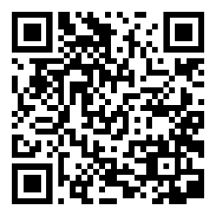
Muaj lus nug txog Primary.Health? Hu rau 650-275-5419

SCAN tus QR code mus SAIB
ib daim video txog tias yuav kuaj licas.

