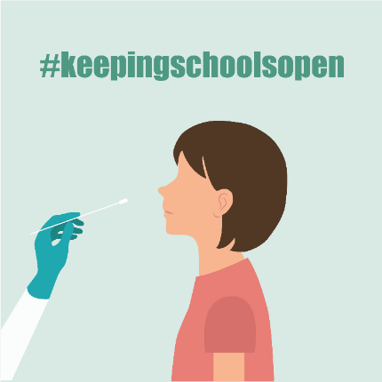
Step 1: Get the following materials:
- Two iHealth COVID-19 Antigen Rapid Tests (with instructions).
- A device with internet access for submitting your results at the link provided by your school. (If you do not have a device or internet, call Primary at (650) 275-5419.

Step 2: Test your student (or yourself if you are a staff member)
NO SYMPTOMS? Students and staff members with NO COVID-19 symptoms and NO known exposure to someone with COVID-19 should TEST TWO TIMES:
- Test #1: Three (3) days before returning to school
- Test #2: The day before returning to school
SCAN the QR code (see below) to WATCH a video on how to test.
ANY SYMPTOMS? KNOWN EXPOSURE? If you HAVE ANY COVID-19 symptoms and/or you know you were exposed, CALL YOUR SCHOOL for next steps before you return.

Step 3: Share your test results on Primary.Health. (DO NOT use the iHealth app.)
If not already registers, go to Primary.Health by December 29 https://my.primary.health/l/scusd-edu
A message will be sent to you from Primary Health on 12/30 and 1/2 to report your results.
NO INTERNET? Call your results in at (650) 275-5419
QR code to register:

Step 4: Understand your test results
POSITIVE TEST?
- Stay home and contact your doctor, your school and email covidreport@scusd.edu right away for further guidance.
NEGATIVE TEST?
- If your student feels well and has no COVID-19 symptoms, RETURN TO SCHOOL!
- If your student has SYMPTOMS or has been in contact with someone with COVID-19, please stay home and CALL THE SCHOOL before they return – even if the test is negative. More testing may be needed.
UNCLEAR TEST RESULTS? Contact the school for next steps, to find the next in-school testing date, or find a local testing site to retest. Make sure you have a photo of your test.
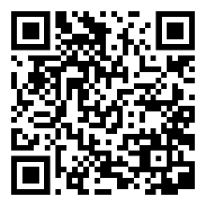
Questions about Primary.Health? Contact 650-275-5419

SCAN the QR code to WATCH
a video on how to test.

