Civic Engagement Learning Summary
Hueling M. Lee

IMPORTANCE OF CIVIC ENGAGEMENT LEARNING FOR DISRUPTING INEQUALITY:
According to LEADE research, large numbers of students today are not receiving the civic education necessary to support informed and active participation in civic and political life. Moreover, inadequate provision of civic learning opportunities is especially common in schools serving low-income communities, communities of color, and immigrant communities. For example, on average, white students, middle-class students, and students in higher-track classes experience more classroom-based, after-school and informal civic learning opportunities, and are much more likely to be engaged in extracurricular groups that support civic development.
By definition, students from “marginalized” communities have been marginalized by the systems of governance that exist, including our education system. Naturally, students from these communities are taught, either explicitly or implicitly, to distrust or disengage with systems of governance or power. By not participating and not representing their needs, these students and their communities co-conspire with the institutions or systems of power to continue marginalizing them.
Throughout American history, public schools have been charged with preparing youth for participation in our democracy. As John Dewey put it “Democracy has to be born anew every generation, and education is its midwife.” However, significant focus on math and ELA assessment test scores in our education system encourage schools serving underprivileged student populations to forego high quality civic engagement learning opportunities for its students – again, co-conspiring to continue the marginalization process of the underprivileged by not providing students with the opportunities to practice using their voice and agency.
High quality civic engagement learning would enable all students to practice participating in and engaging with the decision-making around them. It prepares students to activate their voice and agency, to advocate for their community needs, thereby disrupting the default marginalizing effects of our legacy systems, in schools and in our society.

CIVIC LEARNING AND THE STATE SEAL AS OPPORTUNITIES FOR TRANSFORMATIONAL CHANGE:
The State Seal of Civic Engagement (SSCE) is an opportunity to enable all students, particularly those from marginalized communities, to have relevant, rigorous, and engaging learning opportunities. Such opportunities would enable students to understand that each student matters and belongs in our democratic society and that they have the right and responsibility to make the world, and their community, a better place. The California State Seal of Civic Engagement, marked by a gold seal on the diploma or transcript, recognizes high school juniors and graduates who have demonstrated understanding of civic knowledge, civic skills and action through a civic engagement project; completed a quality reflection of their experience and growth; and have testimony of their civic mindedness.
Civic Engagement Project Requirements: High quality civic engagement learning requires students to go through a cycle of inquiry to foster relevance and rigor in content knowledge and skill acquisition to better engage students. The cycle of inquiry entails:
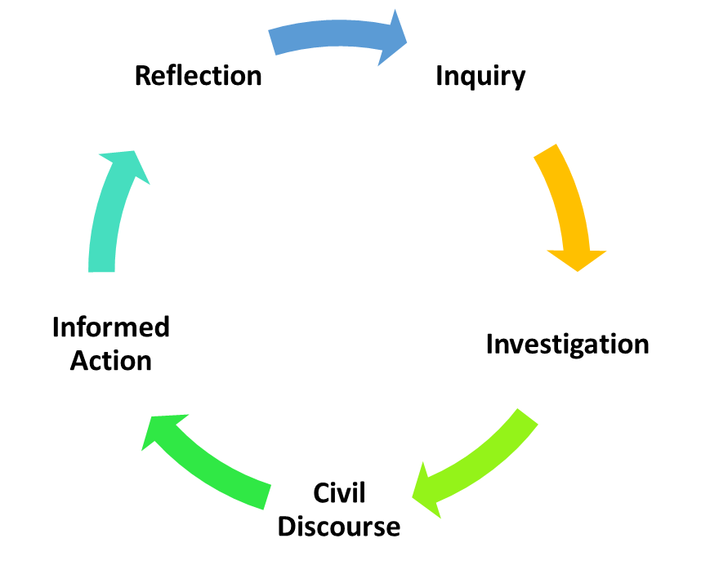
INQUIRY: begin with a compelling question that is intellectually meaty, relevant and interesting to students, and will compel them to investigate a myriad of answers and solutions.
INVESTIGATION: dig into the content of a complex issue, past and present, to search for answers by applying research and analytical skills to examine the social, political, historical, economic, environmental, ethical, and other trends and influences in decision-making.
CIVIL DIALOGUE: engage in civil and respectful dialogues to reveal multiple perspectives around controversial issues to arrive at a conclusion; then, to communicate their conclusions in a variety of ways – speaking, writing, and using various forms of media.
INFORMED ACTION: take effective, practical, and appropriate informed action on conclusions they have drawn by addressing issues and problems in the real world today.
REFLECTION: reflect on how the process enabled the student to learn about themselves, their community, and how power dynamics work in our society, how they have grown, how they have impacted their community or the common good (or not), and what they could’ve done differently to create deeper or more lasting change.
DIFFERENCE BETWEEN CIVIC ENGAGEMENT LEARNING & SERVICE LEARNING:
Both civic engagement learning and service learning involves real-world learning, where students engage with their community in support of a common good. Service learning entails community service or volunteering, such as serving meals to houseless persons, tutoring younger children in a school or non-school setting, reading to elderly persons, picking up litter in a public place, assisting in the office of a nonprofit or community agency, or working for Habitat for Humanity. Civic engagement learning requires students to study up on a community, social, and/or environmental issue to influence policy, understand how governance works, and engage with key decision-makers to practice advocating for their ideas for positive change. Thus, service learning without students going through a cycle of inquiry (above) would be insufficient to qualify as civic engagement.
Assessment or measurement of service learning is usually through the number of “service hours” students completed. Civic learning is assessed through civic competencies – the civic knowledge, skills, and dispositions (or habits) that students are able to demonstrate. Here is a sampling of civic engagement competencies.
Service learning prepares students to become service oriented, to be of service to others. Civic engagement learning prepares students to become civic participants, to embrace their voice, agency, and influence by analyzing problems/issues, building public awareness, and advocating their ideas to influence institutional decision-making. Service learning without the civic engagement components to understand and practice advocacy/influence will not be very effective for preparing our students to disrupt the inequitable effects of our default culture and institutional policies.

Gould, Jonathan, et al.. Guardian of Democracy: The Civic Mission of Schools, 2011.
Kahne, Joseph, and Ellen Middaugh. "Democracy for Some: The Civic Opportunity Gap in High School.” Circle Working Paper 59, Center for Information and Research on Civic Learning and Engagement (CIRCLE), 2008.
Kawashima-Ginsberg, Kei. “Do Discussion, Debate, and Simulations Boost NAEP Civics Performance?” Circle Fact Sheet, Center for Information and Research on Civic Learning and Engagement (CIRCLE). 2013. Kahne, Joseph, and Ellen Middaugh. "Democracy for Some: The Civic Opportunity Gap in High School.” Circle Working Paper 59, Center for Information and Research on Civic Learning and Engagement (CIRCLE). 2008.
Dewey, J. (1916). The Need of an Industrial Education in an Industrial Democracy

