SCUSD
6th Grade Unit of Study
Ratio Relationships

DRAFT
Unit of Study
Ratio Relationships
Grade: 6 |  | Topic: Ratios |  |  | Length of Unit: 8-12 days
Focus of Learning
Common Core Standards:  Understand ratio concepts and use ratio reasoning to solve problems.  6.RP.1 Understand the concept of a ratio and use ratio language to describe a ratio relationship between two quantities. For example, “The ratio of wings to beaks in the bird house at the zoo was 2:1, because for every 2 wings there was 1 beak.” “For every vote candidate A received, candidate C received nearly three votes.”  6.RP.3 Use ratio and rate reasoning to solve real-world and mathematical problems, e.g., by reasoning about tables of equivalent ratios, tape diagrams, double number line diagrams, or equations.  a. Make tables of equivalent ratios relating quantities with whole number measurements, find missing values in the tables, and plot the pairs of values on the coordinate plane. Use tables to compare ratios. |  |  |  |  | Mathematical Practices:  - Make sense of problems and persevere in solving them.  - Reason abstractly and quantitatively.  - Construct viable arguments and critique the reasoning of others.  - Model with mathematics.  - Use appropriate tools strategically.  - Attend to precision.  - Look for and make use of structure.  - Look for and express regularity in repeated reasoning.
Enduring Understanding(s): Students will understand that…
- A ratio expresses the relationship between two quantities.
- Ratio reasoning can be applied to many different types of mathematical and real-life problems.
- A ratio is a distinct entity, different from the two measures that make it up.
Essential Questions: These questions will guide student inquiry.
- Why are ratios important?
- How are ratios used in everyday life?
- What kind of problems can I solve with ratios?
- When is it useful to be able to relate one quantity to another?
- How can I compare two different quantities?
Student Performance
Knowledge: Students will understand/know…  - A ratio compares two related quantities  - Ratios can be represented in multiple formats including for each, per, to, each, %, 1:5, 1/5, 0.2, etc.  - There are two kinds of ratio; part:part and part:whole  - Appropriate use of mathematical strategies for solving problems involving ratios and rates such as tables of equivalent ratios, tape diagrams, double number lines, graphs or equations |  |  | Application: Students will be able to...  - Use ratio language  - Write ratios to describe the relationship between two quantities  - Make and manipulate tables of equivalent ratios  - Use tables to compare ratios  - Plot pairs of values on the coordinate plane  - Use double number lines to solve problems  - Use tape diagrams to solve problems  - Propose, justify and communicate solutions  - Use ratio reasoning to solve real-world and mathematical problems
Assessments (Attached)
Suggested Formative Assessments:
  - MARS – 7th grade 2006 “Square Tiles” (Use after Lesson 2)
  - SBAC-MAT.06.CR.1.000RP.A.174 (Use after Lesson 2)
  - Illustrative Mathematics 6.RP.A.3 “Mixing Concrete”

Post-Assessment (Culminating Task):
- Bead Bracelets
Learning Experiences (Lesson Plans Attached)
Days (Approx) | Lesson Sequence |  |  |  | Materials
1 | Lesson 1: Introduction to Ratios  Students will know:  - A ratio compares two related quantities  - Ratios can be represented in multiple formats including for each, per, to, each, %. 1/5, etc.  Students will be able to:  - Use ratio language to describe the relationship between two quantities
1 | Lesson 2: Writing Ratios  Students will know:  - A ratio compares two related quantities  - Ratios can be represented in multiple formats including for each, per, to, each, %, 1:5, 1/5, etc.  Students will be able to:  - Write ratios to describe the relationship between two quantities |  |  |  | Suggested Formative Assessments:  - MARS – 7th grade 2006 “Square Tiles”  - SBAC-MAT.06.CR.1.000RP.A.174
2 | Lesson 3: Problem Solving with Ratios (tables of equivalent ratios)  Students will know:  - Appropriate use of mathematical strategies for solving problems involving ratios and rates such as tables of equivalent ratios, tape diagrams, double number lines, graphs or equations  Students will be able to:  - Use tables to compare ratios  - Make and manipulate tables of equivalent ratios  - Plot pairs of values on the coordinate plane
2 | Lesson 4: Graphing Ratios  Students will know:  - Appropriate use of mathematical strategies for solving problems involving ratios and rates such as tables of equivalent ratios, tape diagrams, double number lines, graphs or equations  Students will be able to:  - Plot pairs of values on the coordinate plane  - Make and manipulate tables of equivalent ratios
1 | Lesson 5: Problem Solving with Ratios (double number lines)  Students will know:  - Appropriate use of mathematical strategies for solving problems involving ratios and rates such as tables of equivalent ratios, tape diagrams, double number lines, graphs or equations  Students will be able to:  - Use double number lines to solve problems
2 | Lesson 6: Problem Solving with Ratios (tape diagrams)  Students will know:  - Appropriate use of mathematical strategies for solving problems involving ratios and rates such as tables of equivalent ratios, tape diagrams, double number lines, graphs or equations  Students will be able to:  - Use tape diagrams to solve problems |  |  |  | Suggested Formative Assessment:  - Illustrative Mathematics-6.RP.A.3 “Mixing Concrete”
1 | Post Assessment (Culminating Task)  Students will:  - Propose, justify and communicate solutions |  |  |  | Culminating Task:  - “Bead Bracelets”
Resources
Online |  |  |  | Text
Georgia Department of Education  https://www.georgiastandards.org/Common-Core/Pages/Math.aspx  Illustrative Mathematics  http://www.illustrativemathematics.org/  Inside Mathematics/MARS tasks  http://www.insidemathematics.org/ ; http://map.mathshell.org/materials/index.php  Massachusetts Department of Elementary and Secondary Education http://www.doe.mass.edu/candi/model/units/Mathg6-RatioRates.docx  North Carolina Department of Public Instruction  http://www.dpi.state.nc.us/acre/standards/common-core-tools/#unmath  Progressions for the Common Core State Standards in Mathematics  http://ime.math.arizona.edu/progressions/  Smarter Balanced Assessment Consortium  http://www.smarterbalanced.org/smarter-balanced-assessments/#item  Utah State Office of Education  http://schools.utah.gov/CURR/mathelem/Core-Curriculum/Ratios-and-Proportional-Reasoning.aspx |  |  |  | McGraw-Hill. California Mathematics: Concepts,  Skills, and Problem Solving, Grade 6. New York: McGraw-Hill Companies, Inc. 2008. Print.  National Council of Teachers of Mathematics.  Developing Essential Understanding of Ratios, Proportions & Proportional Reasoning: Grades 6 – 8. Virginia: National Council of teachers of Mathematics, Inc. 2011.  Shoseki, Tokyo. Mathematics International: Grade 6.  2012. (Japanese Text)  Van de Walle, John, and LouAnn Lovin. Teaching  Student-Centered Mathematics: Grades 5-8. Vol. 3. Boston: Pearson, 2006.

Lessons

Ratio Relationships – Lesson 1
Unit Title: Ratio Relationships  Lesson: Introduction to Ratios | Approx. time: 50 min | CCSS-M Content Standards: 6.RP.1  CCSS-M Standards for Mathematical Practice: 1,4,6
A. Focus and Coherence  Students will know…  - A ratio compares two related quantities  - Ratios can be represented in multiple formats including for each, per, to, each, %, 1/5, etc.  Students will be able to…  - Use ratio to describe the relationship between two quantities  Student prior knowledge:  - Students understand the concept of fractions.  - Students have domain-specific vocabulary: comparison, relate, quantity, part, and whole.  Which math concepts will this lesson lead to?  - Students will be able to find unit rates and ratios. |  | B. Evidence of Math Practices  What will students produce when they are making sense, persevering, attending to precision and/or modeling, in relation to the focus of the lesson?  SMP 1 - Students will make sense and persevere by…  - restating problems in ratio language, e.g.: for every red object, there are two blue objects.  SMP 6 - Students will attend to precision by…  - using “for each”, “per”, “to”, “each”, “%”, etc  SMP 4 - Students will attend to precision by…  - creating their own examples of ratios.
Essential Question(s)
- Why are ratios important?
- How are ratios used in everyday life?
Formative Assessments
Informal oral response (step 6 in lesson plan)
Written short-response - Students will fill out a “Quick Write/Exit Ticket” answering the following: Create a ratio to describe your family using a sentence stem.
Anticipated Student Preconceptions/Misconceptions
- Students might confuse the fraction concept of “out of a whole”.
- Students may mis-order quantities, e.g.: a comparison win-loss ratio of two wins to three losses is written as 3:2, and switched to 2:3. It is helpful if students begin labeling the quantities of the things they are comparing both in writing and orally;
- Students have difficulty distinguishing a part-part comparison to a part-whole ratio, e.g.: There are 12 girls compared to 11 boys in the class (12:11), but 12 of the 23 students in the class are girls (12:23);
Materials/Resources
- whiteboards
- dry erase markers
- Artwork for step 5 in lesson plan – Suggested artists: Seurat, Vasarely, Magritte, Escher, you may also use images from the OCR anthologies
- Half sheets of paper for closure

C. Rigor: fluency, deep understanding, application and dual intensity
What are the learning experiences that provide for rigor? What are the learning experiences that provide for evidence of the Math Practices? (Detailed Lesson Plan)
Warm Up
- Ask students to count the chairs in the room. Have them write the counts up on their white board. Then, have them count the chair legs.
- Ask students to show their whiteboards when finished.
- Ask for a sentence to describe those two numbers and their relationship. (suggest Think-Pair-Share, Sentence Frame for ELs, etc.)
- Extension:
  - If you are using a Math Board to record concepts, share sentences on paper/post-its by putting them on the board.
  - Have students/partners draw a picture of their comparison
Lesson
- Create a context for vocabulary: Ask for a count of boys and girls in the class. Work with part-to-part and part-to-whole ratios on those numbers. (Girls: Boys, Girls: Whole, Whole: Boys, etc.)
- Introduce the vocabulary words: Label the parts and whole: ratio, part labeling the ratio;
- Extend to analytical writing: Write an example sentence about one of the ratios, modeling “of”, “for each/every”, “per”, “to”, “each”;
Sample sentence stems: (customize to your own classroom)
  - There are 14 girls, for every 17 boys in our classroom.
  - The chairs have a seat to leg ratio of 1 to 4.
  - Our classroom has 1 teacher per 31 students.
  - For each desk in the classroom there is one student.
- Record the sentence stems on board/chart paper for students to refer to;
- Students come up with comparisons in pairs/small group;
  - Students write sentences to describe all the ratios they can (at least 4) find within a piece of artwork, using domain-vocabulary/stems.
  - Students share aloud the ratios they have found.
  - (These sentences will also be used in lesson 2)
- Have a discussion based on the following questions from the teacher:
  - Why do you think ratios are important?
Desired Responses:
They help us compare different quantities; You can use them to figure out real-world problems, etc.

Closure
Students will fill out a “Quick Write/Exit Ticket” answering the following:

Create a ratio to describe your family using a sentence stem.
Sample desired responses:
There are two sisters for every brother in our family.
My family has a parent to daughter ratio of two to one.

Suggested Homework/Independent Practice
Find three ratios in your home, and write sentences to describe them using sentence stems for ratios.

Ratio Relationships – Lesson 2
Unit Title: Ratio Relationships  Lesson: Writing Ratios | Approx. time: 40 min | CCSS-M Content Standards: 6.RP.1  CCSS-M Standards for Mathematical Practice: 1, 4, 6
A. Focus and Coherence  Students will know…  - A ratio compares two related quantities  - Ratios can be represented in multiple formats including for each, per, to, each, %, 1:5, 1/5, etc.  Students will be able to…  - Write ratios to describe the relationship between two quantities  Student prior knowledge:  - Number sense  - Knowledge of various forms of measure (i.e. gallons, miles, feet, seconds)  Which math concepts will this lesson lead to?  - Appropriate use of mathematical strategies for solving problems involving ratios and rates such as tables of equivalent ratios, tape diagrams, double number lines, graphs or equations |  | B. Evidence of Math Practices  What will students produce when they are making sense, persevering, attending to precision and/or modeling, in relation to the focus of the lesson?  SMP 1 - Students will make sense and persevere by…  - Using tables to compare ratios  SMP 4 - Students will model with mathematics by…  - Using ratio and rate reasoning to solve real-world  and mathematical problems  - Making and manipulating tables of equivalent ratios  SMP 6 - Students will attend to precision by…  - Using ratio and rate language  - Writing ratios to describe the relationship between two quantities
Essential Question(s):
1) Why are ratios important?
2) How are ratios used in everyday life?
Formative Assessments:
- White boards in step 3 of lesson, student created ratios from sentences
- SBAC-MAT.06.CR.1.000RP.A.174 or Square Tiles task
Anticipated Student Preconceptions/Misconceptions:
1) Students may relate ratios to improper fractions and have concerns about a larger number coming first in the ratio. Assure students that in a ratio context it is completely appropriate.
2) Students may apply fraction concepts to ratios inappropriately. For example, students may want to find equivalent ratios in a situation where changing the ratio takes away from the meaning of the ratio.
Materials/Resources:
Student sentences from artwork (completed in lesson 1)
McGraw-Hill Chapter 6 teacher resources – Word Problem Practice (copy if needed)

C. Rigor: fluency, deep understanding, application and dual intensity
What are the learning experiences that provide for rigor? What are the learning experiences that provide for evidence of the Math Practices? (Detailed Lesson Plan)
Warm Up:
Write a sentence to describe a new ratio you observe in the classroom*
Have students share their responses aloud to a neighbor then select several students to share out whole class.
Sample desired responses:
There are 32 desks for every 31 students in our classroom.
The ratio of windows to students is 6 to 31.
*Record several student responses on the board and leave them there for use during the lesson.
Lesson: Writing Ratios
Today students will learn to use ratio notation to describe situations.
- Begin by introducing ratio notation in both colon form (3:2) and fraction form (3/2) using some student responses to the warm-up.
- Write out explicitly for students the “pronunciation” of ratio notation, i.e. “3/2 is read as three to two”
- Ask students to use whiteboards to write ratio notation for the remaining student sentences from the warm-up, specify the form of notation you would like to see for each sentence, colon or fraction.
- Next, students will use the sentences they wrote in lesson 1 based on a piece of artwork and write the ratio notation that represents each sentence.
- Students will then share their ratios either in small-group or pair-share, reading them aloud to their peers. (Students need opportunities to read the fraction notation aloud.)
- Students may begin work on Word problem practice from Teacher’s Chapter Resource

Closure:
Students complete SBAC sample item MAT.06.CR.1.000RP.A.174 or square tiles task

Suggested Homework/Independent Practice:
1) Create story problem involving ratios
2) Observe ratios encountered in daily life and write them down
3) Word problem practice from Teacher’s Chapter Resource

Ratio Relationships – Lesson 3
Unit Title: Ratio Relationships  Lesson: Problem Solving with Ratios | Approx. time: | CCSS-M Content Standards: 6.RP.3a  CCSS-M Standards for Mathematical Practice: 1, 4, 6
A. Focus and Coherence  Students will know…  - Appropriate use of mathematical strategies for solving problems involving ratios and rates such as tables of equivalent ratios, tape diagrams, double number lines, graphs or equation  Students will be able to…  - Use tables to compare ratios  - Make and manipulate tables of equivalent ratios  Student prior knowledge:  - What ratios & equivalent ratios are  - Read tables  - Write equivalent fractions  Which math concepts will this lesson lead to?  - Rates/Unit Rates  - Percents |  | B. Evidence of Math Practices  What will students produce when they are making sense, persevering, attending to precision and/or modeling, in relation to the focus of the lesson?  SMP 1 - Students will make sense and persevere by…  - Creating their own tables of equivalent ratios given a problem situation  SMP 4 - Students will model with mathematics by…  - Creating a table of equivalent ratios to model a given situation.  SMP 6 - Students will attend to precision by…  - Demonstrating the use of vocabulary such as equivalent and ratio during the gallery walk  - Using academic vocabulary such as, “ratio,” “equivalent,” “increase,” “decrease” and/or “rate.”
Essential Question(s)
- What is a ratio?
- How are ratios similar/different from fractions?
Formative Assessments
Warm-Up – Brain Dump, what do you know about 2:5
Student thinking as they complete recipes for “Sandy’s Super Sweet Lemonade” (Steps 5&6 in lesson)
Student Posters with tables of equivalent ratios
Anticipated Student Preconceptions/Misconceptions
Students might think that…
- ratios are a part of a whole
- ratios are fractions
- students might reverse ratios or misplace ratio values
Materials/Resources
Required:
Index cards with beverage recipes cut up, 1 recipe per group of 2-4

C. Rigor: fluency, deep understanding, application and dual intensity
What are the learning experiences that provide for rigor? What are the learning experiences that provide for evidence of the Math Practices? (Detailed Lesson Plan)
Warm Up
Brain Dump - Quickly write at least 4 things that you know about the following:
2:5
Students share out what they have written (Consider using a CLRT protocol such as Whip Around or Pass It On)
Lesson
Today you will work with a recipe for making “Sandy’s Super Sweet Lemonade”
- Begin by introducing a recipe for lemonade that calls for 1 lemon, 1/3 cup sugar and 2 cups of water per serving.
- Ask the students to give ratios of the different ingredients (lemon: sugar, water: sugar, lemon: sugar: water etc.)
- Present the situation that you want to make enough lemonade for 2 servings that tastes exactly the same as “Sandy’s Super Sweet Lemonade”. Ask the students how they think the ratios would change. (Give think time, pair share, record student thinking whole group)
- Introduce a table of equivalent ratios for recording student thoughts. Explain that it is a way of finding equivalent ratios and a way of organizing their thinking. Accurately record in the table the lemonade recipe for 1 and 2 servings.
- Next ask students to formulate a recipe for 6 servings. Give independent think time before group or class discussion. Elicit student thinking for both correct and incorrect thinking.
Individual students:
- “How do you know?”
- “Where did you get __ cups from?”
Whole class:
- “Do you agree or disagree with (student)?”
- “Why do you think (student) thought there would be ___ cups of ________?”
- Complete the rest of the table below with the students. Elicit student thinking along the way. Help students to notice the role of addition, multiplication and division in how entries are related to each other.

Lemon | 1 | 2
Sugar | 1/3 cup | 2/3 cup
Water | 2 cups | 4 cups
SERVINGS | 1 Serving | 2 Servings | 6 Servings | 10 Servings | - ervings

7) Hand out index cards with different lemonade recipes and chart paper. In small groups, have students create a table of equivalent ratios on chart paper for their recipe that includes 1, 2, and 6 servings, the number of servings it would take to serve the class, and at least 2 more serving sizes of their choice.
Closure
When students have completed charts, complete a “gallery walk” of the different recipes in the room. Ask each group to leave a “docent” at their poster to explain how they found values in their table as groups rotate.
Suggested Homework/Independent Practice

Suzie’s Sour Lemonade  Lemon: 2  Sugar: ¼ cup  Water: 2 cups  Servings: 1 |  | Polly’s Puckering Lemonade  Lemon: 4  Sugar: 2/3 cup  Water: 4 cups  Servings: 2 |  | Piers Perfect Lemonade  Lemon: 1  Sugar: 1/2 cup  Water: 2 cups  Servings: 2
Jenny’s Just-Right Limeade  Lime: 4  Sugar: 1 cup  Water: 12 cups  Servings: 6 |  | Sal’s Sugary Limeade  Lime: 1  Sugar: ½ cup  Water: 2 cups  Servings: 1 |  | Tran’s Tart Limeade  Lime: 3  Sugar: ½ cup  Water: 2 cups  Servings: 2
Conrad’s Cool Lemonade  Lemon: 16  Sugar: 2 cups  Water: 8 cups  Servings: 4 |  | Jeanetti’s Juicy Lemonade  Lemon: 9  Sugar: 1 ½ cups  Water: 6 cups  Servings: 3 |  | Sofia’s Super Lemonade  Lemon: 2  Sugar: 1/2 cups  Water: 4 cups  Servings: 2
Renee’s Radical Limeade  Lemon: 6  Sugar: 2 cups  Water: 8 cups  Servings: 4 |  | Christal’s Ice Cold Limeade  Lemon: 6  Sugar: 3 cups  Water: 6 cups  Servings: 3 |  | Leo’s Luscious Limeade  Lemon: 4  Sugar: 1 cup  Water: 2 cups  Servings: 2
Dulce’s Delicious Lemonade  Lemon: 2  Sugar: 2 cups  Water: 2 cups  Servings: 2 |  | Pavel’s Punchy Lemonade  Lemon: 1  Sugar: ½ cup  Water: 4 cups  Servings: 2 |  | Yesenia’s Yummy Lemonade  Lemon: 2  Sugar: 3 cups  Water: 4 cups  Servings: 2
Meuy’s Mouthwatering Limeade  Lemon: 4  Sugar: 2 cups  Water: 6 cups  Servings: 4 |  | Armando’s Amazing Limeade  Lemon: 6  Sugar: 3 cups  Water: 9 cups  Servings: 6 |  | Tommy’s Tasty Limeade  Lemon: 8  Sugar: 4 cups  Water: 12 cups  Servings: 8

Ratio Relationships – Lesson 4
Unit Title: Ratio Relationships  Lesson: Graphing Ratios | Approx. time: | CCSS-M Content Standards:6.RP.1, 6.RP.3a, 5.OA.3  CCSS-M Standards for Mathematical Practice: 1, 2, 6, 7
A. Focus and Coherence  Students will know…  - Appropriate use of mathematical strategies for solving problems involving ratios and rates such as tables of equivalent ratios, tape diagrams, double number lines, graphs or equations  Students will be able to…  - Plot pairs of values on the coordinate plane  - Make and manipulate tables of equivalent ratios  Student prior knowledge:  - Multiplication and division  - Plotting pairs of points on a plane from a table  Which math concepts will this lesson lead to?  - Slope and equations of lines |  | B. Evidence of Math Practices  What will students produce when they are making sense, persevering, attending to precision and/or modeling, in relation to the focus of the lesson?  SMP 1 Students will make sense and persevere by…  - Creating tables of equivalent values  - Scaling the axes on their graph to fit the data from the tables.  SMP 2 Students will reason abstractly and quantitatively by …  - connecting their knowledge of the sugar: lemon ratio to the data points in their table and the line on their graph.  SMP 6 Students will attend to precision by …  - Labeling their graphs and tables with appropriate units.  SMP 7 Students will look for and make use of structure by…  - Creating tables of equivalent values and graphing data from their tables. They may notice that for instance that for every cup of sugar or 1 unit on the x-axis, there are 3 lemons or 3 units on the y-axis.
Essential Question(s)
- How are ratios used in everyday life?
Formative Assessments
Warm-up – Using a table of equivalent ratios to solve a problem
Closure – Creating a table and graph

Anticipated Student Preconceptions/Misconceptions
Just as students may write ratios in reverse order (2:3 vs. 3:2), they may graph pairs of values on the coordinate plane in reverse order.

Materials/Resources
Graph Handout (attached)
Different color pens/pencils
C. Rigor: Conceptual Understanding, Procedural Skills and Fluency, and Application
What are the learning experiences that provide for rigor? What are the learning experiences that provide for evidence of the Math Practices? (Detailed Lesson Plan)
Warm Up
The ratio of orange to green M&M’s in any size bag is 5 to 4. If there are 60 orange M&M’s in a bag, how many green M&M’s will be in the bag? Use a table of equivalent ratios to solve.

In debriefing the warm-up, allow students to explain their thinking. Draw attention to the multiplication and division relationship between entries.
Sample questions for students:
  - “How do you know?”
  - “Where did you get __ from?”
for Whole class:
- “Do you agree or disagree with (student)?”
- “Why do you think (student) thought there would be ___ orange/green M&M’s?”

Lesson
1) Today we are going to graph the sugar: lemon ratio in different lemonade recipes. How does this ratio affect the taste of a batch of lemonade?
  - Allow students a moment of silence then some time to pair share
  - Use a participation protocol for student to share out their thoughts (pick-a-stick, roll ‘em, raise a righteous hand, etc.)
- Introduce the graph handout for students to use. Students will need to decide how to label the axes numerically. (Note: this should be a student decision)
- Students will be given 3 sugar: lemon ratios (see handout). They will need to create tables of equivalent ratios for the ratios and then graph all the data in the tables on the same axes. Students should graph each ratio with a different color.
- Classroom Discussion – the purpose of the discussion is to draw attention to the properties of the lines. Without using the vocabulary slope or intercept, students should begin noticing rate of change and the connection to the slope and the steepness of the line.
Sample questions:
  - Looking at your graph, which lemonade will be the sweetest? How do you know?
  - What would be the ratio of a lemonade that is sweeter than Memah’s and tarter than Erdos’?
  - Where can you see the original ratio of sugar to lemon in your graph? Is there more than one place? Explain.

Closure
Make a sugar: lemon ratio for your own special lemonade recipe. Create a table of equivalent ratios and a graph for your special recipe. Explain all you know about your recipe, table and graph.
Suggested Homework/Independent Practice –
Illustrative Mathematics - 6.RP Walkathon 1 http://www.illustrativemathematics.org/illustrations/711

Create tables of equivalent ratios for the three given ratios:
- Julia’s Juicy Lemonade has a sugar to lemon ratio of 1:4

- Memah’s Marvelous Lemonade has a sugar to lemon ratio of 2:3

- Erdos’ Easy Lemonade has a sugar to lemon ratio of 3:1

Sugar to Lemon Ratios

Ratio Relationships – Lesson 5
Unit Title: Ratio Relationships  Lesson: Problems solving with Ratios (double number lines) | Approx. time:  60 minutes | CCSS-M Content Standards: 6.RP.1, 6.RP.2, 6.RP.3  CCSS-M Standards for Mathematical Practice: 1, 4, 6
A. Focus and Coherence  Students will know…  - Appropriate use of mathematical strategies for solving problems involving ratios, tables of equivalent ratios, tape diagrams, double number lines.  Students will be able to…  - Use double number lines to find missing values  Student prior knowledge:  - Multiplication and division  - Equivalent fractions  - Definition of a fraction  - Number lines  Which math concepts will this lesson lead to?  - Understanding rates and unit rates |  | B. Evidence of Math Practices  What will students produce when they are making sense, persevering, attending to precision and/or modeling, in relation to the focus of the lesson?  SMP 1 - Students will make sense and persevere by…  - Creating double number lines as a method and give a verbal explanation of their significance.  - Writing ratios as fractions in simplest form  - Showing the relative size of two quantities in different contexts  SMP 4 - Students will model with mathematics by…  SMP 6 - Students will attend to precision by…  - Demonstrating understanding of vocabulary such as double number lines, ratio, equivalent ratio
Essential Question(s)
- What is a ratio?
- What kind of problems can I solve with double number lines?

Formative Assessments
Warm-up – Writing ratios from a recipe
Anticipated Student Preconceptions/Misconceptions
- Students might not understand that the intervals marked on each number line remain the same, even though the each number line is different.
Materials/Resources

C. Rigor: fluency, deep understanding, application and dual intensity
What are the learning experiences that provide for rigor? What are the learning experiences that provide for evidence of the Math Practices? (Detailed Lesson Plan)
Warm Up
A recipe calls for;
4 tsp garlic powder
6 tsp of dried oregano
2 tsp of pepper

Use the recipe to write the following ratios:
a. pepper: garlic powder b. oregano: pepper c. garlic powder: oregano

Note – Students may express ratios in three ways, 3 to 4, 3:4 or $\frac{3}{4}$. Students may also write ratios in reduced form. Call attention to the similarities between representations and what a reduced form of the ratio would mean for the actual recipe.

Lesson

- Today we will be learning a new way to represent ratio relationships called double number lines. Introduce a double number line to represent the ratio of garlic powder: oregano in the recipe used in the warm-up.
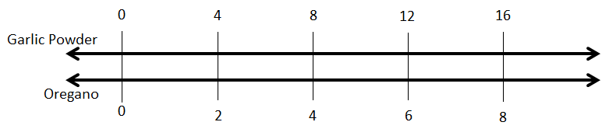

- Ask students to examine the double number line and write down on their own piece of paper:
  - Everything they know about the given double number line
  - Any questions they have about the double number line
  - Connections they can make to tables of equivalent values

- Students should share what they wrote down with a partner, adding to their lists as needed.
- Partners should pair up into groups of 4 and share what they have written down and come up with 1-2 questions to share with the whole class.
- Teacher draws two columns on the board labeled “Everything I know” and “Questions we have”. Teacher collects data from class to fill in columns. Teacher may answer the questions students have if students are not able to answer them for each other.
- Questions for students. Students should pair-share before having a whole group discussion:
  - What would it mean for the recipe if you drew a line between the 0:0 and 4:2 lines (dashed in picture).
  - What do they think they should label the line and why.
- Have students create their own double number line to represent the ratio of pepper: garlic powder from the warm-up.

Closure
Teacher uses an engagement strategy allowing students to articulate what double number lines are. Independently students will then create a double number line, with given values provided by the instructor, explaining how and why it represents equivalent proportions.

Suggested Homework/Independent Practice
Guided Practice from Mathematics International Page B4 – B8, using a double number line to solve the problems.

Ratio Relationships – Lesson 6
Unit Title: Ratio Relationships  Lesson: Problem solving with ratios (tape diagrams) | Approx. time:  2 class sessions | CCSS-M Content Standards: 6.RP.3  CCSS-M Standards for Mathematical Practice: 1, 4, 6
A. Focus and Coherence  Students will know…  - Appropriate use of mathematical strategies for solving problems involving ratios and rates such as tape diagrams.  Students will be able to…  - Use tape diagrams to solve problems  Student prior knowledge:  - Multiplication and Division facts/strategies  - Equivalent fractions  - Definition of a ratio  Which math concepts will this lesson lead to?  - Proportionality  - Solving algebraic equations |  | B. Evidence of Math Practices  What will students produce when they are making sense, persevering, attending to precision and/or modeling, in relation to the focus of the lesson?  SMP 1 - Students will make sense and persevere by…  - Noticing a ratio in the Suzie’s scoops problem  - Creating their own tape diagrams  SMP 4 - Students will model with mathematics by…  - Creating tape diagrams that model real-world situations  SMP 6 - Students will attend to precision by…  - Labeling their tape diagrams  - Explaining their model to their peers in the gallery walk
Essential Question(s):
- When is it useful to be able to relate one quantity to another?
- What other applications could a tape diagram have?

Formative Assessments:
A mixture of concrete is made up of sand and cement in a ratio of 5 : 3. How many cubic feet of each are needed to make 160 cubic feet of concrete mix?
Anticipated Student Preconceptions/Misconceptions:
Units don’t have to be the same in a tape diagram. (They do)
Students will draw the diagrams disproportionally
Students will not label diagram correctly
Students will confuse the whole with the part

Materials/Resources:
Paper, attached word problems cut into strips

C. Rigor: fluency, deep understanding, application and dual intensity
What are the learning experiences that provide for rigor? What are the learning experiences that provide for evidence of the Math Practices? (Detailed Lesson Plan)
Warm Up
Lin rode a bike 20 miles in 150 minutes. If she rode at a constant speed…
a) How far did she ride in 15 minutes?
- b) How long did it take her to ride 6 miles?
- c) How fast did she ride in miles per hour?
- d) What was her pace in minutes per mile?

Lesson
- Begin class with a “Close Read” of the completed tape diagram below using the following question prompts:
- First read - What do you notice about the tape diagram?
- Second read - What connections can you make to our ratio unit of study?
- Third read – What questions do you have about the tape diagram?
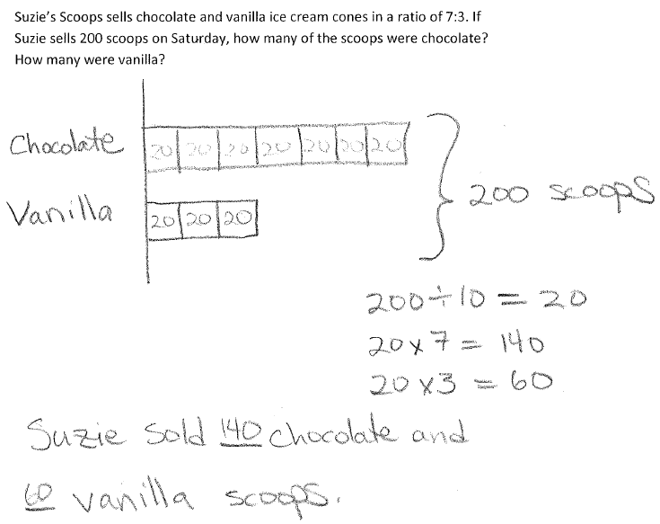

- Introduce the word problem below and the steps for making tape diagrams. (You may give each student a copy of the attached steps, or post on the wall in your classroom.) Give students some time to make sense of the word problem and create a tape diagram to represent and solve the problem. Complete the tape diagram together.

Trail mix is made with peanuts, raisins and chocolate chips in a ratio of 4:3:5. Andie is making a batch of trail mix to share with her class with 12cups of raisins. How many cups of peanuts and chocolate chips will she need?

- Distribute one of the attached ratio word problems apiece to groups of 3-4 students. Students should complete their problem on their own papers, check with each other, then collect poster paper or blank paper from the teacher (who should check their work before they create their poster) and create a mini-poster of their problem.

- Gallery Walk - students will complete a gallery walk of the posters completed by the whole class. During the gallery walk, one student from each original group will remain at their own poster to act as docent and explain their work. Students visiting the poster may ask questions, make comments and give compliments. The gallery walk will begin with the whole group at their own poster so that the docent can practice what they will say to visitors and the group can coach the docent. Students can move clockwise around the room to see each poster. Consider playing music to cue students to move.
- Once the gallery walk is complete, all students should solve the following problem on their own as a formative assessment of what they have learned. A mixture of concrete is made up of sand and cement in a ratio of 5 : 3. How many cubic feet of each are needed to make 160 cubic feet of concrete mix?

Closure:
Describe the type of problems that can be solved using a tape diagram.
Suggested Homework/Independent Practice:

Ratio Problems to Solve:

1. The ratio of boys to girls at a party was 2:3. If there were 9 girls, how many boys were at the party?
2. The ratio of burritos to hamburgers eaten in the school cafeteria is 3:4. If 350 students ate lunch, how many ate burritos?
3. The ratio of dogs to cats a veterinarian sees in a day is 5:6. If on Tuesday she sees 40 dogs, how many cats does she see?
4. Celia’s Cellphones sells Iphones and Androids in a ratio of 2:7. In February, Celia sold 900 phones. How many were Iphones? How many were Androids?
5. The ratio of cheese pizzas to pepperoni pizzas sold at Sal's Pizzeria last Thursday was 7:5. There were 45 pepperoni pizzas sold that day. How many pizzas were sold in all on Thursday?
6. The ratio of cheese pizzas to pepperoni pizzas sold at Sal's Pizzeria last Thursday was 7:5. There were 45 pepperoni pizzas sold that day. How many pizzas were sold in all on Thursday?
7. The ratio of flutists to trumpeters to drummers in the school bank is 3:4:1. If there are 5 drummers, how many flutists are there? How many trumpeters are there?
8. The ratio of soda to popcorn to candy sold at the movie theater last weekend was 8:5:6. There were 18 packages of candy sold. How many sodas were sold? In all, how many sodas, boxes of popcorn, and packages of candy were sold?
9. Jasmine went shopping with $180. She spent her money on cd's, movies, and games in a ratio of 1:3:5. How much more did Jasmine spend on games than on movies?
10. The ratio of boys to girls in the school chorus was 2:3. After 8 more boys joined the chorus, there were twice as many boys as girls. How many girls are in the chorus?
11. Judah withdrew his savings from the bank and kept 1/4 for himself. He then divided the rest of his savings between his brother and his sister in a ratio of 1:2. What fraction of the total savings did his brother receive?

Steps for making Tape Diagrams

Step 1. Read the entire problem, “visualizing” the problem conceptually
Step 2. Rewrite the question in sentence form leaving a space for the answer
Step 3. Decide and write down (label) who and/or what the problem is about
Step 4. Draw unit bars of equal length that you’ll eventually adjust as you construct the visual image of the problem
Step 5. Chunk the problem and adjust the unit bars to reflect the information in the problem
Step 6. Compute the problem to come up with an answer (show all work!)
Step 7. Fill in the space from the sentence you wrote in step 2.

Suggested
Formative
Assessments

“Square Tiles” (Use after Lesson 2)

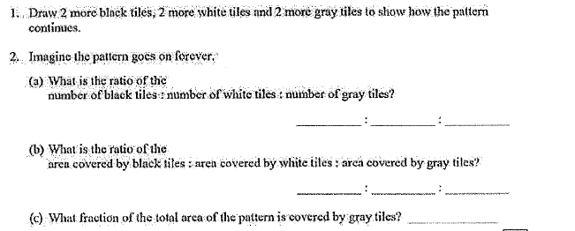
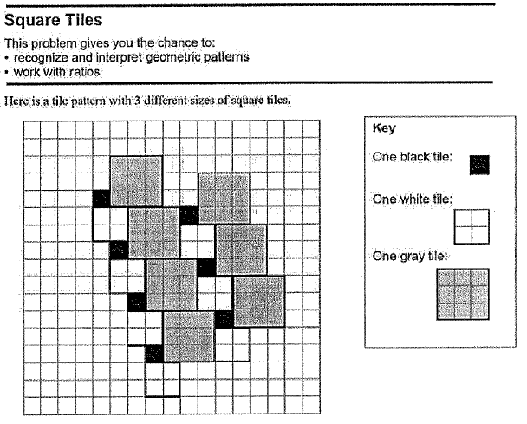

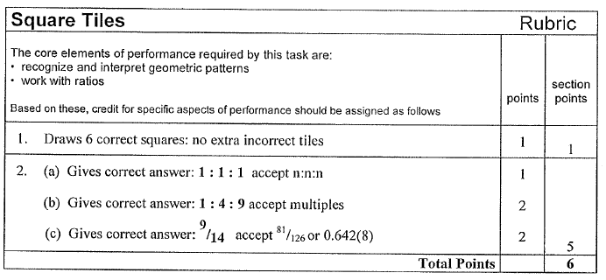
Scoring Rubric – “Square Tiles”

SBAC-MAT.06.CR.1.000RP.A.174 (Use after Lesson 2)
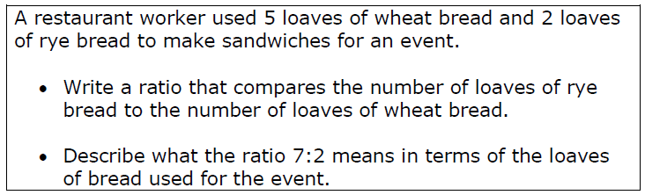

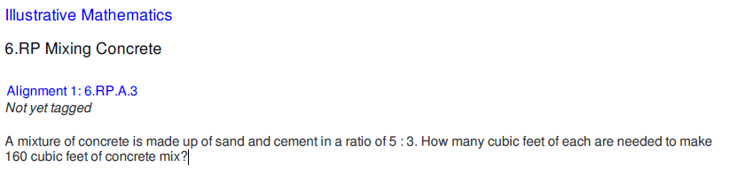
Illustrative Mathematics – “Mixing Concrete” (Use after Lesson 6)

Culminating Task:
“Bead Bracelets”

Bead Bracelets | Name_____________________

Your school is hosting an Arts and Crafts Fair to raise funds. Your class has been asked to help by designing and making jewelry for the fund-raiser. In this task, you will be asked to design a bracelet and calculate ratios.

Designing a Bracelet
Your principal has purchased the materials to make the jewelry. The materials include:

• Three types of glass beads
• Three types of spacer beads (the beads used to separate sections of glass beads)
• Beading wire (the wire that holds the beads when making a bracelet)

Each type of bead is shown below.

Glass Beads |  | Spacer Beads
Type A | 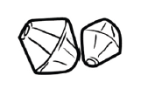 | Type D
Type B | 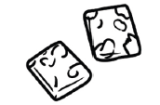 | Type E | 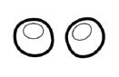
Type C | 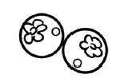 | Type F | 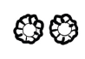

Design a bracelet using at least two types of glass beads and one type of spacer bead.
• Use between 8 and 12 glass beads.
• Use at least 6 spacer beads.
• Use no more than 25 total beads in your bracelet.

I. Write the type letter (A, B, C, D, E, or F) to represent each bead in your design. Use the 25 blanks below to lay out the design for your bracelet. Only write one letter in each blank you use.

__,__,__,__,__,__,__,__,__,__,__,__,__,__,__,__,__,__,__,__,__,__,__,__,__

Write 5 ratios below that can be used to mathematically describe the bracelet you designed. Be sure to include labels when writing your ratio.

Write ratios to describe:

- The relationship between one type of glass bead used and another type of glass bead used

- The relationship between one type of glass bead used and all the beads used

- The relationship between one type of glass bead used and a type of spacer bead used

- The relationship between all the glass beads used and all the spacer beads used

- The relationship between one type of spacer bead used and all the beads used

II. Tanya’s Necklaces
Tanya designed a necklace that she wants to make for some of her friends containing only Types A and C beads. The beads in Tanya’s Necklaces are in the following ratio:

Type A to Type C beads are in a ratio of 3:2

If one necklace contains a total of 120 beads, how many of each type of bead are in the necklace? Explain your answer using a table of equivalent values, tape diagram, graph, equation, or double number lines.

III. Edwin’s Jewelry
Edwin wanted to make a piece of jewelry using Type B and Type C beads in a ratio of 3:4 for his friend Jasmine. Edwin has 20 Type C beads and wonders how many Type B beads he will need. Edwin made a table and thinks he will need 18 Type B beads but when he checked with Jasmine she had made a graph and thought it would be 15 Type B beads. Below is both of their work. Who do you agree with and why?

Edwin’s Work` | Jasmine’s Work
Type B beads | Type C Beads
3 | 4
9 | 10
18 | 20
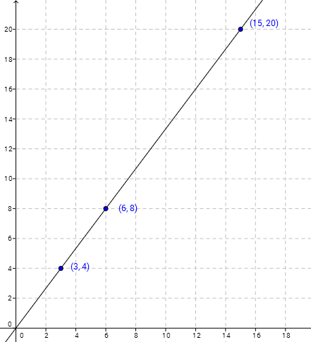
Type B Beads
Type C Beads

Grading Rubric
Part I
Sample Top Response: F, D, A, D, A, D, F, B, F, D, A ,D, A, D, F, B, F, D, A, D, A, D, F

Ratios will vary based upon the layout of beads chosen by the student.
1 Type B glass bead to 3 Type A glass beads (1:3)
3 Type A glass beads to 1 Type B glass bead (3:1)
6 Type A glass beads out of 23 beads in total (6:23)
2 Type B glass beads out of 23 beads in total (2:23)
2 Type A glass beads to 3 Type D spacer beads (2:3)
1 Type A glass bead to 1 Type F spacer bead (1:1)
2 Type B glass beads to 9 Type D spacer beads (2:9)
2 Type B glass beads to 6 Type F spacer beads (1:3)
8 glass beads to 15 spacer beads (8:15)
9 Type D spacer beads out of 23 beads in total (9:23)
6 Type F spacer beads out of 23 beads in total (6:23)

Scoring Rubric
5 points: Thorough understanding of ratio and proportional relationships. Thorough understanding of the given directions. The student correctly used one type of spacer bead and at least two types of glass beads. The student correctly used no more than 25 total beads and correctly used 8 to 12 glass beads and at least 6 spacer beads. The student correctly wrote a set of 5 ratios according to bulleted directions.

4 points: Partial understanding of ratio and proportional relationships. Partial understanding of the given directions.
- The student did everything else required, but only correctly wrote 3 of the 5 required ratios. OR
- The student did everything else required, but only correctly wrote 4 of the 5 required ratios OR
- The student did everything else required, but used a number of glass beads or spacer beads that were outside of directions and only correctly wrote 4 of the 5 required ratios. OR
- The student did everything else required, but used a number of glass beads or spacer beads that were outside of directions

3 points: Partial understanding of ratio and proportional relationships. Partial understanding of the given directions.
- The student did everything else required, but only correctly wrote 2 of the 5 required ratios. OR
- The student did everything else required, but only correctly wrote 3 of the 5 required ratios OR
- The student did everything else required, but used a number of glass beads or spacer beads that were outside of directions and only correctly wrote 3 of the 5 required ratios. OR
- The student used a number of glass beads or spacer beads that were outside of directions, made an error with 1 ratio.

2 points: Partial understanding of ratio and proportional relationships. Partial understanding of the given directions.
- The student did everything else required, but only correctly wrote 1 of the 5 required ratios. OR
- The student did everything else required, but only correctly wrote 2 of the 5 required ratios OR
- The student did everything else required, but used a number of glass beads or spacer beads that were outside of directions and only correctly wrote 2 of the 5 required ratios. OR
- The student used a number of glass beads or spacer beads that were outside of directions, made an error with 2 ratios.

1 point: Limited understanding of ratio and proportional relationships. Limited understanding of the given directions.
- The student used a number of glass beads or spacer beads that were outside of directions, made an error with 3 or more ratios, OR
- The student used a number of glass beads or spacer beads that were outside of directions, made an error with 4 or 5 ratios.

0 points: No understanding of ratio and proportional relationships. No understanding of the given directions. The student made errors in every section.

Part II
Sample Top-Response

Type A | 24 | 24 | 24
120
Type C | 24 | 24

Tanya’s necklace has 72 Type A beads and 48 Type C beads.

Scoring Rubric
3 points: Thorough understanding of ratio and proportional relationships. The student correctly used either a table of equivalent values, tape diagram, graph, equation, or double number lines and found that there are 72 Type A beads and 48 Type C beads.

2 points: Partial understanding of ratio and proportional relationships. The student used either a table of equivalent values, tape diagram, graph, equation, or double number lines and correctly found that there are 72 Type A beads or 48 Type C beads. OR The student used either a table of equivalent values, tape diagram, graph, equation, or double number lines but made a minor computational error.

1 point: Limited understanding of ratio and proportional relationships. The student attempted use of a table of equivalent values, tape diagram, graph, equation, or double number lines, but was unable to produce a valid answer.

0 points: No understanding of ratio and proportional relationships.

Part III
Sample Top-Response

I agree with Jasmine. Each point on her graph can be found by going up four and right 3. Edwin made some mistakes in his table. I think he got his second entry from adding 6 to 3 to get 9 and adding 6 to 4 to get 10. His mistake is that ratios are multiplicative, not additive unless you are adding the ratio, like 3 + 3 = 6 and 4+4 = 8. Also, his last entry, 18 and 20 is not in a 3:4 ratio.

3 points: Thorough understanding of ratio and proportional relationships. The student agrees with Jasmine and is able to explain why using the language of ratio and proportional relationships. The student also recognizes errors within Edwin’s work using the language of ratio and proportional relationships.

2 points: Partial understanding of ratio and proportional relationships. The student agrees with Jasmine but is not able to thoroughly explain why.

1 point: Limited understanding of ratio and proportional relationships. The student agrees with Jasmine but gives no reasoning why.

0 points: No understanding of ratio and proportional relationships.

