SCUSD
4th Grade Unit of Study
Getting into Fractions

Unit of Study
DRAFT
Getting into Fractions
Grade: 4 |  | Topic: Numbers and Operations: Fractions |  | Length of Unit: 12-17 days
Focus of Learning
Common Core Standards:  Extend understanding of fraction equivalence and ordering.  4.NF.1 Explain why a fraction a/b is equivalent to a fraction (n × a)/(n × b) by using visual fraction models, with attention to how the number and size of the parts differ even though the two fractions themselves are the same size. Use this principle to recognize and generate equivalent fractions.  4.NF.2 Compare two fractions with different numerators and different denominators, e.g., by creating common denominators or numerators, or by comparing to a benchmark fraction such as 1/2. Recognize that comparisons are valid only when the two fractions refer to the same whole. Record the results of comparisons with symbols >, =, or <, and justify the conclusions, e.g., by using a visual fraction model. |  |  |  | Standards for Mathematical Practice:  - Make sense of problems and persevere in solving them.  - Reason abstractly and quantitatively.  - Construct viable arguments and critique the reasoning of others.  - Model with mathematics.  - Use appropriate tools strategically.  - Attend to precision.  - Look for and make use of structure.  - Look for and express regularity in repeated reasoning.
Enduring Understanding(s): Students will understand that…
- two equivalent fractions are two ways of describing the same amount by using different-sized fractional parts.
Essential Questions: These questions will guide student inquiry.
- How can I use what I know about whole numbers to help me better understand fractions?
- How are fractions related to whole numbers?
- How can I use different size pieces to create equivalent fractions?
- How can equivalent fractions be identified?
- Why are fractions important?
- How do we compare fractions?
- How are fractions used in real life?
- Why is it easier to compare fractions with like denominators or like numerators?
- Why are equivalent fractions useful?
Student Performance
Knowledge: Students will understand/know…  - When comparing fractions, the whole must be the same.  - Fractions can be represented as parts of a whole, parts of a set, parts of an area, as a measure, and as numbers on the number line.  - The size or the amount of the whole matters when expressing relationships with fractions.  - The more fractional parts used to make a whole, the smaller the parts. E.g. eighths are smaller than fifths.  - Fractions with like numerators can be compared.  - Fractions with like denominators can be compared.  - Fractional parts can be equivalent without necessarily being congruent  - Fractions with the same whole can be compared.  - Equivalent fractions can be used to generate equal sized parts of the whole, or common denominators  - For equivalence the ratio must be kept constant  - How many pieces it takes to make a whole and each piece is a unit fraction.  - A whole number is a multiple of each of its factors. |  |  | Application: Students will be able to…  - Build and manipulate fractions  - Read, write, and label fractions  - Identify fractions  - Compare fractions  - Represent fractions as parts of a whole, parts of a set, on a number line, as an area…  - Generate equivalent fractions  - Use equivalent fractions to compare fractions with unlike denominators and in relationship to benchmark fractions  - Use visual fraction models to justify conclusions  - Recognize equivalent fractions  - Identify unit fractions  - Generate area models
Assessments (Attached)
Pre-Assessment:
- Ready for More with Fractions
Formative Interim Assessment
- Mid-Unit Check (Use after Lesson 4)
Suggested Formative Assessments:
- Illustrative Mathematics 4.NF Explaining Fraction Equivalence with Pictures (Use after lesson 1)
- Smarter Balanced Sample Task: MAT.04.ER.3.000NF.F.210 (Use after lesson 2)
- Illustrative Mathematics 4.NF Comparing Two Different Pizzas (Use after lesson 2)
- Illustrative Mathematics 4.NF Running Laps (Use after lesson 5)
- Illustrative Mathematics 4.NF Listing fractions in Increasing Size (Use after lesson 6)
- Illustrative Mathematics 4.NF Using Benchmarks to Compare Fractions (Use after lesson 6)
Post Assessment: (Culminating Task)
- Picking Fractions
Learning Experiences (Lesson Plans Attached)
Days | Lesson Sequence |  |  |  | Materials
1 day | Pre-Assessment: Ready for More Fractions  Lesson 1: Explore Parts of Whole  Students will know…  - the size of the whole matters when expressing relationships with fractions  - the more fractional parts used to make a whole, the smaller the parts  - how many pieces it takes to make a whole and each piece is a unit fraction.  Students will be able to…  identify, build, read, write, and label fractions |  |  |  | Suggested Formative Assessment:  - Check for students who are not correctly labeling fraction pieces.  - Ask students to explain how they knew what to label the given part.
1 day | Lesson 2: Sharing Equally  Students will know…  - the size or the amount of the whole matters when expressing relationships with fractions  - the more fractional parts used to make a whole, the smaller the parts  - fractional parts can be equivalent without necessarily being congruent  Students will be able to…  - identify, build, read, write, and label fractions |  |  |  | Suggested Formative Assessment:  - Illustrative Mathematics 4.NF Comparing Two Different Pizzas  - Explain how fractions are related to whole numbers.
1 day | Lesson 3: Benchmark Fractions  Students will know…  - the size of the whole matters and be able to compare known fractions to benchmark fractions (0, 1/2, 1)  Students will be able to…  - identify, build, read, write, label, and compare fractions |  |  |  | Suggested Formative Assessment:  - Thumbs up / thumbs down for agreement throughout lesson  - Ticket out the door: How do you know 6/7 is closer to one, than it is closer to 1/2 or 0?
1 day | Lesson 4: Ordering Unit Fractions  Students will know…  - the size of the whole matters when expressing relationships with fractions  Students will be able to…  - identify, build, read, write, label, and compare fractions |  |  |  | Suggested Formative Assessment:  - Have students put the following fractions in order from least to greatest: 1/10, 1/2/, 1/5, 1/25  and add two more unit fractions to this list of their choosing. Then have students explain how they knew which fraction was the least, and which was the greatest.

1 day | Review and Assessment: Fraction Concepts Checkpoint  Students will…  - propose, justify and communicate solutions | Formative Interim Assessment:  Mid-Unit Check
1 day | Lesson 5: Comparing Fractions with Common Denominators  Students will know…  - when comparing fractions the whole must be the same, fractions can be represented as part of a whole, parts of a set, parts of an area, as a measure, and as a number on the number line  - fractions with like denominators can be compared.  Students will be able to…  - identify, build, read, write, label, compare, and represent (as part of a whole, parts of a set, parts of an area, as a measure, and as a number on the number line) fractions.  - use visual fraction models to justify conclusions. | Suggested Formative Assessment:  - Look for students who are not putting fractions into the correct order.  - Ask students to explain how they knew what order to put the given fractions into.  - Use white boards for quick checks of students understanding.
1 day | Lesson 6: Comparing Fractions with Common Numerators  Students will know…  - when comparing fractions the whole must be the same, fractions can be represented as part of a whole, parts of a set, parts of an area, as a measure, and as a number on the number line  - fractions with like numerators can be compared.  Students will be able to…  - identify, build, read, write, label, compare, and represent (as part of a whole, parts of a set, parts of an area, as a measure, and as a number on the number line) fractions  - use visual fraction models to justify conclusions. | Suggested Formative Assessment:  - Give students two fractions to compare, and look for students who are not able to place the fractions in the correct order.  - Place fraction in both correct and incorrect order on the board and have students agree and disagree with thumbs up or down, followed by student explanations to their responses.
2 days | Lesson 7: Visual Representation of Equivalent Fractions  Students will know…  - the more fractional parts used to make a whole, the smaller the parts; equivalent fractions are ways of describing the same amount by using different-sized fractional parts  - equivalence is preserved when equal-sized pieces are combined or broken into smaller equal-sized pieces.  Students will be able to…  - identify, compare, build, manipulate, generate equivalent fractions  - use visual fraction models to justify conclusions  - generate area models | Suggested Formative Assessment:  - Bobby is studying equivalent fractions in class. He has learned that 5/10 can be written as 1/2. He also says that fifths can be written as 1/2. Do you agree with Bobby? Explain your thinking using an illustration to justify your answer.  - Equivalent Fractions worksheets
2-3 days | Lesson 8: Making Equivalent Fractions  Students will know…  - the more fractional parts used to make a whole, the smaller the parts  - equivalent fractions are ways of describing the same amount by using different-sized fractional parts; equivalence is preserved when equal-sized pieces are combined or broken into smaller equal-sized pieces. (e.g. 1/3 x 2/2=4/6 and 1/3=4/6 because 2/2=1)  - A whole number is a multiple of each of its factors.  Students will be able to…  - identify, compare, build, manipulate, generate equivalent fractions use visual fraction models to justify conclusions | Suggested Formative Assessment:  - Students can demonstrate equivalence through a visual representation  - Small group/pair share discussions as teacher facilitates through the room (Ex: Asking students to explain how their visual shows the fractions/equivalence. Students’ responses and drawings)  - Whole-class fraction family chart  - Closure activity
1 day | Culminating Task: Picking Fractions | Summative Assessment:  - Picking Fractions Assessment

Resources
Online | Text
Georgia Department of Education  https://www.georgiastandards.org/Common-Core/Pages/Math.aspx  Illustrative Mathematics  http://www.illustrativemathematics.org/  Inside Mathematics  http://www.insidemathematics.org/  MARS tasks  http://map.mathshell.org/materials/index.php  Massachusetts Department of Elementary and Secondary Education http://www.doe.mass.edu/candi/commoncore/  National Library of Virtual Manipulatives http://nlvm.usu.edu/en/nav/vlibrary.html  North Carolina Department of Public Instruction  http://www.dpi.state.nc.us/acre/standards/common-core-tools/#unmath  Progressions for the Common Core State Standards in Mathematics  http://ime.math.arizona.edu/progressions/  Smarter Balanced Assessment Consortium  http://www.smarterbalanced.org/smarter-balanced-assessments/#item | McGraw-Hill. California Mathematics: Concepts, Skills, and Problem Solving: Grade 4. New York: McGraw-Hill Companies, Inc. 2009.  Shoseki, Tokyo. Mathematics International: Grade 4. 2012 (Japanese Text)  Van de Walle, John, and LouAnn Lovin. Teaching Student-Centered Mathematics: Grades 3-5. Vol. 2. Boston: Pearson, 2006.

SCUSD Common Core Mathematics Lesson Planning Guide
Unit Title: Getting into Fractions  Lesson: 1 Explore Parts of Whole | Approx. time:  1 day | CCSS-M Standards:  4.NF.1
A. Focus and Coherence  Students will know…  - the size of the whole matters when expressing relationships with fractions  - the more fractional parts used to make a whole, the smaller the parts  - how many pieces it takes to make a whole and each piece is a unit fraction.  Students will be able to…  - Identify, build, read, write, and label fractions  Student prior knowledge:  - How to order numbers  - Numerator and denominator  - Equal parts  - Equivalency  Which math concepts will this lesson lead to?  - Fractional parts can be equivalent without being congruent.  - The size of the shape or amount in the set (the whole) matters when expressing relationships with fractions. |  | B. Evidence of Math Practices  What will students produce when they are making sense, persevering, attending to precision and/or modeling, in relation to the focus of the lesson?  1.Make sense of problems and persevere in solving them.  - “One half means I have one object that is broken into two equal pieces.”  - “The halves are not the same if the original objects weren’t the same size.”  - “Half of a tiny square is not the same size as half of a large square, but they are still both ½.”  - “The more times I fold (or segment) my shape the smaller the pieces get. The smaller the pieces get the more pieces make up the whole.”  6. Attend to precision.  - Students will use academic language such as:  denominator  numerator  fraction  equivalence  unit fraction
Essential Question (s)
- How can you use what you know about whole number to better understand fractions?
- How are fractions related to whole numbers?
- How can you use different-sized pieces to create equivalent fractions?

Formative Assessments
- Check for students who are not correctly labeling fraction pieces.
- Ask students to explain how they knew what to label the given part.

Anticipated Student Preconceptions/Misconceptions
Students may…
- Assume that larger numbers are larger fractions (numerators or denominators)
- Fractions are part of a whole (not necessarily equal parts)
- Numerator can’t be bigger than the denominator

Materials/Resources
- Construction paper- 2 square pieces or Handout with two congruent squares
- Scissors

C. Rigor: fluency, deep understanding, application and dual intensity
What are the learning experiences that provide for rigor? What are the learning experiences that provide for evidence of the Math Practices? (Detailed Lesson Plan)
Warm Up
Day 1: (with construction paper squares or handout)
- With square #1, students will fold (or draw a line) on a vertical line of symmetry.
- With square #2, students will fold (or draw a line) on a corner-to-corner line of symmetry.
- Students will independently label the parts (It is ok if students do not label the parts 1/2, this is part of the discussion to come.)
- In partners or small group students will discuss how they labeled the parts.
- Whole class share out ideas. (Teacher will strategically choose students to share out, with the third student explaining 1/2. Student work being shared should be displayed in a way that all students have access.)

Lesson
Day 1:
Teacher will model the same process of dividing a square into two equal parts with a smaller or larger piece of paper.
- Ask student if the teacher’s “one of two” is equivalent to the “one of two” from their squares.
  - Student should recognize that the halves are not the same size because the wholes are not the same size. (Teacher should identify 1/2 as a unit fractions)
  - Questions to guide student understanding
    - What would I label the unit fraction/one part of this square?
    - Why are the small squares and the large square both labeled with 1/2?
    - What makes the halves different?
- On a teacher prepared handout (part 1), students will divide shapes into three equal parts, then color and label the unit fraction/one part.
  - Questions to guide student understanding
    - What did you label the unit fraction/part you colored? Why?
    - What did you label the part you didn’t color? Why?
    - Are all 1/3 fractions equal? What has to be true for them to be equal?
    - Note: Tell students that when comparing numerical fractions without visuals it is ok to assume the wholes are the same size.
- Give students the following fractions to create using the rectangles on the handout (part 2) (Students should be allowed think time without direct instruction on how to divide the rectangles.)
(Have 1-2 students explain to the class what they did and why for each rectangle [you may want to call on a student who is incorrect to help fix any misconceptions the class may have])
  - Rectangle 1: Show 1/4
  - Rectangle 2: Show 1/2
  - Rectangle 3: Show the unit fraction 1/6
  - Have students color, label one unit fraction on each rectangle
- Have students revisit their rectangles
  - Rectangle 1-3: Segment each piece into two equal pieces (example: rectangle 1 has 4 pieces and each of those will be segmented into two pieces making 8 total pieces.)
Have students re-label the new unit fractions. (Have 1-2 students explain to the class what they did and why for each rectangle)
  - Questions to guide student understanding

    - What happened to each piece?
    - Did the whole change?
    - What happened to the denominator?
    - What happened to the numerator?

Closure
Have students responded to the following prompt:
The bottom number of a fraction tells me ____________________. This number is called the _________________.
The top number of a fraction tells me ____________________. This number is called the __________________.
What do you know about unit fractions? ___________________________________________________________.

Suggested Homework/Independent Practice
Have students identify and build fractions.

Warm-up

Square 1 Square 2

Warm-up

Square 1 Square 2

Warm-up

Square 1 Square 2

Warm-up

Square 1 Square 2

Name: ____________________________ Date: ______________
Handout

Part 1

Part 2
Rectangle 1

Rectangle 2

Rectangle 3

Name____________________________________ Date_______________________
Homework

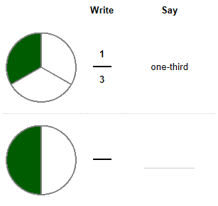
Draw lines to divide each of the following bars into the fraction shown:

1
8

1
4

1
3

How do you know the bar above shows the unit fraction one-third?
________________________________________________________________________________________________________________________________________________________________________________________________________________________________________________________________________________________________________________________
SCUSD Common Core Mathematics Lesson Planning Guide
Unit Title: Getting into Fractions  Lesson 2: Sharing Equally | Approx. time:  1 day 75 min | CCSS-M Standards:  4.NF.1
A. Focus and Coherence  Students will know…  - The size or the amount of the whole matters when expressing relationships with fractions.  - The more fractional parts used to make a whole, the smaller the parts  - Fractional parts can be equivalent without necessarily being congruent  Students will be able to…  - Identify, build, read, write, and label fractions  Student prior knowledge:  - Recognize and generate simple equivalent fractions  - Explain why the fractions are equivalent by using a visual fraction model  - Know multiplication facts  - Fraction represents part of a whole  - Fractional parts are equal shares or equal-sized portions of a whole or unit  Which math concepts will this lesson lead to?  - Ordering fractions  - Comparing fractions  - Comparing fractions with common denominators/numerators  - Making equivalent fractions |  | B. Evidence of Math Practices  What will students produce when they are making sense, persevering, attending to precision and/or modeling, in relation to the focus of the lesson?  1.Make sense of problems and persevere in solving them.  - “When the sandwich is cut into more pieces, the pieces get smaller.”  - “Two pieces of this sandwich equal ___.”  - “This is 1/? of the sandwich.”  - “It’s only fair if everyone gets the same amount of sandwich.”  4. Model with mathematics.  - Students will be solving real world problems  6. Attend to precision.  - Students will use academic language  denominator, numerator  fraction  Equivalence, fair, share  greater than, less than, and equal to
Essential Question (s)
- How can I use different size pieces to create equivalent fractions?
- How are fractions related to whole numbers?
- How do we compare fractions?
- How are fractions used in real life?
Formative Assessments
- Illustrative Mathematics 4.NF Comparing Two Different Pizzas
- Explain how fractions are related to whole numbers.
Anticipated Student Preconceptions/Misconceptions
- Students assume bigger denominator means bigger pieces
- The more people sharing the sandwich the bigger the pieces
- Students may struggle with dividing visuals into equal parts
Materials/Resources: poster paper, markers, tortillas or circular paper

- Mathematics International- Unit 12 page B39, B44
- https://www.georgiastandards.org/Common-Core/Common%20Core%20Frameworks/CCGPS_Math_4_Unit2FrameworkSE.pdf

C. Rigor: fluency, deep understanding, application and dual intensity
What are the learning experiences that provide for rigor? What are the learning experiences that provide for evidence of the Math Practices? (Detailed Lesson Plan)
Warm Up
Materials: tortillas (or circular paper)
Vocabulary: equal pieces called fractions
- Teacher will show tortilla to the class. Teacher asks: “How can I share this equally among two students?”
- Teacher will cut it into two unequal pieces and discuss why the class doesn’t think this is fair. (not equal)
- Teacher will cut another tortilla into two equal pieces and discuss why the class thinks this is fair.
- Teacher will ask, “What fraction will each student get?” (1/2 of the whole)
- Teacher will hold up two tortillas and ask, “How can I share these equally among 3 people?”
  - Give students independent think time (1-2 minutes), partner share time (2-4 minutes)
before whole class discussion

Lesson
Students will be given 2-3 minutes of solo time to work through the problem without support.
Then, students will be paired up to complete their work and discuss what they have done so far.

Task directions:
Students will follow the directions below from the “Their Fair Share” student sheet.

A fourth- grade class traveled on a field trip in three separate vehicles. The school provided a lunch of submarine sandwiches for each group. When they stopped for lunch, the subs were cut and shared as follows:

• The first group had 3 people and shared 2 subs equally.
• The third group had 9 people and shared 6 subs equally.
• The last group had 6 people and shared 4 subs equally.

When they returned from the field trip, the children began to argue that the portion of the sandwiches they received was not fair, that some children got more to eat than others. Did everyone get the same amount? Explain why or why not each student received an equal share.
Create a poster of the ideas and strategies you used to solve this problem. Be sure your poster is labeled using academic language and clear presentations of the important ideas and strategies you want to present.

Closure
2-3 pairs will share whole class how they solved the problem and show their work.
The class will be given the chance to agree or disagree with each group.

Suggested Homework/Independent Practice
- Students will respond in writing: If you are in a group of three people would you rather share four sandwiches or five sandwiches? Explain why and draw an illustration to justify your answer.

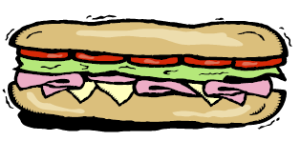

Adapted from: Georgia Department of Education

Name _________________________________________ Date___________________________
Their Fair Share

Directions
A fourth-grade class traveled on a field trip in three separate vehicles. The school provided a lunch of submarine sandwiches for each group. When they stopped for lunch, the subs were cut and shared as follows:

• The first group had 3 people and shared 2 subs equally.
• The third group had 9 people and shared 6 subs equally.
• The last group had 6 people and shared 4 subs equally.

When they returned from the field trip, the children began to argue that the portion of the sandwiches they received was not fair, that some children got more to eat than others. Were they right? Or did everyone get the same amount?

Use the space below to illustrate the ideas and strategies you used to solve this problem. Be sure your work is labeled correctly and is clear.

Name________________________________ Date______________
Homework

If you are in a group of three people would you rather share four sandwiches or five sandwiches? Explain why and draw an illustration to justify your answer.

______________________________________________________________________________________________________________________________________________________________________________________________________________________________________________________________________________________________________________________________________________________________________________________________________

SCUSD Common Core Mathematics Lesson Planning Guide
Unit Title: Getting into Fractions  Lesson 3: Benchmark Fractions | Approx. time:  1 day | CCSS-M Standards: 4.NF 1 4.NF.2
A. Focus and Coherence  Students will know…  - The size of the whole matters and be able to compare known fractions to benchmark fractions (0, ½, 1)  Students will be able to…  - Identify, build, read, write, label, and compare fractions  Student prior knowledge:  - Definition of a fraction  - Number line.  - Definition of >, =, <  - Concept of equivalency and congruency  - Parts of a fractions (denominator and numerator)  Which math concepts will this lesson lead to?  - Compare two fractions with different numerators and/or denominators  - Order fractions using a number line and other graphic representations |  | B. Evidence of Math Practices  What will students produce when they are making sense, persevering, attending to precision and/or modeling, in relation to the focus of the lesson?  Students will make sense of problems and persevere in solving them  - Ss, “The number line shows that 0 is on the left side, 1 is on the right side and ½ is the middle of 0 and 1.”  - Ss,”11/12 is only 1/12 away from 1, but it is 5/12 away from 1/2.”  - Ss, “3 is more than half of 5, so 3/5 goes to the right of 1/2 on the number line.”  Students will attend to precision  - Students will use academic language such as:  one-whole, zero, half, greater than, less than, equal to, denominator, numerator, etc.…  - Number lines are accurate
Essential Question (s)
- How are fractions related to whole numbers?
- How can I use different size pieces to create equivalent fractions?
- How can equivalent fractions be identified?
- Why are fractions important?
- How do we compare fractions?
- How can benchmark fractions be useful in real life?

Formative Assessments
- Thumbs up / thumbs down for agreement throughout lesson
- Ticket out the door: How do you know 6/7 is closer to one, than it is closer to 1/2 or 0?

Anticipated Student Preconceptions/Misconceptions
- The bigger the denominator the bigger the piece.
- It doesn’t matter where you shade the unit fraction on a number line when showing more than one part.

Materials/Resources
- Worksheet of number lines
- 12 premade fraction cards
C. Rigor: fluency, deep understanding, application and dual intensity
What are the learning experiences that provide for rigor? What are the learning experiences that provide for evidence of the Math Practices? (Detailed Lesson Plan)

Warm Up (Teacher Model)
- Using a number line, label the 0 on the left side, and the 1 on the right side, divide into 2 parts, and shade 1 part.

- Draw another number line the same length; again divide into 2 parts, and shade 1 part.

- Ask if the shaded parts are equivalent.
- Divide each part of the second number line into 2 equal pieces.

- Ask students to think about how they would label the pieces and if the shaded parts are still equivalent.

Lesson
Hand out worksheet of number lines
- Independently: Students will repeat warm up step on the first two number lines on their handout (a and b), then label the new fractions (fourths)

- Whole Class: Ask students to share how they labeled the second number line and have them compare 1/4 to 0, 1/2, and 1.
  - Teacher, “When thinking about fractions it is good to have some benchmark fractions to use for comparison. Today we will think about the benchmark fractions 0, 1/2, and 1 whole.”
How does 1/4th compare to the benchmark fractions? ( 1/4 > 0, 1/4 < 1/2 and 1/4 < 1, 1/4 is
equidistance from 0 and 1/2 but farther from 1)
Which benchmark fractions are closer to 2/4, 3/4, 4/4?

- In pairs: Have individual students label 0, ½ and 1 on the remaining number lines (c, d, and e).
Students will then work in pairs to continue making 6 parts, 8 parts, and 10 parts and label the fractional parts.
After 2-3 minutes ask pairs to discuss which fractions are closer to 0, 1/2, and 1.
Ask students, “Why would knowing the location of 0, 1/2, and 1 on a number line help when comparing fractions?”

- Whole Class: Share-out

- Teacher draws a large number line on the board labeling only 0, 1/2, and 1.
Students make their own number line like the one on the board on the back of their worksheet.
Teacher passes out fraction cards to a selection of students or to groups of students.
Students are called upon to tell what their fraction is.
Before student places fraction card on the front board’s number line, seated students label their number line where they think it should be placed without cutting the number line into more pieces.
Called on students then places the fraction card on the number line, class asked to agree or disagree with hand signals, then discuss how they knew where to place the fraction on the number line. (note: we are looking for students to refer to the benchmark fractions. for example: “I knew 8/9 was almost one whole, so I put it on the number line close to 1.”)
Continue with each of the other cards.
Closure
- Ticket out the door: What is 6/7 closer to 0, 1/2, or 1? How do you know?

Suggested Homework/Independent Practice
- Homework sheet

a)number line
b)number line
c)number line
d)number line
e)number line

2  3 | 7  9 | 1  10 | 2  99
3  5 | 3  7 | 11  12 | 2  18
9  20 | 89  90 | 4  9 | 6  13
Flash Cards for Whole Class Activity

Ticket out the door Name____________________________ Date_______________
Ticket out the door: What is 6/7 closer to 0, 1/2, or 1? How do you know?

Ticket out the door Name____________________________ Date_______________
Ticket out the door: What is 6/7 closer to 0, 1/2, or 1? How do you know?

Ticket out the door Name____________________________ Date_______________
Ticket out the door: What is 6/7 closer to 0, 1/2, or 1? How do you know?

Homework
Name____________________________ Date_______________
1. What is closer to 0, , or 1? How do you know?

2. Name three fractions that are closer to 1 whole than they are to .

3. Amie says that of a Snickers candy bar is larger than of a Snickers candy bar, but Rachel doesn’t agree. Who do you agree with and why?
Use the space below to draw pictures, use numbers, and write words to justify your thinking.

SCUSD Common Core Mathematics Lesson Planning Guide
Unit Title: Getting into Fractions  Lesson 4: Ordering Unit Fractions | Approx. time:  1 day | CCSS-M Standards: 4.NF.1 4.NF.2
A. Focus and Coherence  Students will know…  - The size of the whole matters when expressing relationships with fractions  Students will be able to…  - Identify, build, read, write, label, compare fractions  Student prior knowledge:  - Fractional parts are used to make up a whole  - How many pieces it takes to make a whole and each piece is a unit fraction  - Know what a numerator and denominator are and what they signify  Which math concepts will this lesson lead to?  - Comparing and ordering fractions with common denominators |  | B. Evidence of Math Practices  What will students produce when they are making sense, persevering, attending to precision and/or modeling, in relation to the focus of the lesson?  Students will make sense of problems and persevere in solving them:  - “The smaller the denominator the larger the fractional piece.”  - “The larger the denominator the smaller the fractional piece.”  - “The denominator tells me the number of equal size pieces.” (i.e. ½ means the whole is cut into 2 equal size pieces.)  - “It will take more tenths to measure my desk than it will take sixths, because the tens are smaller than the sixths.”  - “Ken’s measuring tool was longer than Sam’s measuring tool because 1/3 is greater than 1/4.”  - “If I put my 1/3 and 1/4 side by side, it will take more fourths to equal one whole length.”  Students will attend to precision:  - denominator  - numerator  - one-half, one-fourth, one-seventh…  - fraction is a part of a whole piece/set
Essential Question(s):
- How do I compare fractions?
- How are fractions used in real life?

Formative Assessments:
- Have students put the following fractions in order from least to greatest: 1/10, 1/2/, 1/5, 1/25
and add two more unit fractions to this list of their choosing.
Then have students explain how they knew which fraction was the least, and which was the greatest.

Anticipated Student Preconceptions/Misconceptions:
- As the denominator increases, students do not understand that the fraction pieces decrease in size.
- Just because the numerator is larger does not mean that the fraction is in fact larger.

Materials/Resources:
- Mathematics International Grade 4 B44-B45

C. Rigor: fluency, deep understanding, application and dual intensity
What are the learning experiences that provide for rigor? What are the learning experiences that provide for evidence of the Math Practices? (Detailed Lesson Plan)
Warm Up
Teacher should pose the following question to the class. Students should be given independent think time prior to whole class share-out. (This problem can be done on white boards or paper)

Paul and his brother were eating the same kind (and size) of candy bar. Paul had cut his candy bar into 4 pieces. His brother cut his candy bar into two pieces. If each boy only ate one of their pieces, who ate the most candy bar?

Lesson

Hands-on experience:
Give students strips of paper and have them cut or fold each into half, fourths and sixths.
Use these strips to measure objects in the classroom.

In small groups have students discuss what they discovered through the measuring activity.
Allow students 3-6 minutes to work with a partner to explain their understanding and come to an agreement.
Have 2-3 students share out giving class the chance to agree or disagree.

Ask Class:
Would it take more sixths or tenths to measure the length of your desk/table?
Repeat with other unit fractions as needed.

Give students independent think time of 2-3 minutes.
Allow students 3-6 minutes to work with a partner to explain their understanding and come to an agreement.
Have 2-3 students share out giving class the chance to agree or disagree.

Have students put the unit fractions used into order from least to greatest.

Closure:
Using page B45 (Mathematics International), have the students explain in words why ½ is larger than 1/3, why 1/7 is less than 1/5.

Suggested Homework/Independent Practice:
Have students order the following unit fractions from least to greatest and justify their answer with a visual representation:
1/17, 1/10, 1/6, 1/12, 1/20, 1/1, 1/2, 1/88…

Homework
Name________________________________ Date _____________________
Order the following unit fractions from least to greatest and justify their answer with visual representations.
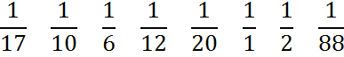

SCUSD Common Core Mathematics Lesson Planning Guide
Unit Title: Getting into Fractions  Lesson 5: Comparing Fractions with Common Denominators | Approx. time:  1 Day | CCSS-M Standards: 4NF1 4NF2
A. Focus and Coherence  Students will know…  - when comparing fractions the whole must be the same, fractions can be represented as part of a whole, parts of a set, parts of an area, as a measure, and as a number on the number line  - fractions with like denominators can be compared.  Students will be able to…  - identify, build, read, write, label, compare, and represent (as part of a whole, parts of a set, parts of an area, as a measure, and as a number on the number line) fractions.  - use visual fraction models to justify conclusions.  Student prior knowledge:  - Fraction vocabulary (numerator, denominator)  - Fractions are parts of wholes  - Comparing words and symbols (>, <, =)  Which math concepts will this lesson lead to?  - Comparing fractions with unlike denominators  - Finding equivalent fractions |  | B. Evidence of Math Practices  What will students produce when they are making sense, persevering, attending to precision and/or modeling, in relation to the focus of the lesson?  Students will make sense of problems and persevere in solving them:  - “I know that 3/8 is less than 5/8 because it takes more 1/8 to make 5/8 than it does to make 3/8.”  - “Since the denominators are the same, I just look at the numerator and that tells me which are greater and which are less.”  - “The numerator tells me how much of the whole is represented.”  Students will attend to precision  - Students will use academic language such as:  denominator, numerator, fraction, greater than, less than,…
Essential Question(s)
How do we compare fractions?
What is a common denominator?
When comparing fractions, why is a common denominator important?
How can we use models to demonstrate common denominators?
Why do we need to compare fractions?
When do we need to compare fractions in real life situations?

Formative Assessments
- Look for students who are not putting fractions into the correct order.
- Ask students to explain how they knew what order to put the given fractions into.
- Use white boards for quick checks of students understanding.

Anticipated Student Preconceptions/Misconceptions
- Numerator represents the whole
- Same numerator indicates equality
- Same denominator indicates equality
- A greater number value indicates a greater fraction

Materials/Resources
Fraction manipulatives (optional)

C. Rigor: fluency, deep understanding, application and dual intensity
What are the learning experiences that provide for rigor? What are the learning experiences that provide for evidence of the Math Practices? (Detailed Lesson Plan)
Warm Up
On white boards or paper have students independently represent 3/5 in as many ways as they can in 2-minutes.
Then as a whole class share out, create a poster that shows all the different ways they can represent 3/5 (number line, bar model, pie, group of items, area model…)?
and/or
Have students: “Tell me everything you know about 3/5.”

Lesson
Teacher uses guided inquiry :
Teacher draws two parallel number lines each cut into eight equivalent pieces on whiteboard with 0 and 1 labeled.
Elicits student response to label the fractions on number line.
Use the parallel number lines to demonstrate how 3/8 is 1/8+ 1/8+ 1/8, while the second number line shows how
5/8 is 1/8 + 1/8 +1/8 + 1/8 +1/8
Teacher asks, “What do you notice about 3/8 and 5/8?” (Students should notice that 3/8<5/8 and 5/8>3/8)

Protocol for each lesson activity:
- Independent work time for 2-4 minutes
- Partner share for 3-5 minutes
- Whole class share out: Choose 2-4 students to explain the thinking

Activity 1:
Have students demonstrate using similar methods to show 3/4 is greater than 2/4, then repeat with 6/7 and 3/7, etc. as needed to reach student comprehension (number line page available if needed)

Expand lesson by having students go beyond using number lines (bars, pies, etc.) to continue demonstration of the concept of comparing fractions with like denominators

Activity 2:
Have students compare 27/128 and 84/128 (without the use of manipulatives or drawing), asking them which of these fractions is larger and how do you know?

Closure
Activity 3:
Have students put the following fractions in order from least to greatest: 3/25, 12/25, 21/25, 6/25
and respond in writing (with visuals and words) to the following prompt: “How do you know which fraction is greater, and which is least?”

Suggested Homework/Independent Practice
Continued practice using same technique on premade up worksheet.

number line
number line
number line
number line
number line
number line
number line
number line

Name_____________________ Date__________
Put the following fractions in order from least to greatest: 3/25, 12/25, 21/25, 6/25
Using pictures and words show how you know which fraction is greater, and which is least?

Name_____________________ Date__________
Put the following fractions in order from least to greatest: 3/25, 12/25, 21/25, 6/25
Using pictures and words show how you know which fraction is greater, and which is least?

Name _______________________________ Date_________________
Homework

Put the following fractions in order from least to greatest and illustrate how you knew which order to put the fractions into.

- 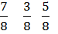

- 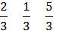

- 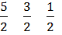

Compare the following fractions using the greater than, less than, and equal symbol ( >, <, = )

- 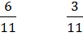
What does the denominator of the fraction tell you?
__________________________________________________________________________________________________________________________________________________________________________________________________________________________________________________________________________________________________________________

- 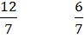

- 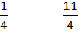

- 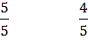
SCUSD Common Core Mathematics Lesson Planning Guide
Unit Title: Getting into Fractions  Lesson 6: Comparing Fractions with Common Numerators | Approx.time  1 day | CCSS-M Standards:  4.NF.1 4.NF.2
A. Focus and Coherence  Students will know  - When comparing fractions the whole must be the same  - Fractions can be represented as part of a whole, parts of a set, parts of an area, as a measure, and as a number on the number line  - Fractions with like numerators can be compared  Students will be able to  - Identify, build, read, write, label (using <, >, =), compare, and represent (as part of a whole, parts of a set, parts of an area, as a measure, and as a number on the number line) fractions  - Use visual fraction models to justify conclusions  Student prior knowledge:  - What is a fraction  - Addition facts  Which math concepts will this lesson lead to?  - Reinforce the values within a whole  - Ordering fractions with unlike denominators and unlike numerators  - Creating Equivalent Fractions |  | B. Evidence of Math Practices  What will students produce when they are making sense, persevering, attending to precision and/or modeling, in relation to the focus of the lesson?  Students will make sense of problems and persevere in solving them  - “The number of pieces the whole is cut into is the denominator.”  - “The number of pieces being used/shaded is the top numerator.”  - “We can compare fractions with like numerators because the denominator tells us how big each of those pieces are.”  - “2/3 more than 1/2, but 2/5 is less than 1/2, so I know 2/3 is greater than 2/5.”  - “2/3 is greater than 2/5 because while both have 2 shaded pieces, the thirds are larger than the fifths.”  Students will attend to precision  - Students will use academic language such as:  denominator, numerator, fraction, greater than, less than, represent  - The individual pieces in a whole will be segmented equally.
Essential Question (s)
When would you compare fractions in the real world? Why?
How do we compare fractions?
When comparing fractions, why does a common numerator help?

Formative Assessments
- Give students two fractions to compare, and look for students who are not able to place the fractions in the correct order.
- Place fraction in both correct and incorrect order on the board and have students agree and disagree with thumbs up or down, followed by student explanations to their responses.

Anticipated Student Preconceptions/Misconceptions
Students would automatically go to the denominator and look at the value of the digit without understanding the concept of fractions to a whole.
Students may think fractions cannot be compared if they do not have common denominators.

Materials/Resources
Number line strips or white paper to draw number lines on
C. Rigor: fluency, deep understanding, application and dual intensity
What are the learning experiences that provide for rigor? What are the learning experiences that provide for evidence of the Math Practices? (Detailed Lesson Plan)
Warm Up
2/5, 2/8 and 2/3 order these fractions from least to greatest. They will do this individually (Students may not do this correctly, but this leads to class discussion).
Teacher chooses 2-3 students to share out their thinking process (Strategically choose students who came up with different results, but do not tell students the correct answer at this time.)

Lesson
Teacher, “Now we will use number lines to clarify our understanding.”

- Students create three number lines (use attached form) labeling each end with 0 and 1.
- Students divide the number lines to represent equal parts within each number line to represent halves, eighths, and thirds accurately. (Teachers may need to guide division of lines to ensure accuracy.)
- Students are to identify each fraction piece by coloring a line of distance from 0 to 2/5, 2/8 and 2/3.
- Students are asked now to pair share and compare the distances from each fraction, example “Which distance is greater 2/3 or 2/5?” Write comparisons on paper 2/3<2/5.
- As a whole class develop some statements reinforcing the concept. Example “The numerator determines the number of pieces out of the whole, whereas the denominator tells us the size of each fractional part.”
- Students will now compare additional fractions with same numerators: 3/8, 3/6 and 3/4; 5/12, 5/7, and 5/5…

Closure
If fractions have the same numerator, but different denominators how can we tell which is least and greatest? Explain your thinking in writing and use an illustration to justify your answer.

Suggested Homework/Independent Practice
Compare fractions with common numerators, common denominators, and to benchmark fractions.

Name _______________________________ Date_______________________
Homework

Compare each of the following fractions. Explain your thinking in writing and use an illustration to justify your answer.
- 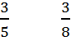
- 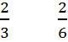

- Which of these fractions is closer to 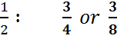

Name _______________________________ Date_______________________

number line
number line
number line
number line
number line
number line
number line
number line
SCUSD Common Core Mathematics Lesson Planning Guide
Unit Title: Getting into Fractions  Lesson 7: Visual Representation of Equivalent Fractions | Approx. time:  2 Days | CCSS-M Standards:  4.NF.1 4.NF.2
A. Focus and Coherence  Students will know…  - The more fractional parts used to make a whole, the smaller the parts  - Equivalent fractions are ways of describing the same amount by using different-sized fractional parts  - Equivalence is preserved when equal-sized pieces are combined or broken into smaller equal-sized pieces.  Students will be able to…  - Identify, compare, build, manipulate, generate equivalent fractions  - Use visual fraction models to justify conclusions  - Generate area models  Student prior knowledge:  - A fraction is a part of a whole  - How many (fractional) pieces it takes to make a whole. e.g. Eight 1/8’s =1 whole  - Number line  Which math concepts will this lesson lead to?  - Solving to find equivalent fractions  - Comparing fractions and mixed numbers |  | B. Evidence of Math Practices  What will students produce when they are making sense, persevering, attending to precision and/or modeling, in relation to the focus of the lesson?  Students will make sense of problems and persevere in solving them:  - “Equivalent fractions don’t have to have the same numerator or denominator.”  - “I can use diagrams to justify my answer.”  - “The fractions that are equal to 1/2 all have numbers that are multiples of 2 in the denominator.”  Students will attend to precision:  - Students will label their diagrams.  - Students will use academic language such as:  denominator, numerator, half, equivalents, fraction, multiples…
Essential Question (s)
How can equivalent fractions be identified?
What are ways to generate equivalent fractions?
How can I use different size pieces to create equivalent fractions?

Formative Assessments
- Bobby is studying equivalent fractions in class. He has learned that 5/10 can be written as 1/2. He also says that fifths can be written as 1/2. Do you agree with Bobby? Explain your thinking using an illustration to justify your answer.
- Equivalent Fractions worksheets

Anticipated Student Preconceptions/Misconceptions
Fractions cannot be compared if the numerators and denominators are all different. e.g. 3/10 cannot be compared to 2/8

Materials/Resources
Enlarged fraction strip from curriculum resources sized to fit 8 ½ x 11 page of six number lines.
Two blank sheets of paper for day 2.
Equivalent Fractions worksheet

C. Rigor: fluency, deep understanding, application and dual intensity
What are the learning experiences that provide for rigor? What are the learning experiences that provide for evidence of the Math Practices? (Detailed Lesson Plan)
Warm Up
Day 1
- Provide nine colored construction paper strips per student (or have students color white strips).
- Strips should be divided into one whole, halves, thirds, fourths, fifths, sixths, eights, tenths, and twelfths.
- Show that each fraction strip is of equal length and equals 1 whole.
- Ask, “How many 1/2 will it take to equal 1 whole?” (Students will use their fraction strips and compare the 1/2 strip to the 1 whole strip.)
- “How many 1/3 will is take to equal 1 whole?” Repeat with other fraction strips.
Lesson
DAY 1
- Using fraction strips from warm up have students fold each strip so that only a unit fraction is showing on each.
- Tell students, “Using your fraction strip, find as many equivalence to 1/2 as you can. Independently record your findings and be prepared share out.”
  - After 2-3 minutes of independent work time, have students share with a partner.
  - As a whole class create a 1/2 equivalence chart.
- Ask students, “How many 1/5 (repeat with 1/3) equal 1/2?”
“Why can’t fifths and third fraction strips be used to show 1/2?”

- Challenge students to work in partners to create other equivalence charts using their fraction strips.
  - After 5-10 minutes of partner work time, have students create equivalence charts as a whole class. Charts should include: 1/3, 1/4, 1/5…
  - Encourage students to find patterns in the equivalence charts.
  - Ask, “Are there any fractions that you know can be added to one of these charts, even though we do not have strips for those fractions?” (Students should see that all the fractions on the 1/3 chart have denominators that are multiples of three; therefore, 15th,18th, etc. can be added to the chart.)
Closure
Day 1
Bobby is studying equivalent fractions in class. He has learned that 5/10 can be written as 1/2. He also says that fifths can be written as 1/2. Do you agree with Bobby? Explain your thinking using an illustration to justify your answer.
Warm up
Day 2
On a half sheet of paper, or individual white boards, have students show some fractions that are equivalent to 1/2. Have 3-4 students share out.
Lesson
DAY 2
- Each student to receive two 8 ½ x 11 pieces of paper folded into fourths horizontally.
- Label the first row as 1 whole.
- Students fold the paper in half, labeling ½ on the middle line in the second row. Shade in ½.
- Fold the paper in half and then in half again, open the paper and label ¼, 2/4, ¾ on the corresponding lines in the third row. Shade in ¼.
- Repeat for eighths in the final row.
- Using the second sheet, students will label the first row as 1 whole.
- Students will fold the paper into thirds, open, label, shade in 1/3 on the second row.
- Fold into thirds, then in half creating sixths, open and label the third row.
- Repeat to create twelfths, open and label the fourth row.
- Pose questions about the relationship between equivalent fractions.
- Have students make a list of equivalent fractions they can see using their fraction strips. (give 3-5 minutes of solo time and 3-5 minutes of partner time)
- Whole class: allow students to give equivalent fractions to add to a class chart. Including fractions equal to: 1/2, 1/3, 1/4, 1/6, 1/12, 1 whole
Closure
Day 2
Sue ate 3/4 of her candy bar, and Tom ate 6/8 of his candy bar (their candy bars are the same size and type). Tom said he ate more, but Sue says she ate more. Who do you agree with and why? Draw an illustration to justify your answer.

Suggested Homework/Independent Practice
Equivalent Fraction Worksheet

number line
number line
number line
number line
number line
number line
number line
number line

Name______________________________ Date____________________
Equivalent Fraction Worksheet

Write an equivalent fraction on the blank provided. Justify your answer using the tape diagrams below.

- =______

- = ______

- = ______

- = ______

- =______

- = ______

0
1
Equivalent Fraction Activity Sheet
Fill in the boxes with the missing fractions. Name _____________________ Date ____________

0
1

SCUSD Common Core Mathematics Lesson Planning Guide
Unit Title: Getting into Fractions  Lesson: Lesson 8 Making Equivalent Fractions | Approx. time:  2-3 days | CCSS-M Standards:  4.NF.1 4.NF.2
A. Focus and Coherence  Students will know…  - The more factional parts used to make a whole, the smaller the parts.  - Equivalent fractions are ways of describing the same amount by using different-sized fractional parts; equivalence is preserved when equal sized pieces are combined or broken into smaller equal-sized pieces. (e.g. 1/3 x2/2 =2/6 and 1/3 =2/6 because 2/2 = 1)  - A whole number is a multiple of each of its factors.  Students will be able to…  - identify, compare, build, manipulate, generate equivalent fractions, and use fraction models to justify conclusions  Student prior knowledge:  - know their multiplication facts  - know unit fractions with denominators of 2, 3, 4, 5, 6, 8, 10, 12  - definitions of a whole and fraction  - understand that fractions could be equal parts of a whole or of a set  - equivalent fractions of ”1”. (e.g. 2/2, 4/4, 3/3, 100/100 . . .)  - Know relative placement of fractions within “0”, “1/2”, and “1”.  - know the denominator is the total number of equal parts  - know the numerator is the parts counted  - read, write, and label fractions  - draw or use a visual of a fraction (picture)  Which math concepts will this lesson lead to?  - simplifying fractions  - adding and subtracting fractions with like and unlike denominators |  | B. Evidence of Math Practices  What will students produce when they are making sense, persevering, attending to precision and/or modeling, in relation to the focus of the lesson?  SMP 1: Students will make sense and persevere in solving problems:  - “When we move from a fraction with 2 in the denominator to a fraction with 4 in the denominator we are simply multiplying by 2s.”  - “We can find like denominators by finding common multiples.”  - “When we compare fractions, and find equivalent fractions we need to have the whole be congruent, or the same size.”  - “When we multiply the denominator, we are multiplying the numerator with the same number.”  - “I can multiply the fraction by the same number to find an equivalent fraction.”  SMP 6: Students will attend to precision:  - Students will use academic language such as:  - denominator, numerator, multiple, congruent, equivalent,…
Essential Question(s)
- How does knowing your multiplication facts help with fractions?
- How are fractions related to whole numbers?
- How can I use different size pieces to create equivalent fractions?
- How can equivalent fractions be identified?

Formative Assessments
- Students can demonstrate equivalence through a visual representation
- Small group/pair share discussions as teacher facilitates through the room (Ex: Asking students to explain how their visual shows the fractions/equivalence. Students’ responses and drawings)
- Whole-class fraction family chart
- Closure activity

Anticipated Student Preconceptions/Misconceptions
- If the denominators are not the same, the fractions can’t be equivalent
- The larger the denominator the smaller the piece
- If the numerator is the same then the fractions are the same size

Materials/Resources
- Teacher’s guide from McMillan text chapter 13

C. Rigor: fluency, deep understanding, application and dual intensity
What are the learning experiences that provide for rigor? What are the learning experiences that provide for evidence of the Math Practices? (Detailed Lesson Plan)
Warm Up
Students will draw 1/2, 3/6, and 4/8 as fraction models and write down what they notice. They will use either number lines or congruent shapes. Students will respond in writing to the following:
What do you notice and wonder? (Sentence frame: “I wonder ______________ because I see ____________.”)

Lesson
Give students 2-3 minutes of independent time to write as many fractions equivalent to 1/2 as they can come up with.

Pair-share (3-5 minutes): Students’ lists of equivalent fractions of 1/2 and how they know.

Whole Class Share-out: Students share-out as teacher charts, creating a whole class list of 1/2 family of equivalent fractions. (Teacher needs to strategically organize the share-out.)

Teacher asks:
- How do you know that these are equivalent to ½?
- Ask students if they can see a pattern in the numbers?

Solo/Independent think time: What patterns do you notice when looking at the class chart?

Pair-share: (2-3) What patterns do you notice when looking at the class chart?

Partner Work: (10 minutes) Based on the patterns that students found, write a rule that will help you find other fractions that are equivalent to 1/2. Then check your rule by using it to find the equivalent fractions on the class chart.

Whole Class Share-out:
- What rule did you write, and how do you know it works?
- Come to a consensus on a class rule that will work.

Partner Work: (10 minutes) Using the rule, find three fractions that are equivalent to 1/4 and draw a visual (number line or congruent shapes) to justify your answer.

Whole Class Share-out: Have 2-3 partners share what fractions they found equivalent to 1/4 and the visuals they used to justify their answers.

(If needed: Repeat activity with 1/3, 2/5… Using the same protocols as above.)

Now that students have a rule that works ask them to use their rule and to find equivalent fractions, and determine whether given fractions are equivalent.
Find an equivalent fraction for each: 2/7, 6/10, 2/12, 2/3

[Supporting standard information that can be used to help students understanding: Point out that because 4 is a composite number we can reduce the fraction with division. Ask students: What other numbers could be denominators that could possibly be reduced? (e.g. 8, 10, 14…) Knowing the numbers that makes up a composite number will help students when deciding what numbers to divide fractions by.]

Extension:
Then use 3/6 and ask them what they can divide by to get ½?
Repeat with 2-4 more examples to cement the new concept.

Closure
Determine if the following are equivalent: 6/8=3/4, 1/2=6/14, 9/18=1/3, 1/6=6/36, 12/20=1/2

Suggested Homework/Independent Practice
Fraction Matching Worksheet

Name ________________________________ Date___________________
Fraction Matching Worksheet

Find the corresponding equivalent fractions and list them in the boxes provided.
Challenge: In the second box write another equivalent fraction that is not listed.

Corresponding equivalent fractions: Challenge:
- =

- =

- =

- =

- =

- =

- How did you know which fractions were equivalent? Write your answer in complete sentences. You may use the space below your sentences to draw a visual to justify your answer.

____________________________________________________________________________________________________________________________________________________________________________________________________________________________________________________________________________________________________________________________________________________________________________________________________________________________________________________________________________________

Name _____________________ Date _____________
Adapted from Copyright © 2007 by Noyce Foundation
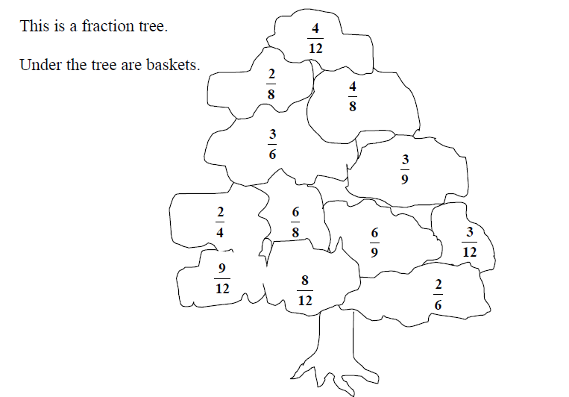
Picking Fractions

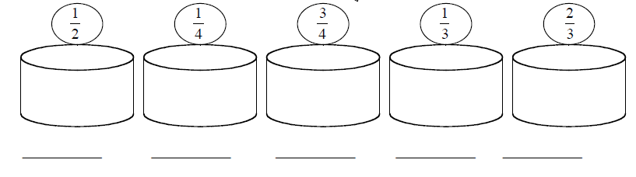

1. Equivalent fractions picked from the tree must be placed in the same basket. Put each fraction on the tree into the correct basket.
2. Find one new equivalent fraction for each basket and write it on the line that is below the basket.

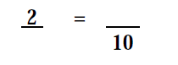
3. Fill in the missing numerator and denominator to make this pair of fractions equivalent.

Explain how you figured it out.
_________________________________________________________________________________________________________________________________________________________________________________________________________________________________
4. The farmer needs to organize the baskets from least to greatest. Put the basket fraction in order from least to greatest. Use the space below to show your work.

5. Fill in the boxes below with fractions that make the statement true.
4
5
>
>
___
___
___

Explain how you know that your answer is correct.
________________________________________________________________________________________________________________________________________________________________________________________________________________________________________________________________________________________________________________________
6. Find fractions that are equivalent to the fraction shown in each rectangle below. Slice the rectangles by drawing line segments in each rectangle to create a different but equivalent fraction.

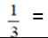
=

Assessment Key ‘
100 points possible
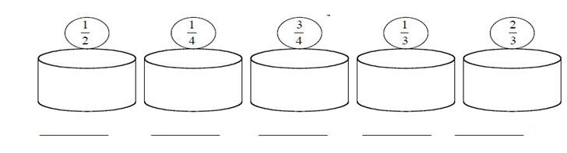
4/8, 3/6, 2/4
2/8, 3/12
6/8, 9/12
4/12, 3/9, 2/6
6/9, 8/12
Possible answers: 5/10, 6/12, 50/100 4/16, 5/20, 25/100 12/16, 15/20 5/15, 6/18, 7/21 4/6, 10/15, 12/18
2 point each
(total 34 problem 1)

1. Equivalent fractions picked from the tree must be placed in the same basket. Put each fraction on the tree into the correct basket.
2 point each
(total 10 problem 2)

2. Find one new equivalent fraction for each basket and write it on the line that is below the basket.
2 point each
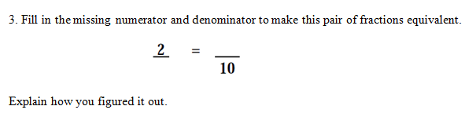
Possible answers: 2/1 = 20/10; 2/2=10/10; 2/5=4/10; 2/10=2/10; 2/20=1/10 …
Possible answers:
- 2/1=20/10 because both fractions are equal to two wholes. If the whole is cut into 1 piece it takes two of those pieces to equal two wholes. If the whole is cut into 10 pieces it takes 20 of those pieces to equal two wholes.
- 2/2=10/10 because both fractions are equal to one whole. No matter how many equal pieces you cut a whole into, if you take all the pieces you still have one whole.
- 2/5=4/10 because if you have a whole cut into 5 equal pieces, then you equally divide each of those pieces once more, you will then have 10 equal pieces. The same is true for the two shaded pieces (numerator) of the 2/5 fraction, the 2 pieces become 4 pieces.
- 2/10=2/10 because the wholes are equally cut into 10 pieces and 2 of those pieces are shaded.
10 points explanation
(total 14 problem 3)

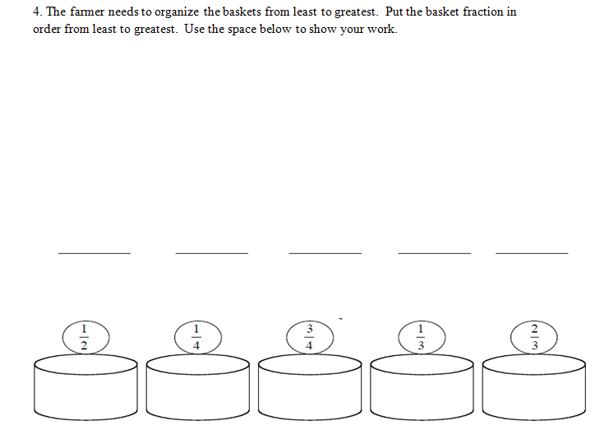
1/4 1/3 1/2 2/3 3/4
1/4<1/3<1/2
3/4
2/3
1/2
Possible work:
2 points each
(total 16 problem 4)
6 points work shown

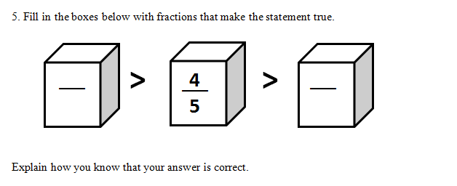
Possible answer:
Possible answers:
- 2/5 is less than 4/5 and 6/5 is greater than 4/5 because the wholes are all cut into the same amount of equal pieces and the number of pieces represented by the numerator is the only thing changing. So the higher the numerator, the larger the fraction.
- If your denominators are equal then the numerator tells you how many pieces you have; so the higher the numerator, the larger the fraction.
2 points each
10 points explanation
(total 14 problem 5)
6
5
2
5

4 points each
(total 12 problem 6)

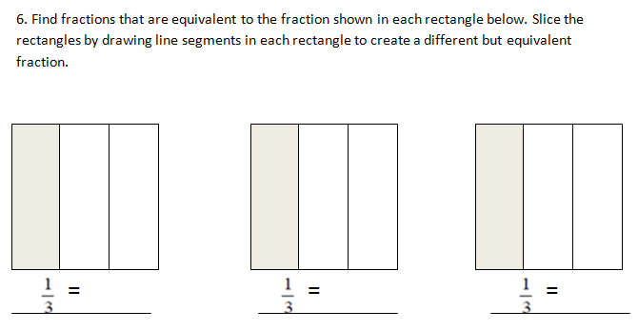
2/6
4/12
8/24
Possible answers:
3/9
6/18
5/15

