2021 School Climate Survey Administration Instructions
WHY?
Data from this survey helps to inform our support for school sites toward improving culture and climate, especially in the areas of connectedness, safety, and social emotional learning. This past year, in particular, has been challenging and the data from this survey will provide additional insight into student experiences and how we can best support all students as we plan for a return to learn.
California Ed Code section 52060(d)(6) requires every LEA in the state administer a school climate survey to the students, teachers, and families it serves and use the results to (1) inform decision making in the LCAP and (2) guide how LCFF funds are utilized. The student survey is designed for students in grades 3 through 12 and the teacher/staff survey is designed for all teachers and site staff. All surveys should take approximately 20-30 minutes to complete.

STUDENT SURVEY
The student survey will be taken on-line through a Google form. Students will need to log-in to Google prior to taking the survey. This will allow for detailed and various aggregation of student responses to inform the District’s LCAP and other decision making processes. Student responses will only be analyzed and reported at the school-level.

Students need to complete the survey by March 26.
Student/Survey Link: https://forms.gle/v8cUbfyt7jC6euSv7

A copy of the student survey is posted on the School Climate Survey web page for review by anyone who expresses interest.

Teacher/Staff Survey
The survey will be taken on-line at: http://tinyurl.com/SCUSDsites. Teacher responses will be analyzed and reported at the school-level, only. Sites should administer the survey during their staff meeting on May XXX.
FACULTY/STAFF SURVEY
The faculty/staff survey will be taken on-line. Participants can take the survey on any device, and faculty/staff are requested to complete the survey by March 26. Faculty/Staff Survey Link: https://forms.gle/joyB8i1LoQXVLo9q6

FAMILY SURVEY
We are encouraging families to take the survey online, but sites should make paper versions of the survey available to families that ask. Completed hard copy surveys should be forwarded to State and Federal Programs, Serna Center.

Each site is asked to email survey links to families and to post the family survey links on their school site web page and any other forms of social media such as site Facebook or Twitter pages.

Recommended text/links for Sharing the Survey on School Web Sites and Social Media
Please take the SCUSD Family survey to help out school in meeting the needs of our families and students. The survey should take no more than 20 minutes to complete. Links to the family survey, in 6 different languages, can be found at:
English https://forms.gle/arwV3EMxbkZZZojA8
Chinese https://forms.gle/HQQKetmqgaCEPGXK8
Hmong https://forms.gle/8BfTLpX4BKHxon668
Russian https://forms.gle/BP8mQR3pNnYoBJNv8
Spanish https://forms.gle/LZEE7TvS9CZnYB7WA
Vietnamese https://forms.gle/ypnFu35x1UkfWTan6
The surveys can also be accessed by scanning one of the QR code below:

English Chinese Hmong Russian Spanish Vietnamese

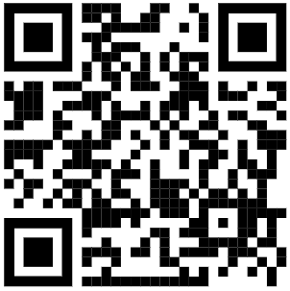
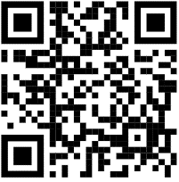
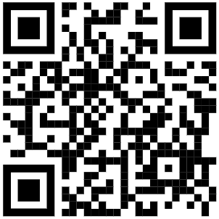
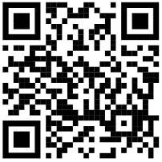
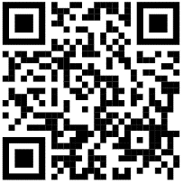
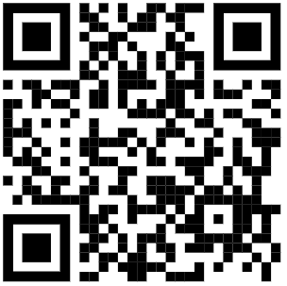

ACCESSING THE STUDENT SURVEY

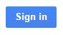
- Students login to Google with their district Login information at www.google.com and click on the sign in button on the right
- Open the survey link https://forms.gle/v8cUbfyt7jC6euSv7
- Students take the survey.

ACCESSING THE FACULTY/STAFF SURVEY
- Enter this link https://forms.gle/joyB8i1LoQXVLo9q6 into any web browser on any electronic device.
- Take the survey.

SURVEY | WHY | Approximate time to take survey | LINKS TO SURVEYS
Faculty/Staff | LCAP and LCFF | 15-20 minutes | https://forms.gle/joyB8i1LoQXVLo9q6
 | SEL Initiative
Parent/Family | LCAP and LCFF | 10-20 minutes | English https://forms.gle/arwV3EMxbkZZZojA8  Chinese https://forms.gle/HQQKetmqgaCEPGXK8  Hmong https://forms.gle/8BfTLpX4BKHxon668  Russian https://forms.gle/BP8mQR3pNnYoBJNv8  Spanish https://forms.gle/LZEE7TvS9CZnYB7WA  Vietnamese https://forms.gle/ypnFu35x1UkfWTan6
Student | LCAP and LCFF | 20-30 minutes | Students log-in to google FIRST: https://forms.gle/v8cUbfyt7jC6euSv7
 | SEL Initiative

ACCESSING STUDENT LOGIN INFORMATION
If Students Don’t Know Their Login Information,
the generic format is:

LOGIN firstname-lastname@student.scusd.edu
PASSWORD student’s date of birth in mm/dd/yyyy format (including slashes)

Students can reset their login information by going to the link below:
http://myaccount.scusd.edu

Teachers can see individual student’s Google usernames in the Student Information tab: General, then Student Account Info tab. This is under Campus Tools, not Instruction.

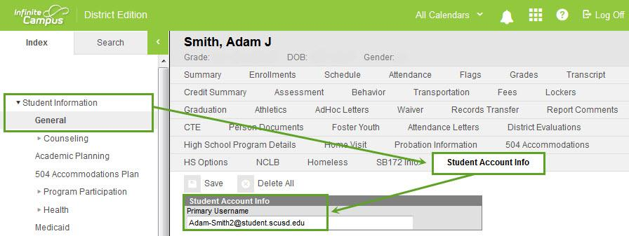

Teachers can access a list of students’ logins through an ad hoc report in Infinite Campus using these steps:

For elementary schools:  - Select Ad Hoc Reporting under the index tab  - Select Data Export  - Select Ad Hoc Reporting in the “Saved Filter” field  - Select student !Student Account Logins! (Elem)  - Under “Pick an Export Format” select Delimited Values (CSV)  - Select Export to download an excel file of students’ login information  - When the file is opened, each teacher can find his or her name under the ‘HR Teacher’ column | For middle and high schools:  - Select Ad Hoc Reporting under the index tab  - Select Data Export  - Select Ad Hoc Reporting in the “Saved Filter” field  - Select student !Student Account Log Ins! (Secondary)  - Select the Copy button  - Under “Pick an Export Format” select Delimited Values (CSV)  - Select Export to download an excel file of students’ login information  - When the file is open, student names can be searched for using the “Ctrl+F” function

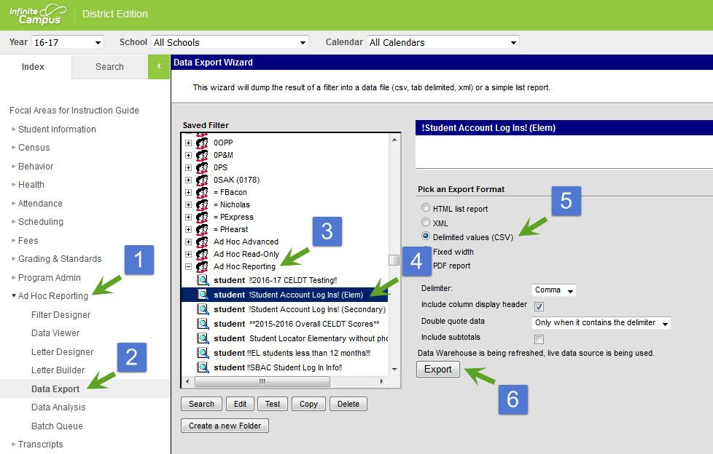

2021 School Climate Survey for Families

We want to hear from you!

Please take the School Climate Survey for Parents and Caregivers

The survey is open from
March 8 to March 26, 2021

You can find the survey by visiting the link below or scanning one of the QR codes

www.scusd.edu/family-survey

English Chinese Hmong Russian Spanish Vietnamese

