Site Coordinators – May 1, 2015

Performance Tasks
Performance Tasks must be completed within 10 days or students will lose access to completing. TAs need to have students pause their PT instead of submit if they have not completed the entire Performance Task to continue testing.
New Students
New students must be tested through June 10. Schools must meet the 95% participation rate for ELA and math on both the summative and performance tasks. Use the Completion Reports to verify participation. It may take up to 10 days for the students’ Performance Tasks to change to your schools assigned PTs. The Completion Reports are down May 1 for maintenance.
Completion Reports
Completion status can take 24 hours to show on the reports. New student’s completion of tests can be verified in your completion reports once you have access to them in TOMS. Please see the attached Completion Status User Guide.
CAA Students
Please verify that students have been marked in TOMS for CAA testing before the students are administered the test. 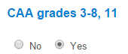
Students and TAs should use the practice test before administering the actual field test. Schools have been assigned specific Directions for Administration versions. If you have completed the training, you should have received your version DFAs. We have also found that if a student is paused out of the test, it may not be available for them to continue until the next day. What appears on the test button is that the test is “unavailable” for that assessment.
Students Not In TOMS
If a student is not showing in TOMS, please verify in Infinite Campus that the student has an SSID number. If they do not, ensure that the following information is completed. It takes 48 hours for a student to appear in TOMS.
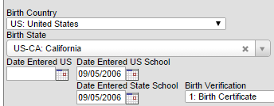
Additional Science Materials
Please place your orders for additional materials by May 6 in order to receive before the Science testing window closes May 15, for Non Public schools and New Tech and May 21 for all others. The additional materials form is attached.

