Site Coordinators - March 20, 2015
Peter Burnett started their testing Tuesday. Some great things we observed:
- Students lined up in numerical order, 1-32 and were handed their strip with log-in information. They went to the same numbered station to take their test. The absent students were immediately put on a log page for make-ups. Students were called in number order to return their log-in when testing was completed.
- Large black 3 sided cardboard “offices” were created on tables seating 6 students to provide privacy while taking the test.
- The directions were read directly from the DFA as written.
- Kleenex on hand

By May 27th:
- Collect Security Agreements from anyone who will be administering the test, proctoring or have access to testing materials.
- Send any updates or changes to your detailed testing schedule to CAASPPSupport@scusd.edu
- STRESS TEST your network: http://cadiagnostic.airast.org/pages/default.aspx?c=California_PT&url=https://capt.tds.airast.org/student
- Accommodations and supports - Last day to have uploaded is May 27. You will need to manually enter after the 27th.
- Emails were sent to all case managers who had not turned their students’ supports (you were cc’d on)
- Check with principals if any students with 504s need to have supports added to TOMS. This may be done manually.
- Attached are the most frequently requested accommodations and supports. Too many are being requested and we want to ensure they are being appropriately requested. Please review with your principal and case managers.
- Ensure all teachers are able to access TOMS and the Teacher Interface.
- Students have multiple opportunities to use the Practice, Training or Interim tests. You cannot help students with items on the test. Using the Practice, Training or Interim tests can ensure they are familiar with items types and can use them independently.
- You have reviewed your student list in TOMS for any errors and had corrections made in Infinite Campus and informed us of the changes at: CAASPPSupport@scusd.edu

What’s New on Our Website: http://www.scusd.edu/caaspp-site-coordinators
- Student Videos – High school and middle/elementary CAASPP information videos are available http://www.scusd.edu/post/student-communication
- Absent Reports: Keep track of who needs make-ups, has an exemption or did not complete testing. http://www.scusd.edu/sites/main/files/file-attachments/absent_report.xlsx
- Classroom Activities: Advertising,” “Animals with Shells,” “Invasive Species,” “Inventions,” “Monuments,” and “Poetry” were updated on 03/16/15. The “School Fair” Classroom Activity has been updated since its initial posting. Please only use the version that is date-stamped for March 19, 2015.
- Shutting Down Auto Updates on the IMacs (step by step directions)
http://www.scusd.edu/sites/main/files/file-attachments/auto_updates.docx
- Completion Status User Guide – Keep track of who has completed testing
http://www.scusd.edu/post/caaspp-testing-administrator-resources
- Revised Frequently Asked Questions
http://www.scusd.edu/sites/main/files/file-attachments/faqs.docx
- CAASPP Science Additional Test Materials Form
- http://www.scusd.edu/post/caaspp-testing-administrator-resources

Paper Tests
You will receive your paper tests the week of April 6-10.
- Inventory materials received
- Securely store
- Ensure you have enough materials for CST, CMA and CAPA
- Complete additional materials form if needed and send to CAASPPSupport@scusd.edu

Interims – Selecting in the TA Interface
- Make sure the Interims are being selected and not the Smarter Summative Adaptive Tests or Performance tasks. For Interims select numbers 3, 4, or 5.
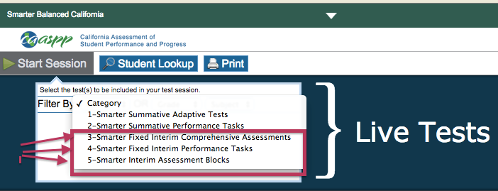
INTERIMS

