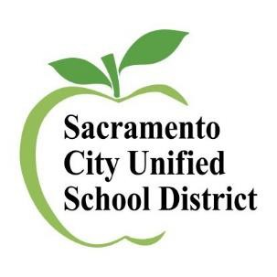
DELAC
Meetings

All meetings will be on ZOOM (virtually) and from 5:30 PM - 7:30 PM

https://scusd.zoom.us/j/89631317359
Zoom meeting ID: 896 3131 7359
Password: DELAC
Wednesday, October 19, 2022
Wednesday, November 16, 2022
Wednesday, January 18, 2023
Wednesday, February 15, 2023
Wednesday, March 15, 2023
Wednesday, May 17, 2023

Interpreters
Spanish – Glenda-Zapata-Neyra
Chinese – Amy Le
Hmong – Kao Lee
Russian – Lidiya Gorbenko
Vietnamese – Dung Hang Vu
Farsi – Ibrahim Safi

Interpreters will be available for the following languages: Chinese Hmong Vietnamese
Any questions, please contact Multilingual Literacy (916) 643-9446

