Fitnessgram “Reasons not tested”
- Go to Fitnessgram on the left side with the blue check mark
- Click on the test you have already created
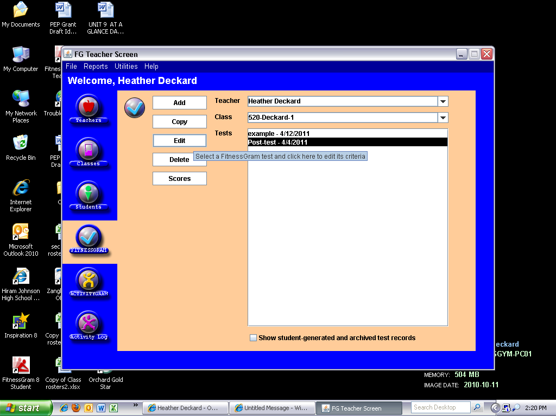
- Click edit
- Click Activity days on the bottom left corner
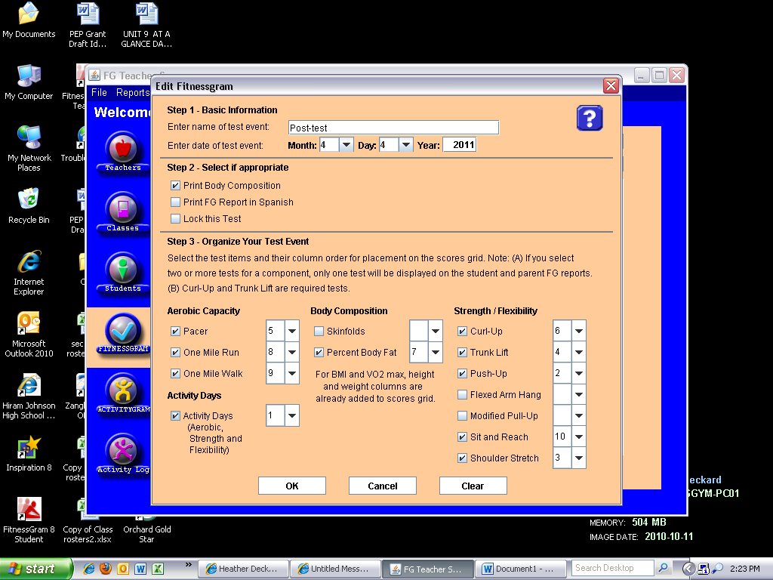
- Click ok, then click on the test name
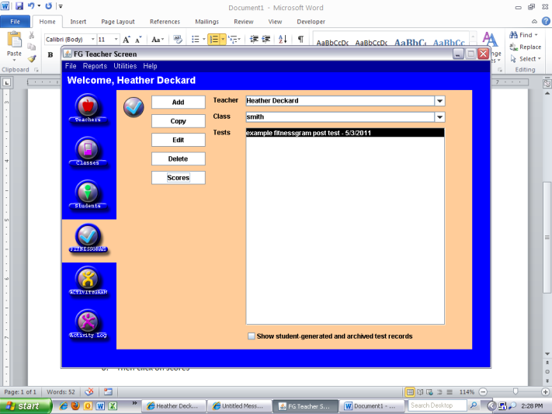
- Then click on scores

- Go Strength Days and enter in the following codes
  - Not Tested Students
0 – Absent on test dates and make up sessions
1 – IEP/section 504 plan/Disabilities
2 – Extraordinary Cuircumstances
3- Medical Excuses
  - Partially Tested Students
    - – Absent on test dates and make up sessions
    - – IEP/section 504 plan/Disabilities
    - – Extraordinary Cuircumstances
    - - Medical Excuses
- Once information is entered click ok
- Your done.

