Assessment, Research & Evaluation
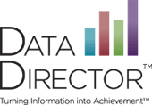

Data Director 101

3:30 – 4:30
September 25 or October 30

Serna Center – Training Room B

Sign Up At: www.SignUpGenius.com/go/4090F4BACAF22A46-data2

Learn the basics of what Data Director has to offer. Find out what is behind the tabs to support you in planning for student success. Participants will be able to use Data Director efficiently, find assessments, peruse multiple reports, find student demographic information and create simple reports.

*There are no professional development hours for these training sessions.

