Bowling Green Charter School:
Chacón Language and Science Academy
& Ken McCoy Academy for Excellence
Renewal Petition Respectfully Submitted to the
Sacramento City Unified School District
January 19, 2018

Contact:
Sylvia Silva-Torres
&
Sue Gibson

For the term July 1, 2018 through June 30, 2023

TABLE OF CONTENTS

Petition Requirement Checklist | 4
Letter of Petition Intent | 5
Petitioner Assurances and Disclosures | 6
Assurances - General | 7
Assurances - Health | 9
Introduction  Vision Statement  Mission Statement  History  Highlights and Accomplishments  Defining Characteristics  School Location | 11
Executive Summary  Overview and Key Points  Highlights and Accomplishments of Current Petition  Plans for the Future | 13
Charter Goals | 14
Element 1—Educational Program  Program Description for CLASA  Curriculum and Instruction for CLASA  Program Description for McCoy  Curriculum and Instruction for McCoy  Identifying the Responding to Needs  English Learner Program  Special Education Program  Instructional Days and Minutes  Technology and Digital Literacy  LCAP Executive Summary  LCAP State Priorities | 15
Element 2—Measurable Student Outcomes | 41
Element 3—Pupil Progress  Common Assessments Chosen and Rationale  Collecting, Analyzing, and Using Data | 46
Element 4—Governance Structure  District Governance of Dependant Charters  Governance Training  Site-based Governance  Parent Involvement Policy | 48
Element 5—Employee Qualifications  General Employee Qualifications  Credentialing Requirements and Record Keeping  Site Administrators | 51
Element 6—Health and Safety  Policies  School Safety Plan  Staff Safety Training  Facilities and ADA Compliance | 55
Element 7—Racial and Ethnic Balance  Demographic Data and Analysis  Outreach and Recruitment | 58
Element 8—Admissions Requirements  Application and Enrollment Process  Application and Enrollment Timeline  Lottery System and Admission Preferences  Recruitment of Diverse Students | 62
Element 9—Annual Financial Audits | 64
Element 10—Suspensions and Expulsions  Suspension and Expulsion Rates  Suspension and Expulsion Policies and Procedures | 65
Element 11—Retirement Programs | 68
Element 12—Attendance Alternatives | 69
Element 13—Employee Rights | 70
Element 14—Dispute Resolution  Uniform Complaints  Office of Civil Rights and Other Complaints  Parent Complaint Process | 71
Element 15—Procedures For School Closure | 73
Impact to District | 74
Miscellaneous  Data-Driven Instruction and Professional Learning | 75
Conclusion | 76
Signatures of Petitioners | 77
Appendix Items (included in separate document)
1A: Bell Schedule
1B: Academic Calendar for 2017-18
1C: LCAP
1D: LCAP Dashboard Information
4A: Bylaws
4B: Student and Family Handbook
6A: Health Assurances, signed
6B: School Safety Plan
6C: Staff Handbook (Emergency and Safety Procedures)
6D: Fire and Earthquake Drills Completed in 2016-2017
8A: Application Forms

Petition Requirement Checklist
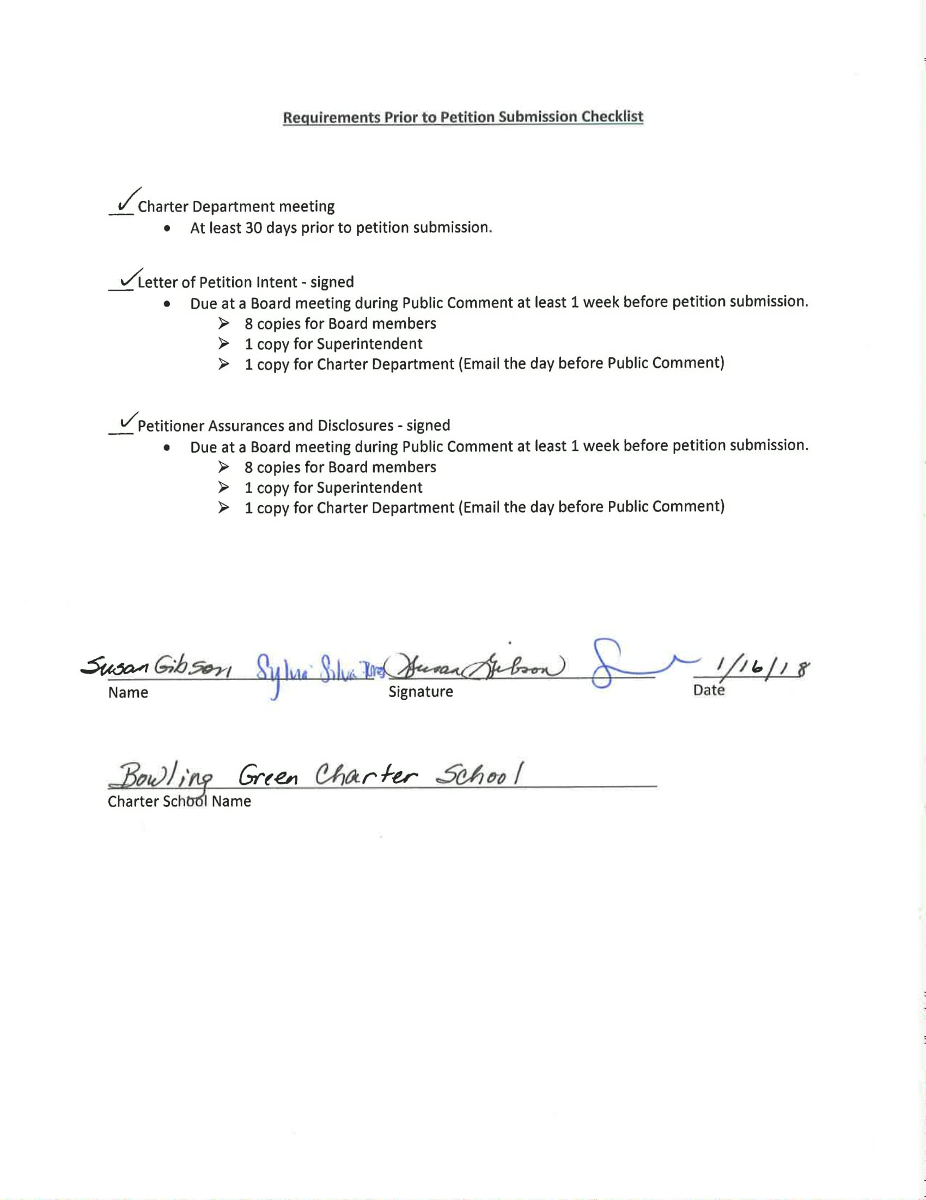

Letter of Petition Intent
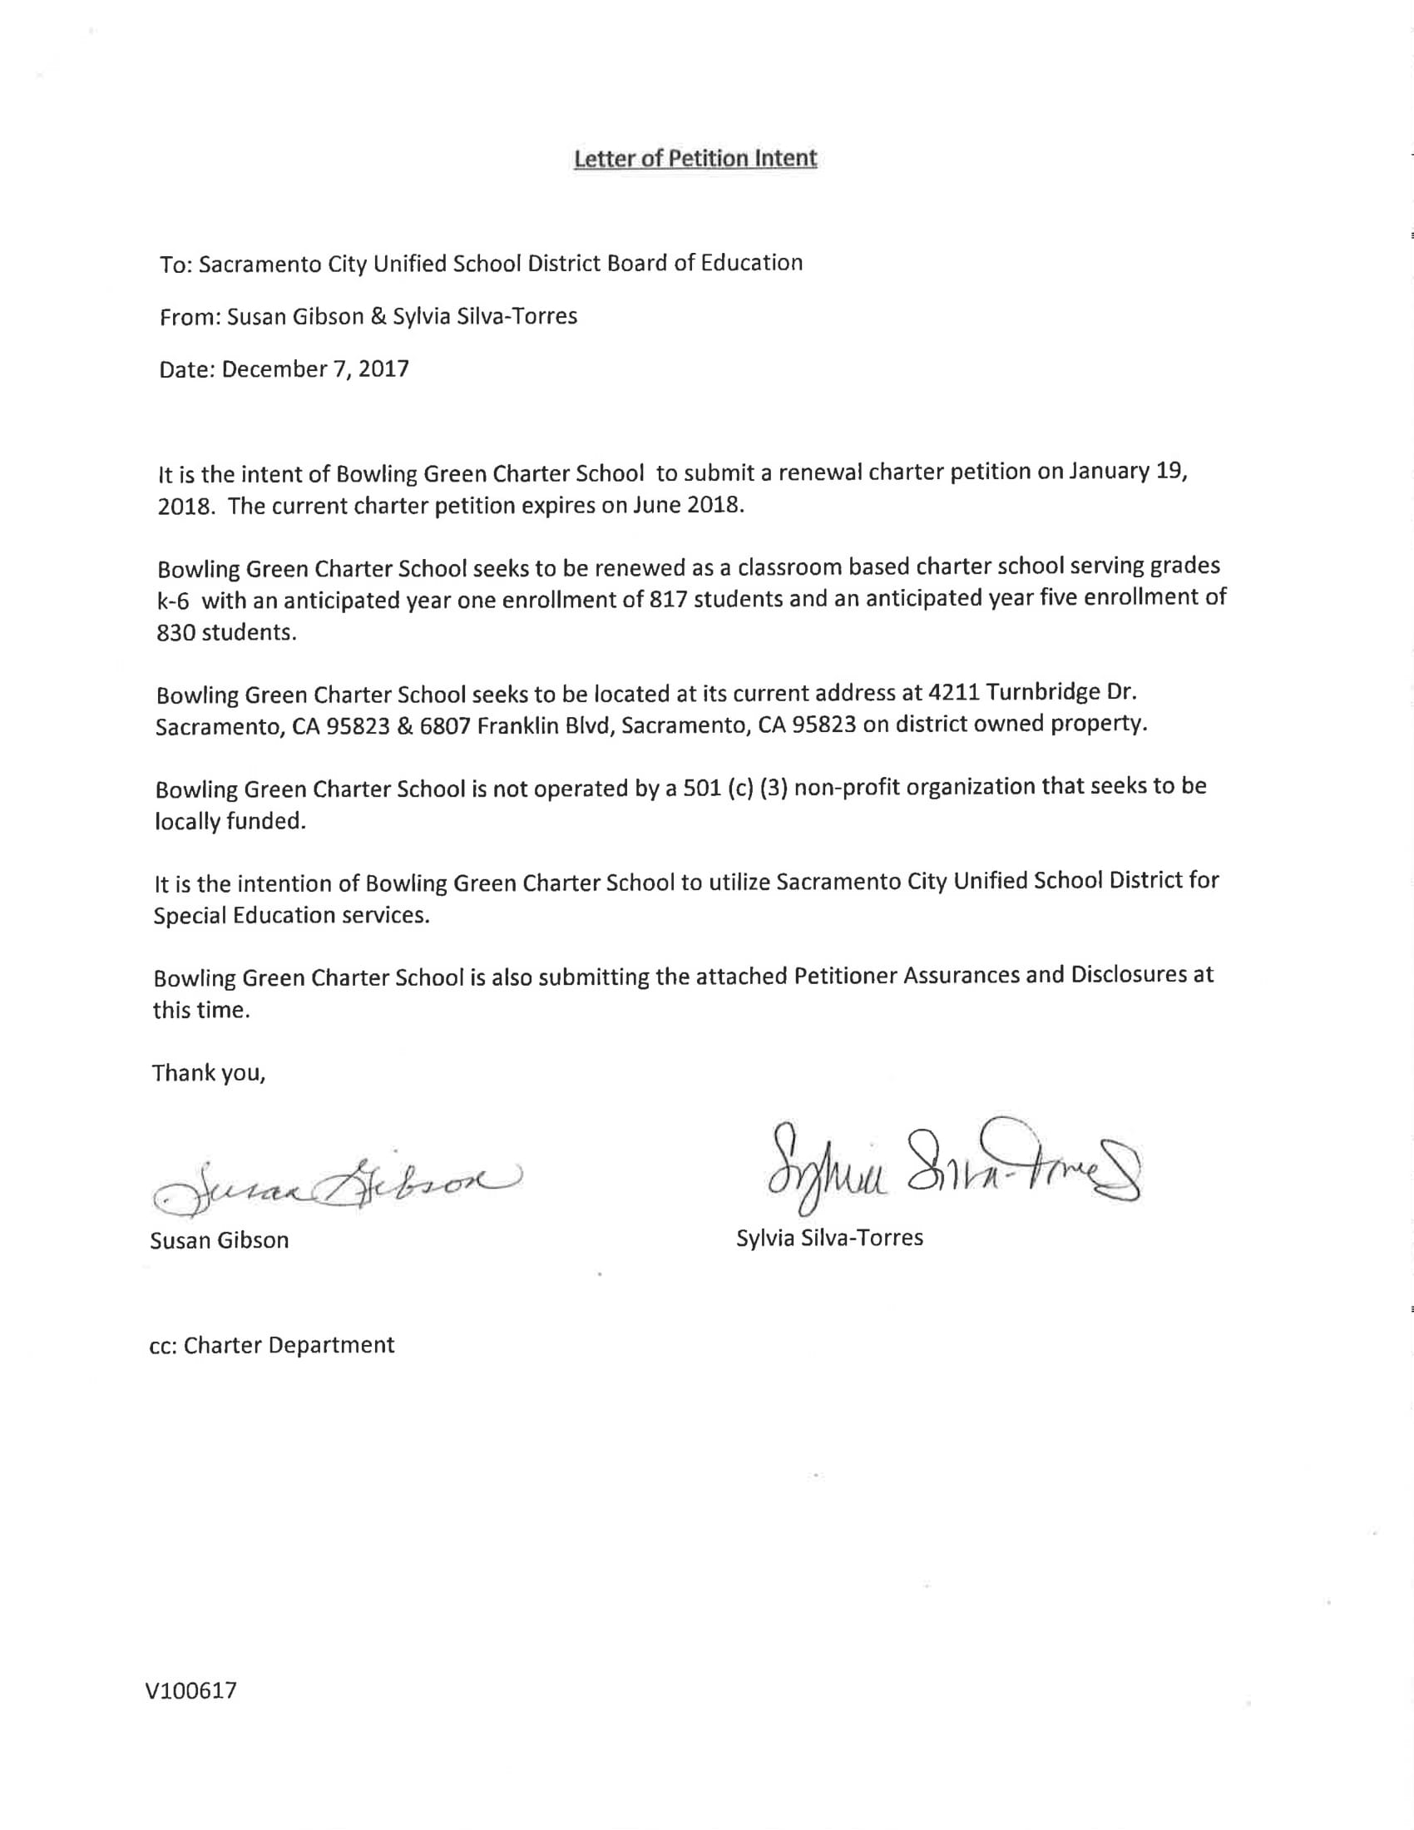
Petitioner Assurances and Disclosures
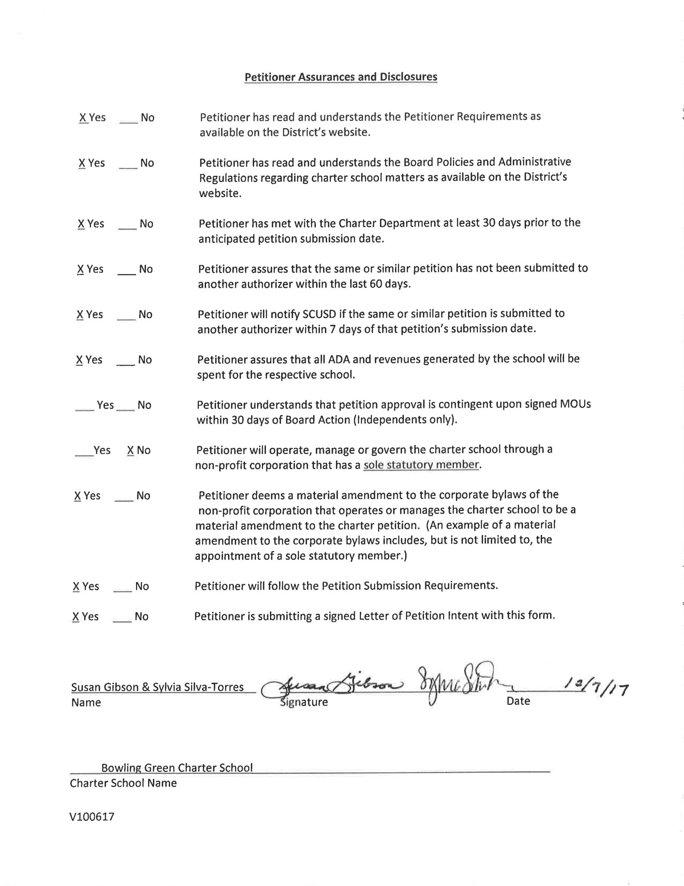
Assurances - General

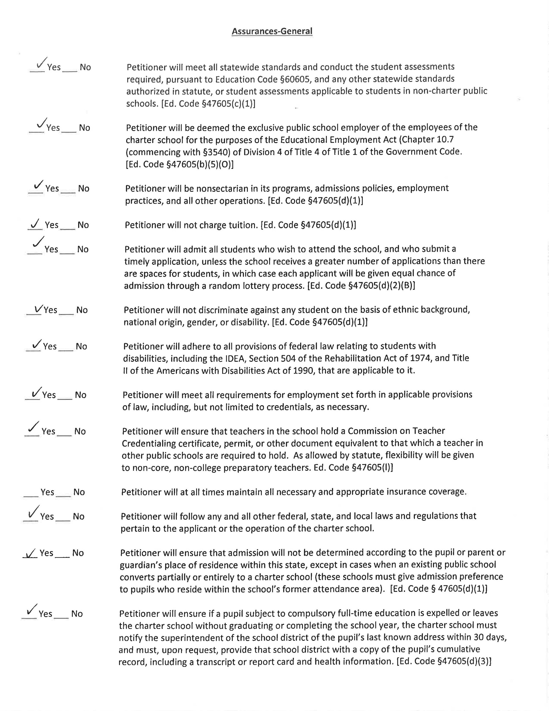
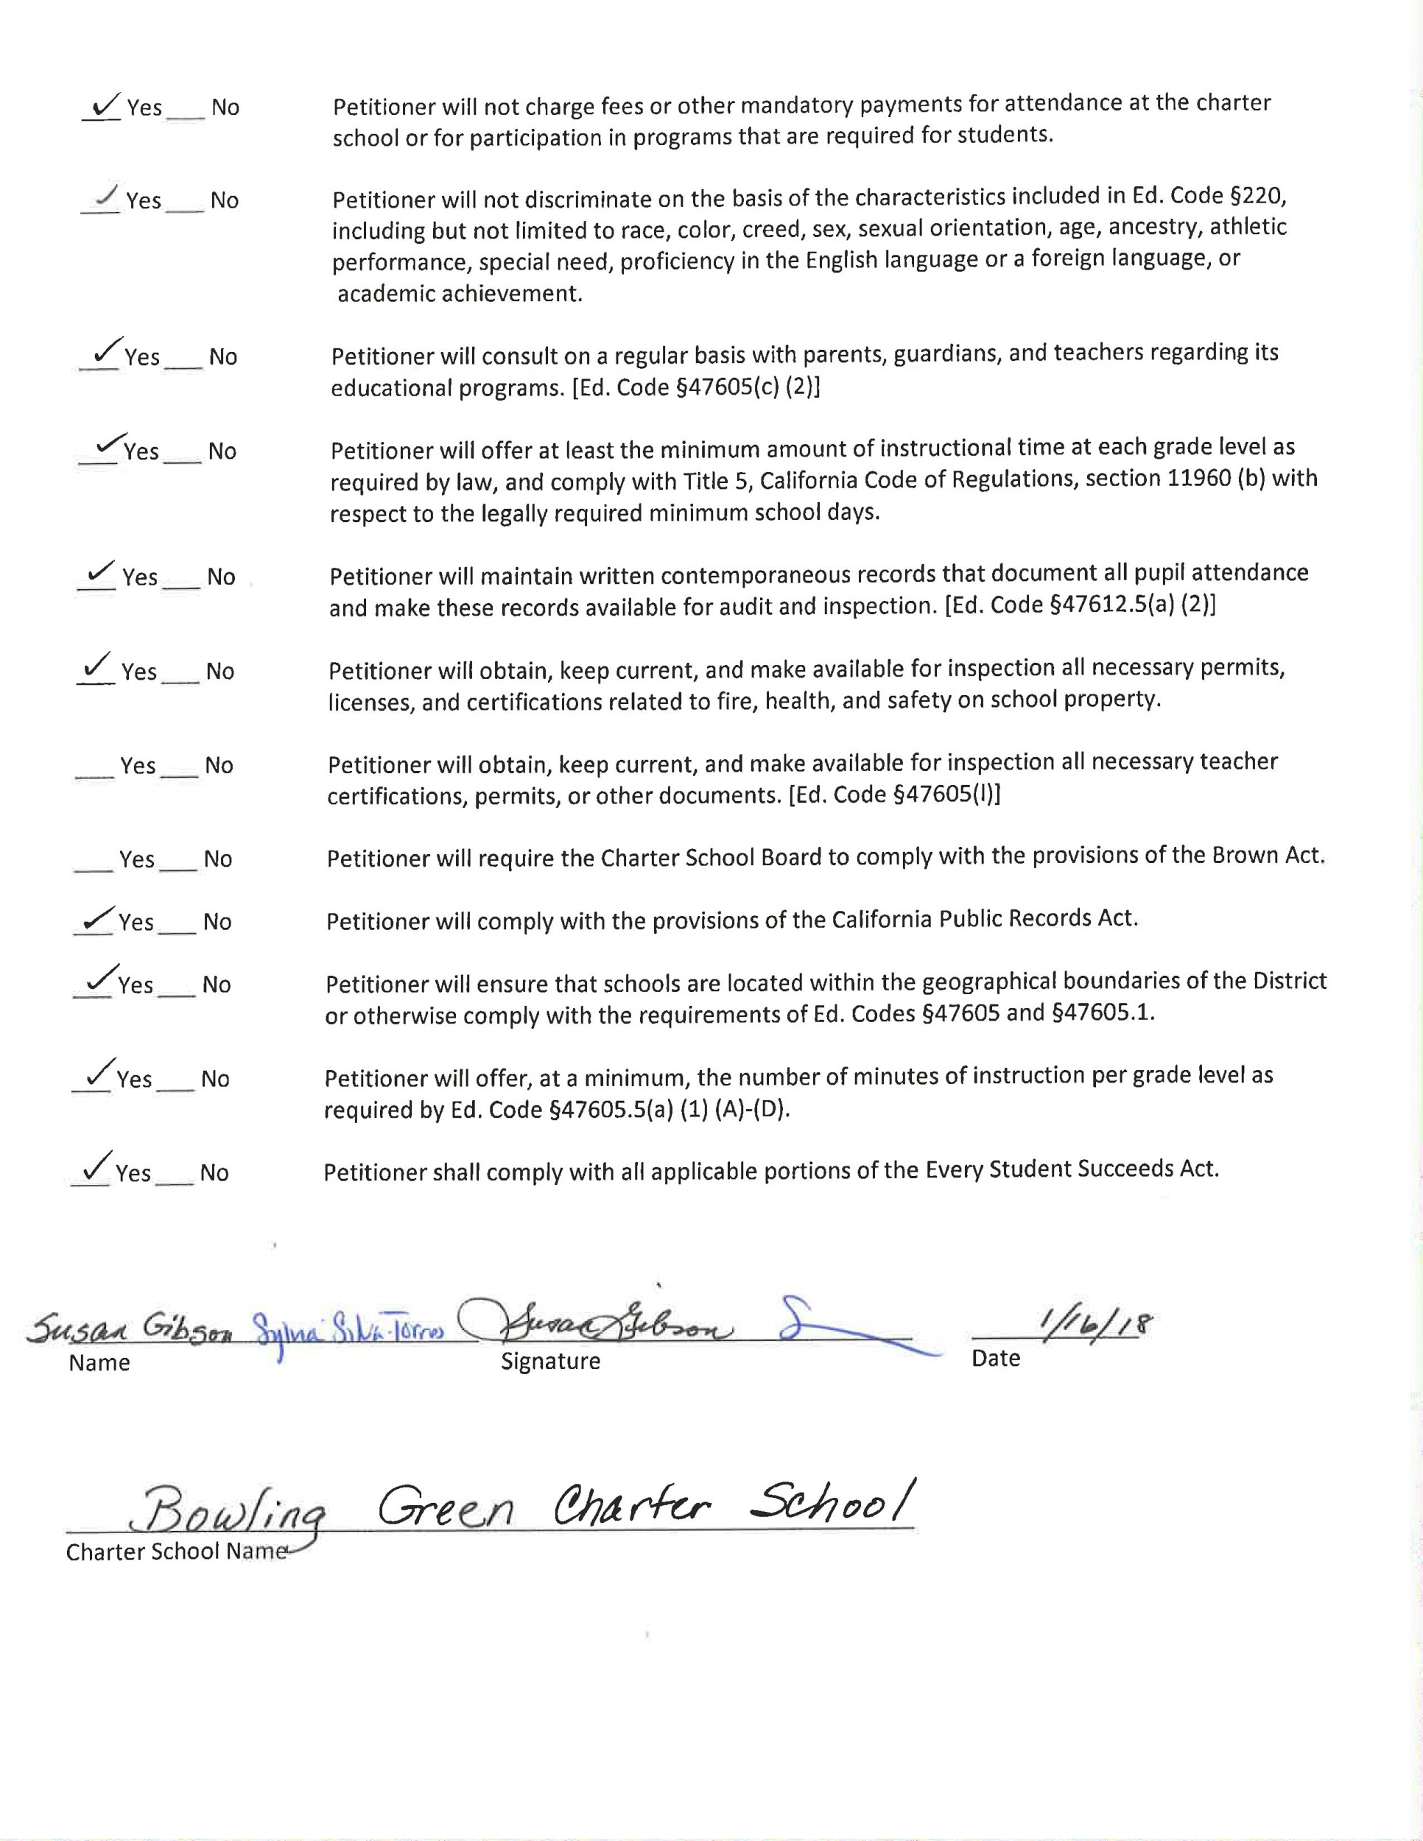

Assurances - Health
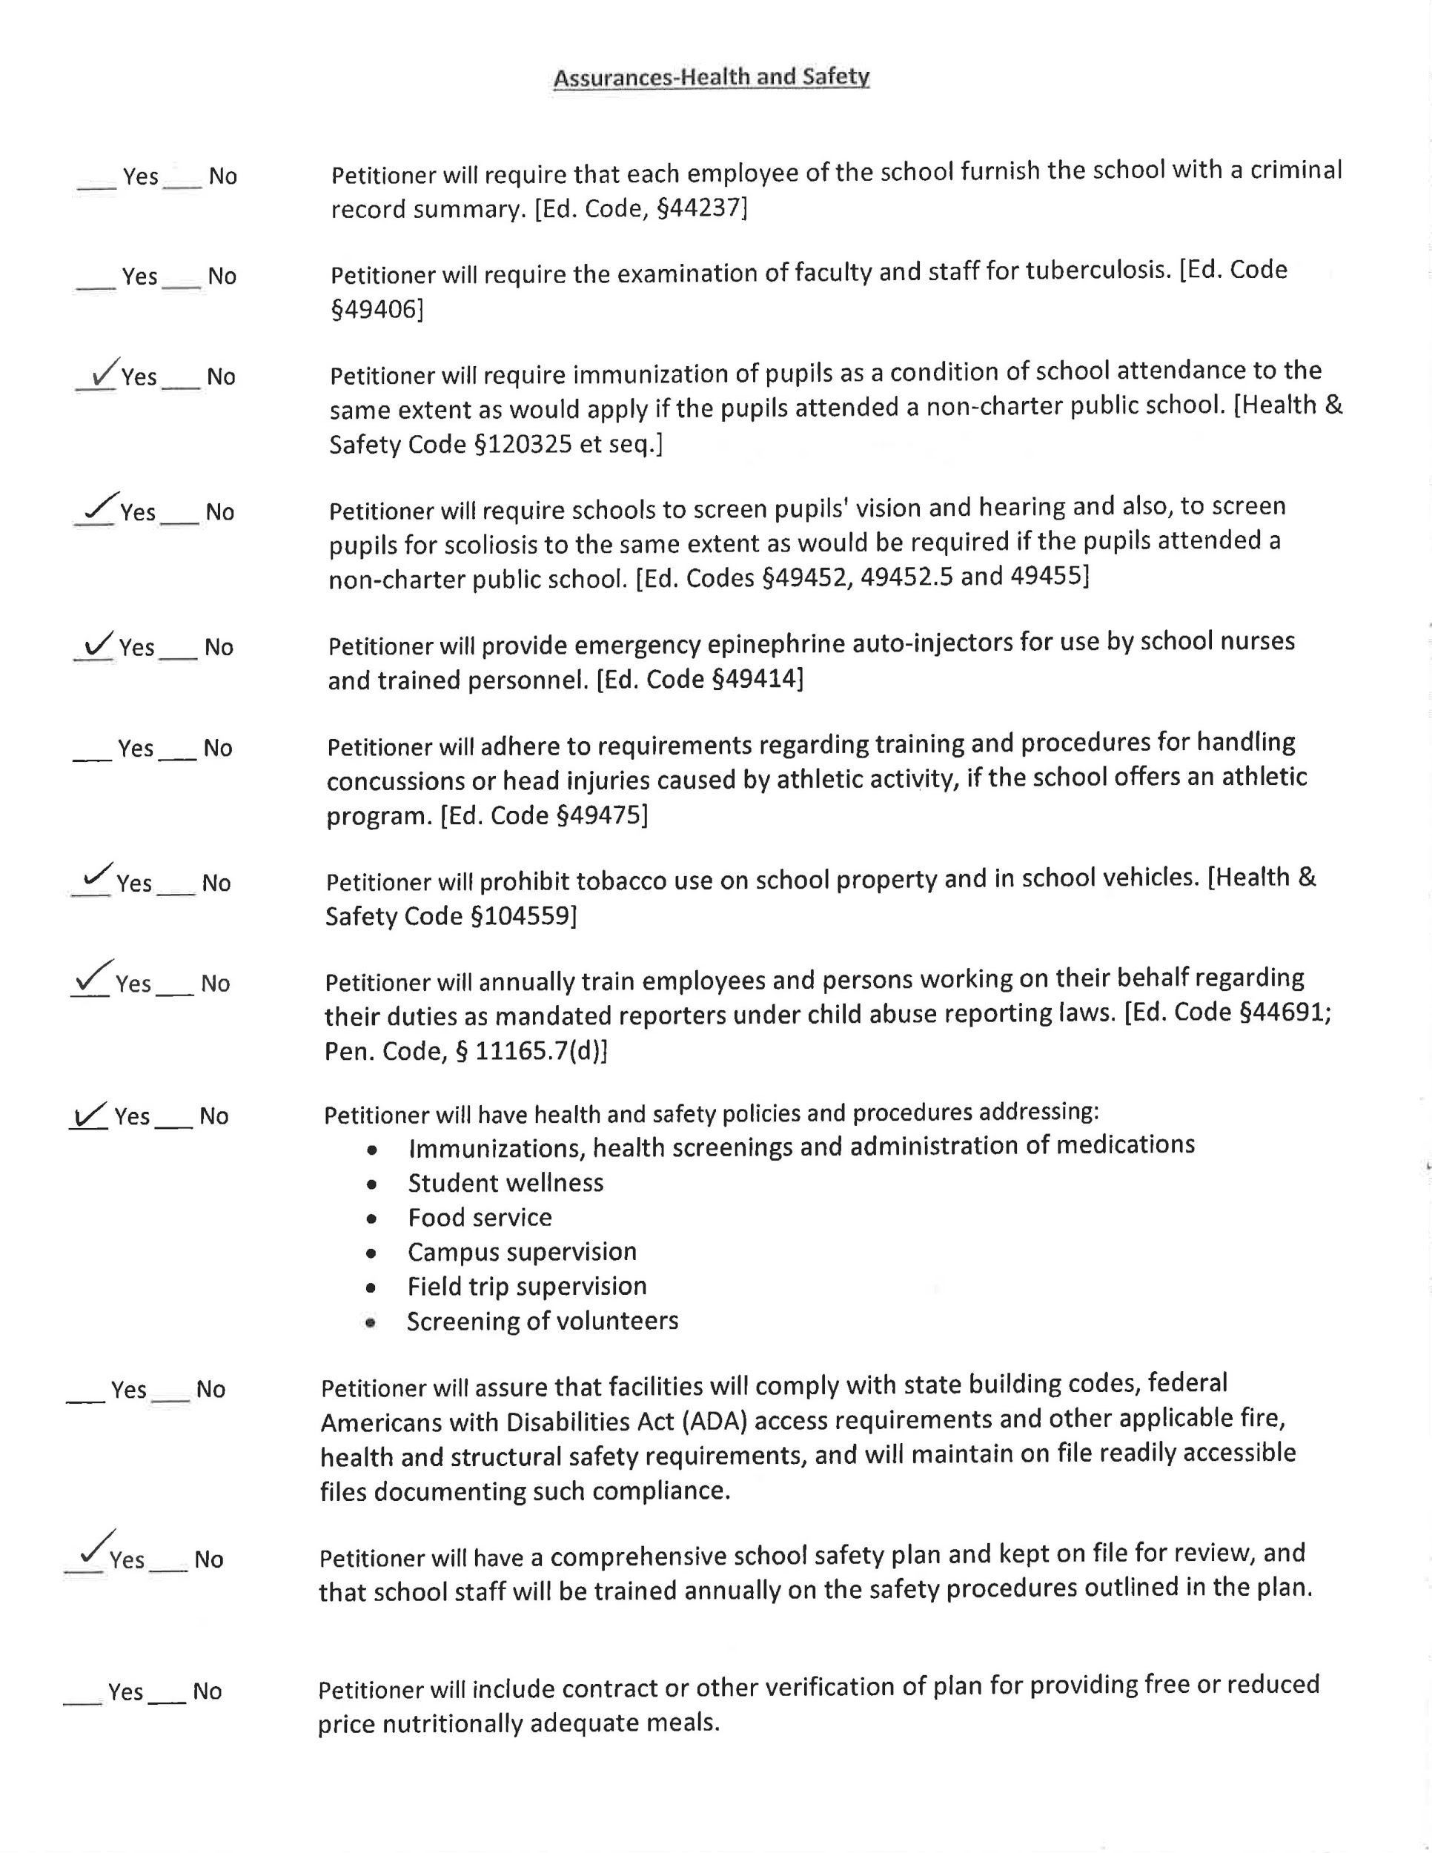
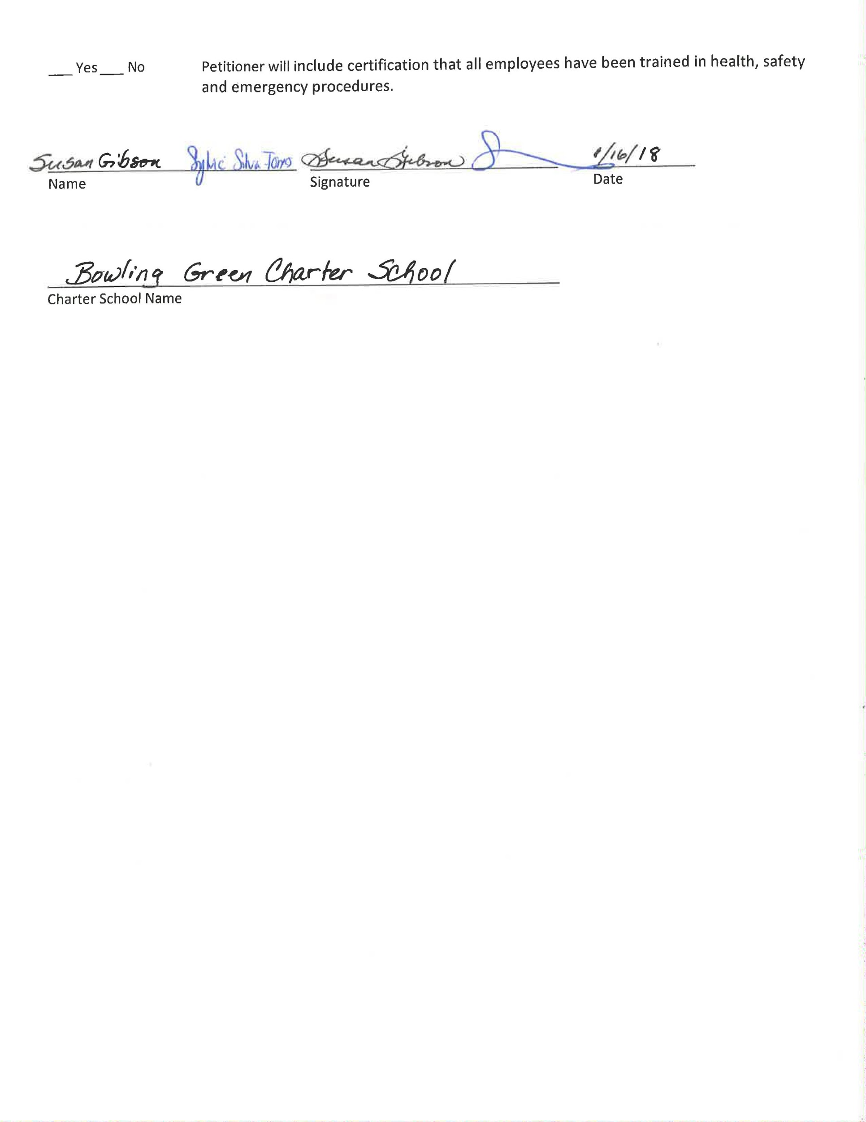

Introduction

Vision Statement
Our vision is that all our students, regardless of background, will leave Bowling Green Charter school proficient in all grade-level standards and, furthermore:
- critical thinkers with a passion for learning
- guiding students to be caring and culturally aware
- confident individuals who apply life skills to become well-rounded, proactive members of society.

Mission Statement
To achieve this vision, we will engage all students in rigorous, standards-based curriculum that both requires and nurtures critical thinking, self-efficacy, empathy, and cultural awareness. Because students, families, and all other stakeholders have unique strengths and needs, we will offer distinct educational programs through our small learning communities (SLCs): the Ken McCoy Academy for Excellence and the Chacón Language and Science Academy. As they have since 2008, each SLC will operate independently to maximize the ability to respond to community needs as they evolve.

History
Bowling Green Charter School (BG) has been a successful charter school since 1993. It was the 18th charter in the State of California. The staff at Bowling Green Charter School has gone through numerous adaptations including changes in program, curriculum and departmental structure. As a result, we are today comprised of a group of teachers and administrators who are flexible, creative and ever more dedicated to providing programs that best meet the needs of our students. The charter renewal we are presenting consists of two distinct small learning communities (SLCs): the Ken McCoy Academy for Excellence and the Chacón Language and Science Academy (CLASA), working in tandem to serve the needs of our changing population. Both SLCs will operate under one charter. Each small learning community will have its own administrator, governance structure, budget and educational program. Recognizing the need for efficient interaction between the two communities, a Joint Leadership Committee (JLC) will meet regularly to oversee common concerns and programs.

BG serves a diverse and ever-changing community of students and families. The needs of this community are extensive and require the swift action of a school site designed to be uniquely attuned to their circumstances. The strengths of this community are also expansive and can be leveraged through the relationships built between families and school-staff. The localized governance structure of the SLCs and Bowling Green’s status as a dependant charter school have allowed the school to maintain a laser-like focus on the unique needs of the local school community, rather than the more global needs of the district as a whole. This has resulted in gains in academic proficiency over the years since becoming a charter. These gains must be maintained and surpassed through a continuation of the dependant charter school status.

Today, a revised charter is being submitted for renewal. It has been updated to reflect changes in our population, organizational structure, and educational plan. Our goal is to consistently provide instruction and support that will meet the needs of our diverse community.

Original Charter Dates and Renewal Dates
Original Charter date was July 1, 1993

Renewal petitions have been approved in 1998, 2003, 2008, and 2013.

Founders/Leadership Team/Key Supporters
The original charter was designed and written by dedicated staff searching for a creative approach to improve the academic success of the neighborhood students. The leadership team for these efforts included Dennis Mah as Principal and a majority of staff, several of whom are still teaching at Bowling Green Charter School. Current leadership is described in the “Governance Section.”

Highlights and Recent Accomplishments

Bowling Green Charter School serves a total of approximately 800 students in grades K - 6 in an economically stressed area of South Sacramento. In a time when many high-needs schools are struggling to keep credentialed teachers in classrooms, Bowling Green Charter School has managed to hire and retain a very highly-qualified and experienced workforce. 100% of teaching positions are filled with fully-credentialed teachers, the vast majority of whom are long-time veteran teachers with over 10 years of experience. This stability is a direct result of the site-based governance and the empowerment that teachers feel as a part of the BG team. Additionally, BG has leveraged their community resources and hired several parents and other family members as classified staff. The leadership at Bowling Green Charter School works hard to empower staff and families so that changes in leadership do not mean drastic changes in educational services, but a new person to provide guidance to the leadership team. The capacity of this leadership team is made evident through the most recent CAASPP data with BG students demonstrating proficiency at much higher rates than the three comparable neighborhood schools. For specific CAASPP data, see Element 1.

Defining Characteristics of Bowling Green Charter School
The governance structure of Bowling Green Charter School defines the school more than the specific instructional program. This is because the school governance is designed to be responsive to the community it serves. As the needs of the community change, changes to the instructional program are made as well in order to better serve students and families. Although many elements of the instructional program have evolved with the community, three elements have remained since the inception of the charter in 1993. The Ken McCoy Academy for Excellence has maintained a looping structure designed to develop deeper student-family-staff relationships. The Chacón Academy of Language and Science has maintained both a focus on the sciences as well as a Two-way Spanish Immersion (TWSI) program. For more detailed description of these research-based instructional programs, see Element 1.

Location
Bowling Green Charter school is located at two locations: 6807 Franklin Blvd, Sacramento, CA 95823 and 4211 Turnbridge Dr, Sacramento, CA 95823 in the Parkway-South neighborhood.

Executive Summary

Overview and Key Points

This charter renewal petition outlines the local governance structure that defines Bowling Green Charter School as well as the instructional programs for each SLC. As a dependant charter school, much of the policies and administrative procedures of the charter school are defined by and/or aligned to Sacramento City Unified School District. As such, some portions of this charter related to policies and procedure will be brief and direct the reader to district policy.

Highlights and Accomplishments of Current Petition Years

One of the biggest accomplishments of Bowling Green Charter School is the stability in staffing and student attendance. Out of 34 teaching positions, only 4 are filled with teachers new to the district in the last 5 years. 18 teachers have been on staff at Bowling Green for over 10 years. This stability in staffing has been proven to have positive effects on academic achievement and is unusual for schools serving low-income students and high concentrations of students of color. (Carver Thomas and Darling Hammond) Another significant predictor of academic success of low-income students is attendance. Both Ken McCoy Academy and CLASA have a daily attendance rate over 95% and a chronic absenteeism rate under 10%. When compared to other district schools with similar demographics, this is quite an accomplishment. The impact on academic achievement can be seen in the school comparison data shown in Element 1.

Plans for the Future

While the comparative data shows a great deal of success at Bowling Green Charter School, we are far from satisfied with our results. As long as we have students who are not achieving academic success, we have more work to do. The steering committees of each SLC will continue to review data, policies, and research to collaborate on solutions to school challenges. Some possibilities currently being explored are: expanding the science focus to a STEM focus, expanding the TWSI program, increasing opportunities for professional collaboration through strategic scheduling, expanding access to the arts, and increasing family engagement opportunities through collaboration with the Family and Community Empowerment office. The most significant financial change is in teacher salaries. Some changes will have to be made to accommodate the increase in financial liability. Those changes will be decided by the steering committee of each SLC.

Charter Goals

Bowling Green Charter School will address the following measurable goals over the term of this charter July 1, 2018 through June 30, 2023:

Attendance: Each SLC will attain and maintain a minimum attendance rate of 95%.

Enrollment: Application and registration information will be publicized annually to maintain enrollment that maximizes the facility capacity while maintaining class size as agreed upon in bargaining agreements. Enrollment for McCoy will be maintained at 450 - 475 and Chacón will maintain enrollment of 340 - 360.

Suspensions: Both SLCs will strive to keep suspension rates as low as possible with a goal of less than 1%.

Teacher qualifications: Each SLC will seek to maintain the current rate of 100% fully credentialed teaching staff.

CAASPP: Instruction and staff development will emphasize the skills and content knowledge of the state standards with a goal of continuous improvement in student SBAC scores. Specific measurable achievement objectives for each SLC and each content area are outlined in Element 1 and revised each year through the development of the LCAP.

Element 1—Educational Program

Chacón

E1 - Educational Program
 | 2015-16 | 2016-2017
Student Served | Total # | Total # | Total % | K # | K % | 1 # | 1 % | 2 # | 2 % | 3 # | 3 % | 4 # | 4 % | 5 # | 5 % | 6 # | 6 %
- Total Enrollment | 381 | 363 | 100 | 45 | 12.3 | 54 | 14.9 | 51 | 14 | 51 | 14 | 53 | 14.6 | 52 | 14.3 | 45 | 12.3
- In District | 327 | 309 | 85
- Out of District | 54 | 54 | 15
- EL | 230 | 245 | 67
- SPED | 43 | 46 | 13
- FRPM | 284 | 311 | 86
- Foster Youth | 3 | 0 | 0
- Homeless | 0 | 0 | 0
- African American | 17 | 10 | 3 | 0 | 0 | 0 | 0 | 5 | 50 | 0 | 0 | 0 | 0 | 2 | 20 | 3 | 30
- American Indian or Alaska Native | 0 | 0 | 0 | 0 | 0 | 0 | 0 | 0 | 0 | 0 | 0 | 0 | 0 | 0 |  | 0
- Asian | 13 | 10 | 3 | 2 | 20 | 1 | 10 | 2 | 20 | 2 | 20 | 2 | 20 | 0 | 0 | 1 | 10
- Filipino | 0 | 0 | 0 | 0 | 0 | 0 | 0 | 0 | 0 | 0 | 0 | 0 | 0 | 0 | 0 | 0 | 0
- Hispanic or Latino | 362 | 325 | 90 | 39 | 12 | 52 | 16 | 43 | 13 | 47 | 14 | 48 | 15 | 47 | 13 | 49 | 15
- Pacific Islander | 3 | 3 | 0 | 1 | 33 | 0 | 0 | 1 | 33 | 0 | 0 | 1 | 33 | 0 | 0 | 0 | 0
- White | 6 | 6 | 2 | 2 | 33 | 1 | 17 | 0 | 0 | 1 | 17 | 0 | 0 | 1 | 17 | 1 | 17
- Two or More Races | 6 | 7 | 2 | 1 | 14 | 0 | 0 | 0 | 0 | 1 | 14 | 2 | 28 | 2 | 28 | 1 | 14

McCoy

E1 - Educational Program
 | 15-16 | 16-17 | 16-17
Student Served | Total # | Total # | Total % | K # | K % | 1 # | 1 % | 2 # | 2 % | 3 # | 3 % | 4 # | 4 % | 5 # | 5 % | 6 # | 6 %
- Total Enrollment | 497 | 461 |  | 76 | 16% | 69 | 15% | 64 | 14% | 67 | 14% | 55 | 12% | 74 | 16% | 64 | 14%
- In District | 433 | 396
- Out of District | 65 | 66
- EL | 164 | 181 | 37% | 32 | 20% | 34 | 20% | 29 | 16% | 24 | 14% | 16 | 9% | 20 | 11% | 21 | 12%
- SPED | 49 | 53
- FRPM | 355 | 398
- Foster Youth | 4 | 10
- Homeless | 0 | 0
- African American | 105 | 105 | 22% | 17 | 16% | 13 | 12% | 18 | 17% | 19 | 18% | 11 | 10% | 11 | 1% | 14 | 13%
- American Indian or Alaska Native |  | 1 |  |  |  |  |  |  |  |  |  |  |  |  |  | 1 | 100%
- Asian | 102 | 102 | 22% | 18 | 17% | 18 | 17% | 10 | 10% | 14 | 14% | 9 | 9% | 21 | 20% | 12 | 12%
- Filipino
- Hispanic or Latino | 214 | 218 | 46% | 35 | 16% | 30 | 14% | 31 | 14% | 27 | 12% | 28 | 13% | 36 | 17% | 29 | 13%
- Pacific Islander | 14 | 14 | 3% | 2 | 14% | 4 | 28% | 0 | 0% | 2 | 14% | 2 | 14% | 1 | 7% | 3 | 21%
- White |  | 21 | 4% | 3 | 14% | 2 | 10% | 3 | 14% | 4 | 19% | 3 | 14% | 2 | 10% | 3 | 14%
- Two or More Races |  | 13 | 3% | 1 | 8% | 2 | 15% | 2 | 15% | 1 | 8% | 2 | 15% | 3 | 23% | 2 | 15%

Vision and Mission
Our vision is that all our students, regardless of background, will leave Bowling Green Charter School proficient in all grade-level standards and, furthermore:
- critical thinkers with a passion for learning
- guiding students to be caring and culturally aware
- confident individuals who apply life skills to become well-rounded, proactive members of society.

To achieve this vision, we will engage all students in rigorous, standards-based curriculum that both requires and nurtures critical thinking, self-efficacy, empathy, and cultural awareness. Because students, families, and all other stakeholders have unique strengths and needs, we will offer distinct educational programs through our small learning communities (SLCs): the Ken McCoy Academy for Excellence and the Chacón Language and Science Academy (CLASA). As they have since 1993, each SLC will operate independently to maximize the ability to respond to community needs as they evolve.

Education Philosophy
The school’s job is to educate the whole person: academically, socially, culturally, and linguistically. The purpose of an education is to prepare a person to make positive changes as an individual as well as impact others in their family, their neighborhood, and the world.

How Does Learning Best Occur?
Students learn best in a nurturing, supportive, and safe environment. In short, learning happens in relationship. To this end, every adult on campus is dedicated to building relationships with students and families that can be leveraged toward academic, social, and/or linguistic goals. Learning also happens when educators can match instruction to specific student needs. This requires knowing students well, both socially and academically to provide targeted instruction that accelerates learning. To support these close relationships between students, families, and staff, Bowling Green Charter School is organized into two distinct SLCs with unique instructional programs. These programs are outlined below.

One Mission, Two Programs
Because each SLC has a unique approach to core instruction based on the needs of their respective communities, their distinct instructional programs are described below. Some aspects of the instructional program, such as Digital Literacy, EL supports and Special Education Services are discussed below and apply to both campuses.

Program Description for Chacón Language and Science Academy (CLASA)

Dual Immersion
Within the Chacón Academy, there are two strands designed to achieve the Bowling Green Charter School vision and mission. There is an English only strand, in which core instruction is provided exclusively in English and a Two-Way Spanish Immersion program, in which instruction is provided in both English and the target language-Spanish. While the philosophical underpinnings of the academy (including Brain Compatible Learning, Efficacy strategies, and Lifeskills and Lifelong Guidelines) are demonstrated in both strands, it is the Two-way Spanish Immersion (TWSI) program that really sets the Chacón Academy apart.

In today’s society, being bilingual is a clear advantage both socially and in the job market. Research conducted through Calderon and Carreon points to the educational, cognitive, social cultural, and economic benefits of bilingualism.

The research conducted by Collier and Thomas concludes that the 90/10 two-way approach, which is the model utilized by CLASA, to be the best approach for acquiring a second language. The model allows for maximizing proficiency in both languages regardless of the student’s primary language. In the 90-10 model students begin their educational careers in kindergarten with 90% of instruction being delivered in the target language - in this case, Spanish. 10% of the instruction is delivered in English. The percentage of instruction delivered in English increases each year until students receive 50% of their instruction in English and 50% in Spanish. This ratio is reached halfway through 3rd grade and maintained through the end of sixth grade.
This model also requires some unique enrollment considerations. The model works best if a balance of English-dominant, Spanish-dominant, and bilingual students can be attained. In order to approximate this balance as closely as possible, applicants to this program are asked to self-report in which of the three language categories the student best fits. The lottery tickets for each student are placed in three separate lotteries. Once the lotteries for each language category have been completed, the remaining tickets are combined to create the waitlist. As openings become available, students from the waitlist are called to fill those spots with priority first given to students of the needed language category and then in the order of the waitlist. For example, if the opening to be filled is in the “bilingual” category, the first student on the waitlist that is in this category will be offered the spot in the program. If no bilingual students are on the waitlist, the first person on the waitlist will be offered the spot, regardless of language category.
The TWSI program provides a unique opportunity to leverage the linguistic assets of the Parkway-South community. In the program native Spanish speakers, native English speakers and bilingual students develop high levels of academic literacy in both languages. The Chacón Language and Science Academy takes pride in providing the only Spanish K-6 90/10 two-way dual immersion program in the Sacramento City Unified School District.

Curriculum and Instruction for CLASA
While the two strands of CLASA deliver instruction in different languages, much of the curriculum is the same. The National Center on Universal Design for Learning defines curriculum as including four components: goals, methods, materials, and assessment. For academic content areas (e.g., English Language Arts, Mathematics, Science, etc.), the goals for the curriculum are outlined by the state of California through the adopted content standards. These standards provide teachers with the “what” of teaching. The methods used to teach grow from a combination of individual student needs and a substantial toolkit of research-based practices. Having a deep understanding of and proficiency with research-based teaching practices allow teachers to strategically design instruction and choose from available materials in response to the children in front of them rather than based on a prescriptive program. In order to make these decision, teachers must also employ a variety of assessment practices that provide detailed information on a student’s strengths and needs. This information, in turn, tells the teachers how to adjust “what” and “how” they are teaching to best accelerate learning for their students. While the goals for each grade-level are non-negotiable based on the standards, there is flexibility and room for professionalism in the methods, materials, and some assessments. Below are some of the methods, materials, and assessment tools and practices used at CLASA.

Methods
Brain Compatible Learning
Brain Compatible Learning, as described by Susan Kovalik, focuses how learning best occurs. by employing highly effective teaching techniques, such as integrated thematic instruction and teaching to modalities (with the understanding that all people are intelligent in a variety of ways.) Using these strategies, Brain Compatible Learning helps students to make connections in all that they learn. Research indicates that when their prior knowledge is activated and new connections are created via their innate intelligences, students succeed better. When students are not only allowed, but are encouraged to bring information into their brains through pathways that are familiar to them, (their “home modalities”), they are far more likely to gain and, maintain meaning, from new material.

Efficacy
Efficacy is a set of teaching techniques propelled by a self-directed Improvement system (SDIS.) The major purpose of Efficacy is to help children to learn how they learn best and to encourage them to internalize those learning behaviors. Efficacy has three components that teach self-motivation and encourage self-directed learners:

- Think you can; work hard; get smarter. In the early stages of learning, it is important that students learn how they get smart; that these three steps explain in a simple way how they learn, that if they: 1) think they can 2) work, hard, then 3) they will achieve and “get smarter.”
- Zone of development All children will learn if instruction is in their Zone of Development, where instruction is not to easy or too difficult, when the work is challenging but not overwhelming. Where each student’s Zone of Development is depends upon prior academic and life experiences.
- Data-Feedback Strategy This last aspect of the Efficacy SDIS involves both students and teachers using data to improve instruction and performance. Students are encouraged to learn to see data as an aid in learning from their errors, seeing mistakes as feedback, not failure. Using data feedback, they can make adjustments and try again. This approach allow students to focus on their actions, what they are doing academically, rather than zeroing in on themselves and seeing their errors as something wrong with them. Teachers use the DFS method to find patterns in their own classroom data, taking the feedback and determining what needs to be retaught and celebrating what is going well. This allows them to focus on what works and gives them more reason to jettison strategies that are not successful.

Through Efficacy strategies, we teach our students to see how they learn and to use mistakes as feedback toward improvement, rather than as indicators of failure. Our hope is to develop self-directed, independent, confident learners.

Science Partnership with California State University of Sacramento (CSUS)
According to the National Academies Committee, to be competitive in the global market the United States must have a highly qualified workforce proficient in mathematics and general sciences. The Chacón Science and Language Academy has had a science partnership with Sacramento State for the past 15 years. In this partnership, Sacramento State student teachers are writing partners with select classrooms, where they exchange letters 3 times with the students, they come to campus to observe/participate in the teacher’s teaching science. At the end of the semester, the classrooms visit Sac State where they teach science lessons to the students and give them a tour of the CSUS STORC AQUAPONICS. We will continue this relationship, as well as build others with local universities and companies in order to achieve a well-rounded science program.

Materials
English Language Arts/Spanish Language Arts
Teachers at CLASA design language arts instruction that supports science and social studies content. To do this, they are provided with class sets of novels, a variety of read-aloud texts, and Ready Common Core.Teachers use the guidance in the ELA/ELD Framework to pull strategically from the variety of resources available. The TWSI program additionally has Benchmark Adelante as the primary resource for Language Arts.

Mathematics
As with language arts, teachers are encouraged to pull from a variety of resources to design instruction to meet the needs of their students. Teachers have access to Envisions, EngageNY, and Ready Common Core. Both Envisions and EngageNY are available in Spanish to teachers in the TWSI program.

Science
To enhance the science experiences of students, the teachers at CLASA have begun using Foss Kits. Foss Kits provide opportunities for hands-on, experiential learning in science in which students can construct their understanding of science concepts over the course of a unit of study. These kits also include a variety of informational texts that support teachers to integrate language arts. Some teachers have also begun exploring STEM units to increase student exposure to the engineering process.

Social Science/History
Teachers are encouraged to use the California History/Social Science Framework as a guide for instruction and to integrate social science and history into their integrated units. This requires sets of text. CLASA has purchased text sets requested by each grade-level team to support this integration.

English Language Development
The new California English Language Development Standards and the ELA/ELD Framework call for language instruction that is integrated and “builds into and from” content area instruction. To this end, CLASA has not provided separate materials for ELD, but supports teachers to design language instruction based on both the ELD Standards and the content with which they are engaging students. For additional details, see “Plan for English Learners.” The TWSI program also has access to the ELD materials included in Benchmark Adelante. Because these lessons have inconsistent quality, teachers are always encouraged to design instruction using the standards.

Assessment
Assessment allows teachers to identify and respond to student needs. It also allows teams of teachers to collaborate and problem solve using a common language and a common perspective on student achievement. At CLASA, common assessments are reviewed, discussed, and chosen by a team of teachers. This assessment team is responsible for ensuring that assessments are providing the type of data teachers need to make effective instructional decisions without putting undue burden on instructional time. CLASA will hold academic conferences twice a year . During these meetings teachers will meet with their partner, as well as the principal, to discuss classroom results, look at student work and set grade-level goals as well as professional goals.

The current common assessments used are listed below.
ELA Assessments

Grade | Baseline | Trimester 1 | Trimester 2 | Trimester 3
Kindergarten | Letter ID  Phonological Aw.  Sight Words* | Letter ID  Phonological Aw.  Sight Words | Letter ID  Phonological Aw.  Sight Words | Letter ID*  Phonological Aw.  Sight Words
First | Phonological Aw.  BPST  Sight Words | Phonological Aw.*  BPST  Sight Words | Phonological Aw.*  BPST  Sight Words  Read. Inventory* | Phonological Aw.*  BPST  Sight Words  Read. Inventory
Second | BPST*  Sight Words  Read. Inventory  DIBELS Fluency | BPST*  Sight Words  Read. Inventory  DIBELS Fluency | BPST*  Sight Words  Read. Inventory  DIBELS Fluency | BPST*  Sight Words  Read. Inventory  DIBELS Fluency
Third | BPST*  Sight Words  Read. Inventory  DIBELS Fluency | BPST*  Sight Words  Read. Inventory  DIBELS Fluency | BPST*  Sight Words*  Read. Inventory  DIBELS Fluency | BPST*  Sight Words*  Read. Inventory  DIBELS Fluency
Fourth | Reading Inventory  DIBELS Fluency | Reading Inventory  DIBELS Fluency | Reading Inventory  DIBELS Fluency | Reading Inventory  DIBELS Fluency
Fifth | Reading Inventory  DIBELS Fluency | Reading Inventory  DIBELS Fluency | Reading Inventory  DIBELS Fluency | Reading Inventory  DIBELS Fluency
Sixth | Reading Inventory  DIBELS Fluency | Reading Inventory  DIBELS Fluency | Reading Inventory  DIBELS Fluency | Reading Inventory  DIBELS Fluency
*as needed

Additionally, the TWSI strand use the end of unit assessments in the Benchmark Adelante curriculum.

Math Assessments
Teachers use the curriculum-embedded assessments for the end of each unit. (currently EngageNY)

Science Assessments
Teachers use the curriculum-embedded assessments for the end of each unit. (currently FOSS kits)

Social-emotional Curriculum
Lifeskills and Lifelong Guidelines
We teach Life Skills and Lifelong Guidelines, various positive character attributes that help students to understand what good behavior actually is, and also give them the means to practice those behaviors in a self-aware manner. The Life Skills include: perseverance, organization, patience, sense of humor, curiosity, common sense, cooperation, effort, friendship, integrity, problem solving, flexibility, caring, initiative, responsibility, resourcefulness, pride and courage. In addition to the skills, five Lifelong Guidelines are taught modeled and practiced. They are:
1) Do your personal best
2) No put downs
3) Active listening
4) Truthfulness
5) Trustworthiness

The Life Skills and Lifelong Guidelines are fundamental to our school’s social and emotional culture. They are taught in class, “target talked” throughout the day (for instance, when a student shows patience, the teacher will note that she or he used that Life Skill. Life Skills are also focused on in class meetings and in upper-grade conflict management (where fifth and sixth graders help monitor and maintain behavior during recesses and at lunch.)

Program Description for Ken McCoy Academy

Looping Structure
In order to support strong relationships among staff and students and families, McCoy Academy implements a looping structure beginning in first grade. Currently, students have the same teacher for first and second grade, a single teacher for 3rd and 4th grade, and one teacher for 5th and 6th grade. Changes to class sizes may necessitate a revision of this looping procedure before the next charter renewal. The LAB and Brown University cites the many benefits of looping including:
- Maximized instructional minutes due to decrease in “getting to know you” time
- Deeper teacher knowledge of students’ strengths and weaknesses
- Improved student/teacher relationship leading to improved student achievement
- Improved job satisfaction for teachers
- Increased opportunities for summer learning
- Increased student social development
- Improved classroom climate
- Increased sense of community among teachers, students, and families

Curriculum and Instruction for Ken McCoy Academy
As in the section on curriculum for CLASA, this section will use the National Center on Universal Design for Learning’s definition of curriculum as including four components: goals, methods, materials, and assessment. For academic content areas (e.g., English Language Arts, Mathematics, Science, etc.), the goals for the curriculum are outlined by the California State standards. These standards provide teachers with the “what” of teaching. The methods used to teach stem from a combination of individual student needs and a substantial toolkit research-based practices. Having a deep understanding of and proficiency with research-based teaching practices allow teachers to strategically design instruction and choose from available materials in response to the children in front of them rather than based on a prescriptive program. In order to make these decision, teachers must also employ a variety of assessment practices that provide detailed information on a student’s strengths and needs. This information, in turn, tells the teachers how to adjust “what” and “how” they are teaching to best accelerate learning for their students. While the goals for each grade-level are non-negotiable based on the standards, there is flexibility and room for professionalism in the methods, materials, and some assessments. Below are some of the practices, materials, and assessment tools and practices used at McCoy.

Methods

Genre-based and Inter-dicsiplinary Units
As is recommended by the Institute of Education Sciences, student motivation and engagement is improved when they are engaged in sustained study around a particular area of learning. Given the high number of English learners and Non-Standard English speakers at BG, it is also critical to provide explicit instruction on the discourse practices, or genres, within a particular discipline. These two ideas come together in Gibbons’s Teaching and Learning Cycle (TLC). This framework for unit design is used across the McCoy Academy as a way of designing units that integrate content, literacy, and language over a sustained unit of study.

Balanced Literacy Model
While the TLC supports teachers to design units of study that integrate multiple content areas, the balanced literacy model provides guidance on how to structure the literacy block to effectively engage students in the Common Core State Standards for English Language Arts. Through this model, students are engaged regularly with interactive read-alouds and other shared reading experiences, targeted small-group reading instruction, and genre-focused process writing.

Interactive Read Alouds are commonly used to apprentice students into the reading behaviors of proficient readers while engaging with grade-appropriate, complex text. Teachers work in collaboration with their grade-level teams to analyze texts for key themes and language structures, plan a strategic sequence of questions, and design relevant writing tasks (e.g., literary analysis). This practice ensures that students are regularly engaged with complex text in a supported and scaffolded way. They can take the skills they learn to apply to other texts they encounter independently or in their small groups.

The balanced literacy model calls for reading instruction that is targeted to student needs. In the K-2 space, this means teaching phonics and early reading behaviors in a small group setting. The teacher meets with small groups to teach targeted phonics or guided reading while the remainder of the students are practicing with relevant literacy skills at stations or centers. In the 3-6 space, this means engaging students in independent books at their level as well as providing opportunity for literature study in groups based on interest. In both cases, the teacher has opportunity through conferring or group coaching to target reading instruction to what students need in that moment.

In addition to the comprehensive reading instruction described above, teachers engage students in genre-based writing units that support their movement through the writing process. Just as each discipline has distinct, purpose-driven expectations, each genre within that discipline has expected structures and language features. Teachers engage students in an inquiry study of the target genre, relying heavily on mentor texts. Students collect ideas, plan, draft, revise, edit and publish their writing for a designated audience.

This balanced approach to literacy instruction has students reading, writing, speaking and listening throughout each piece of the literacy block all while using literacy and language skills for authentic purposes and in collaboration with peers.

Materials

English Language Arts
For English Language Arts (ELA), teachers are provided a variety of resources to pull from. The core adopted resource for K - 4 is Treasures, but teachers also have access to Core Ready and Engage NY. The McCoy Academy also has many class sets and literature circle sets of novels used in the intermediate grades. A guided reading room was recently opened with Guided Reading Books from Fountas and Pinnell levels A-N. The first and second grade teachers also use the Sound-Along program to teach targeted phonics lessons. Additional resources include a variety of applications that can be used on tablets to enhance and enrich student literacy experiences.

Mathematics
Teachers at McCoy Academy currently use the Engage NY Curricular Modules as the core resource. Additionally, teachers use software programs, such as ST Math and TenMarks to provide differentiated math support and improve number sense and problem solving.

Science
Teachers are currently planning instruction using the new California Science Framework and the Next Generations Science Standards. Teachers have access to most of the suggested texts listed in the framework and are encouraged to request additional text as a grade-level team. A Science Committee has also been created to pilot and develop recommendations on Project STEM instructional materials.

Social Science/History
Teachers are encouraged to use the California History/Social Science Framework as a guide for instruction and to integrate social science and history into the TLC units. This requires sets of text. McCoy Academy has purchased text sets requested by each grade-level team to support this integration. Teachers also have access to many of the texts recommended in the framework.

English Language Development
The new California English Language Development Standards and the ELA/ELD Framework call for language instruction that is integrated and “builds into and from” content area instruction. To this end, McCoy Academy has not provided separate materials for ELD, but supports teachers to design language instruction based on the both the ELD Standards and the content with which they are engaging students. For additional details, see “Plan for English Learners.”

Assessment
In order to make effective choices about what and how to teach students, teachers need a cohesive breadth of assessment. Teachers need to diagnose students’ strengths and needs when they enter the classroom or a new topic of study, they need to have mechanisms in place for assessing and responding to student need in the moment, and they need to know if the teaching they provided over the course of a unit or trimester has actually made an impact. Our comprehensive approach to assessment is shown in the graphic below.
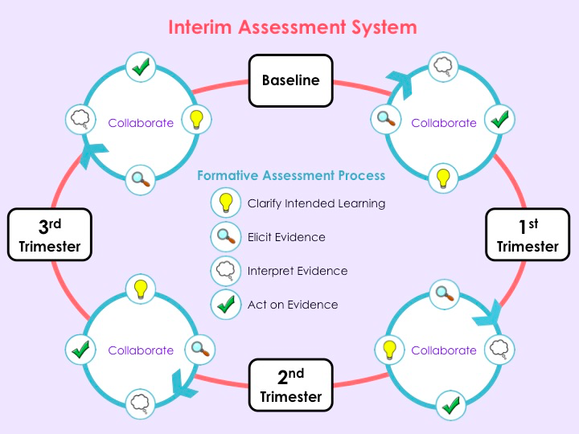

This comprehensive approach to assessment which includes baseline/diagnostic assessment, formative assessment practices, progress monitoring, and summative assessment are what make great teaching possible. Some of the assessment tools and timelines used at McCoy Academy are discussed below.

Baseline and Interim Assessment
The table below outlines the baseline and interim assessment schedule for English Language Arts. As benchmarks are developed at the district level, we hope to add some writing assessments to this list.

Grade | Baseline | Trimester 1 | Trimester 2 | Trimester 3
Kindergarten | Letter ID  Phonological Aw.  Sight Words* | Letter ID  Phonological Aw.  Sight Words | Letter ID  Phonological Aw.  Sight Words | Letter ID*  Phonological Aw.  Sight Words
First | Phonological Aw.  BPST  Sight Words | Phonological Aw.*  BPST  Sight Words | Phonological Aw.*  BPST  Sight Words  Read. Inventory* | Phonological Aw.*  BPST  Sight Words  Read. Inventory
Second | BPST*  Sight Words  Read. Inventory | BPST*  Sight Words  Read. Inventory | BPST*  Sight Words  Read. Inventory | BPST*  Sight Words  Read. Inventory
Third | BPST*  Sight Words  Read. Inventory  DIBELS Fluency | BPST*  Sight Words  Read. Inventory  DIBELS Fluency | BPST*  Sight Words*  Read. Inventory  DIBELS Fluency | BPST*  Sight Words*  Read. Inventory  DIBELS Fluency
Fourth | Reading Inventory  DIBELS Fluency | Reading Inventory  DIBELS Fluency | Reading Inventory  DIBELS Fluency | Reading Inventory  DIBELS Fluency
Fifth | Reading Inventory  DIBELS Fluency | Reading Inventory  DIBELS Fluency | Reading Inventory  DIBELS Fluency | Reading Inventory  DIBELS Fluency
Sixth | Reading Inventory  DIBELS Fluency | Reading Inventory  DIBELS Fluency | Reading Inventory  DIBELS Fluency | Reading Inventory  DIBELS Fluency
*as needed

For math, teachers use the curriculum embedded assessments provided in the instructional materials (currently EngageNY).

Formative Assessment and Progress Monitoring
For ELA, teachers are taught to make continuous observations as student read and write. They develop record keeping systems to organize and share the results of these observations, and adjust instruction in the moment and for future lessons based on the data they collect. Some examples include taking running records, engaging in conferences for reading and writing, and simple checks for understanding (exit tickets). In addition to these formative assessment practices, teachers get progress monitoring data from a variety of software systems. While the specific software systems may change, currently teachers get data from ST Math and Tenmarks.

Social-emotional Curriculum
Our Social Emotional Learning (SEL) program includes the teaching of non-cognitive skills to all students kinder through sixth grade. Students develop five core competencies through SEL including: self-awareness, self-management, social awareness, relationship skills, and responsible decision-making. SEL has been found to have an immediate improvement on mental health, social skills, and academic achievement. In addition, SEL has also demonstrated long term benefits, including, but not limited to; academics, behaviors, and attitudes (CASEL, 2017). SEL has been found to have an eleven-percentile point gain in academic achievement compared to those who have not participated in SEL programs (Durlak, Weissberg, Dymnicki, Taylor, & Schellinger, 2011). In addition, children who obtained early prosocial skills had a decreased likelihood of being on a waiting list for public housing, receiving public assistance, and being detained for criminal activity (Jones, Greenberg, & Crowley, 2015). A cost-benefit analysis conducted found on average there is a return of eleven dollars for every dollar invested in SEL (Belfield, Bowden, Klapp, Levin, Shand, Zander, 2015). In conclusion, SEL is a key component of our educational program which will assist in improving student’s prosocial skills, education, and provide long lasting effects.

Implementation of SEL is supported through monthly school wide character traits with classroom lessons. Teachers and staff reinforce SEL through the use of positive incentives and specific praise. Each classroom selects students of the month who embody the character trait focus for the month. School wide staff development supports consistent incorporation of the character traits into all aspects of the school and content areas. School wide expectations for positive student behaviors are explicitly taught with each classroom and student area having appropriate expectations. The site Student Support Center provides resources and text for teachers to utilize in teaching the character traits. Students are encouraged to spend a few minutes in the classroom break center to cope with frustration and stress; learning how to self-regulate emotions and behaviors.

Identifying and Responding to Needs of All Pupils
One of the primary benefits of a small learning community is the ability for the teachers to develop a personal connection with each of the students and understand the students’ needs on a deeper level. Bowling Green Charter School believes that all students have in common the ability to succeed. Traditionally, however, there have been gaps in opportunity for particular groups of students. History has taught us that without particular attention to the needs of these students, they often go underserved. This section outlines our plan to maintain a focus on and support the needs of targeted students.

Support for Students Performing Below/Above Grade Level
Academically high-achieving students
Bowling Green Charter School participates in district testing to identify GATE students at the first and third grade-level. To support these students in the classroom, the teachers at the McCoy Academy participated in the district-provided GATE training courses and 80% of them have completed their GATE certificates. This course of study focused on various types of giftedness, specific strategies to enrich learning, and differentiation of curriculum. At Chacón, many gifted students are already receiving appropriate enrichment in the TWSI program. Bernal and Garcìa write the “dual-language education can be used for the education of gifted and talented (GT) children.” Above all, the focus on knowing every child’s strengths and needs is what supports high-achieving students at Bowling Green Charter School. Teachers are designing instruction based on their deep understanding of students and and their needs rather than following a prescriptive program. This allows differentiation to be a part of lesson and unit design rather than something that has to be added into the instructional program after the fact.

Academically low-achieving students
Students not achieving at expected levels, in spite of the universally designed curriculum described above, enter the robust Student Study Team (SST) process at Bowling Green Charter School. The student study team typically includes the site administrator, a school social worker, a teacher leader, the intervention teacher and, of course, the classroom teacher and family of the student. This team reviews a variety of data, including academic achievement, attendance, behavior, and current and past intervention services to inform the collaborative creation of personal learning goals. In addition to these learning goals, the team uses the family and teacher knowledge of the student to design interventions that target their strengths and needs. The team then meets periodically to assess progress toward goals and the possible need for additional interventions or referrals for assessment. Some common interventions include: small group instruction during class, one-on-one support during class, one-on-one support from an instructional aide, pull-out intervention with resource teacher, use of a “break center,” and use of a “wiggle seat.”

English Learner Program Description
Bowling Green Charter School takes the obligation to meet the academic and linguistic needs of English learners (ELs) very seriously. Given the high numbers of ELs served by the site, everything we do is with these students in mind.

When students are enrolled at BG, the family completes the Home Language Survey (HLS) to determine if the student speaks a language other than English. If they do, they are given the English Language Proficiency Assessment for California (ELPAC). If the student does not meet the requirements to be classified as Initially Fluent English Proficient (IFEP), they are provided with English Learner services. This includes additional scaffolding of content area instruction and English Language Development (ELD) instruction.

All teachers at Bowling Green Charter School have an English Learner authorization with their credential and are fully qualified to teach English learners. These highly qualified educators follow the guidance of the CA ELA/ELD Framework to provide English Language Development through two structures: integrated ELD and designated ELD. Integrated ELD includes language instruction taught within the content areas and is designed to support developing the language of the particular genre or discipline. Designated ELD is a protected time when English learners can have their particular language needs met in a small group setting. Even during this protected time, the core content of the classroom is the vehicle for language instruction. To support teachers in delivering the type of high-quality ELD instruction described above, Bowling Green Charter School has participated in the Leading With Learning project. This intensive, two-year professional learning experience was a collaboration between WestEd and the Sacramento City Unified School District. Through Leading with Learning, teachers learned how to design interdisciplinary units that support English learners through both integrated and designated ELD.

EL progress in ELD is assessed annually using the ELPAC. Once a student has met the district redesignation criteria for language proficiency and academic achievement in ELA, BG staff consults with the family and recommends redesignation. For the following four years, the student’s academic achievement is monitored and interventions are provided as needed to maintain their success in the classroom.

In order to ensure that the EL program is achieving the desired results (students are making progress in the acquisition of the English language and making progress academically), Bowling Green Charter School will regularly assess the quality of its program in collaboration with the English Learner Advisory Committees (ELACs) at each respective SLC.

Bowling Green Charter School meets all applicable legal requirements for English Learners relative to annual notification to parents, student identification, placement, program options, ELD and core content instruction, teacher qualifications and training, redesignation to Fluent English Proficient (FEP) status, monitoring and evaluation of program effectiveness, and standardized testing requirement. BG implements policies to effectuate proper placement, evaluation, and communication regarding ELs and the rights of parents and students.

Special Education (SPED) Program

BG complies with all applicable state and federal laws in serving students with disabilities including but not limited to Section 504 of the Rehabilitation Act (“Section 504”), the Americans with Disabilities Act (ADA) and the Individuals with Disabilities Education Improvement Act of 2004 (IDEA). BG staff work directly with the SCUSD Special Education Department

As a dependent charter, BG is a SCUSD school and receives Special Education services from the district, which is BG’s SELPA. SCUSD Special Education personnel assist BG in providing Special Education services: referrals, assessment, instruction, and due process. SCUSD allocates actual costs of the Special Education at BG. BG is fiscally responsible for an annual encroachment fee to the district (see budget projections).

Interventions
Interventions begin with the classroom teachers, who are responsible for the ongoing assessment of student progress. When classroom teachers identify students requiring additional support, based on multiple measurements, they provide specific accommodations for those students within the classroom instructional setting. These “tier-one” interventions might include: changes in seating, additional check-ins with the teacher, additional small group instruction, peer support, instructional aide support, and the use of the “break center.”

If additional interventions are deemed necessary, the teacher shall refer students to the school’s Student Study Team (SST). The SST is a problem solving team whose job is to review and analyze all available data and design a plan of support for students. This team can recommend more intensive interventions. Because of the mutually influential factors of social, academic, and attendance issues, the SST at BG consists of experts in all three areas including family members. The SST sets goals for the student that are reviewed within two to three months. If the student is still not making adequate or expected progress, changes can be made to the intervention plan or more extensive evaluation and consultation with special education specialists is requested.

IDEA
Bowling Green Charter School provides special education instruction and related services in accordance with the IDEA, Education Code requirements, and applicable policies and practices of SCUSD, which shall include but not be limited to identification; assessment; IEP development, implementation, and review; and provision of a full continuum of placement options to ensure each identified student is offered a free appropriate public education (FAPE) in the least restrictive environment. BG has two FTEs Resource Specialists, each carrying a 28:1 ratio of students with IEPS to teacher. Speech services are provided by a licensed Speech-Language Pathologist.

BG follows SCUSD policies and procedures, and utilizes SCUSD forms in identifying and serving students who may qualify for special education programs and services and for responding to record requests and maintaining the confidentiality of pupil records.

Section 504 of the Rehabilitation Act/ADA
Bowling Green Charter School recognizes its legal responsibility to ensure that no qualified person with a disability shall, on the basis of disability, be excluded from participation, be denied the benefits of, or otherwise be subjected to discrimination under any program of the school. Any student, who has an objectively identified disability, which substantially limits a major life activity including but not limited to learning, is eligible for accommodation by the school. A 504 team will be assembled by the principal and shall include the parent/guardian, the student (where appropriate) and other qualified persons knowledgeable about the student, the meaning of the evaluation data, placement options, and accommodations. The 504 team will review the student’s existing records, including academic, social and behavioral records, and is responsible for making a determination as to whether an evaluation for 504 services is appropriate. If the student has already been evaluated under the IDEA but found ineligible for special education instruction or related services under the IDEA, those evaluations may be used to help determine eligibility under Section 504. The student evaluation shall be carried out by the 504 team, who will evaluate the nature of the student’s disability and the impact upon the student’s education. This evaluation will include consideration of any behaviors that interfere with regular participation in the educational program and/or activities. The 504 team may also consider the following information in its evaluation:

• Consultation and collaboration with the SCUSD Student Services to determine support especially for aides, transportation and resources beyond the school’s resources.
Tests and other evaluation materials that have been validated for the specific purpose for which they are used and are administered by trained personnel.
• Tests and other evaluation materials include those tailored to assess specific areas of educational need, and not merely those, which are designed to provide a single general intelligence quotient.
• Tests are selected and administered to ensure that when a test is administered to a student with impaired sensory, manual or speaking skills, the test results accurately reflect the student’s aptitude or achievement level, or whatever factor the test purports to measure, rather than reflecting the student’s impaired sensory, manual or speaking skills.

The final determination of whether the student will or will not be identified as a person with a disability is made by the 504 team in writing and notice is given in writing to the parent or guardian of the student in their primary language along with the procedural safeguards available to them. If during the evaluation, the 504 team obtains information indicating possible eligibility of the student for special education per the IDEIA, a referral for assessment under the IDEA will be made by the 504 team.

If the student is found by the 504 team to have a disability under Section 504, the 504 team shall be responsible for determining what, if any, accommodations or services are needed to ensure that the student receives the free and appropriate public education (FAPE). In developing the 504 Plan, the 504 team shall consider all relevant information utilized during the evaluation of the student, drawing upon a variety of sources, including, but not limited to, assessments conducted by the school’s professional staff and SCUSD support. The 504 Plan shall describe the Section 504 disability and any program accommodations, modifications or services that may be necessary.

All 504 team participants, parents, guardians, teachers and any other participants in the student’s education, including substitutes and tutors, must have a copy of each student’s 504 Plan. The site administrator will ensure that teachers include 504 Plans with lesson plans for short-term substitutes and that he/she review the 504 Plan with a long-term substitute. A copy of the 504 Plan shall be maintained in the student’s file. Each student’s 504 Plan will be reviewed at least once per year to determine the appropriateness of the Plan, needed modifications to the plan, and continued eligibility.

Instructional Days and Minutes
Bowling Green Charter School follows the district instructional calendar with 180 days of instruction. BG also complies with the instructional day outlined in the SCTA contract. BG is an “early start” school with the instructional day beginning at 8:00am. The annual instructional minutes for each grade-level are:
Kindergarten - Chacón 41,400 minutes
Mccoy 36,000 (am class) 36,060 (pm class) minutes
1st-3rd Grade - 50,492 minutes
4th-6th Grade - 54,008 minutes
The current year’s academic calendar and bell schedules for each SLC can be found in the appendix.

Technology and Digital Literacy
Both the Chacón Language and Science Academy and the Ken McCoy Academy recognize the importance in developing digital literacy skills to be successful in the 21st century. Given the well-documented “digital divide” seen in communities with high rates of poverty (like ours), it is absolutely critical that students learn digital literacy in the classroom setting. This starts with providing access to technology in the classroom. Beginning in 2018, Bowling Green Charter School is a “one-to-one” school with every student having a dedicated computer or tablet. Teachers are already using technology to provide differentiated skills practice, and some teachers are learning how to use the technology to provide authentic collaboration and content publishing opportunities. Bowling Green Charter School will continue to explore how to best support our students’ digital literacy.

LCAP Executive Summary

The mission is proficiency for all children. Enrollment at our charter school totaled 850 students for the 2015-16 school year. Bowling Green Charter School offers two small learning communities: Chacon Language & Science Academy and The McCoy Academy of Excellence. Students are admitted on a first come, first served basis and must complete a reservation form annually. The school’s attendance area covers the entire state. Bowling Green Charter School has been a charter school since 1993. The school’s charter governs the school. The Ken McCoy Academy for Excellence focus is on Looping and the Chacon Language and Science Academy focus is on an Immersion program and a conversational Spanish program. Both learning communities focus on the development of a balanced rigorous curriculum and the development of social character. The social skills curriculum includes teaching students how to resolve conflict, how to live by the school rules, how to employ SEL character strengths, and how to believe that if you work hard you can get smarter. We believe that smart is something you become. It is not something you have when you are born. Teachers support students by providing them a safe learning environment. Students are expected to meet Common Core State Standards and 5th Grade California State Standards for science. The Brain Compatible approach takes into consideration different learning styles. Students are moved from knowledge to higher order thinking by having them prove and disprove their responses. Having confidence is the first step in getting smarter. The next step is effective effort, which is more than just working hard. Working hard can get you nowhere. Effective effort, however, will get you somewhere. Effective effort is characterized by:
1) tenacious engagement with what you are doing,
2) use of feedback from a continuous data stream, and
3) strategic progress based on feedback.
Then you will get smarter! That’s what our charter school is all about: getting smarter!

The LCAP in its entirety, along with the LCAP Dashboard Information, can be found in the appendix.

LCAP State Priorities

CHARTER SCHOOL OUTCOMES THAT ALIGN WITH THE STATE PRIORITIES

Pursuant to Education Code Section 47605(b)(5)(B), following is a table describing that the Charter School’s outcomes that align with the state priorities and the Charter School goals and actions to achieve the state priorities, as identified in Element 1 of the charter.

The LCAP and any revisions necessary to implement the LCAP, including outcomes and methods of measurement listed below, shall not be considered a material revision to the charter, and shall be maintained by the Charter School at the school site.
State Priority #1—Basic Services
The degree to which teachers are appropriately assigned (E.C &44258.9) and fully credentialed, and every pupil has sufficient access to standards aligned instructional maternal (E.C.&60119, and school facilities are maintained and in good repair )E.C. &17002(d).
Sub Priority A—Teachers
GOAL TO ACHIEVE SUB-PRIORITY | 100% of teachers are appropriately assigned pursuant to Education Code section 44258.9, and fully credentialed in the subject area(s) and for the pupils that they are teaching.
ACTIONS TO  ACHIEVE GOAL | SCUSD requires that all teaching applicants produce the appropriate credentials when hired, before they begin their teaching assignments.
MEASURABLE OUTCOME | SCUSD will measure success of this outcome by identifying the credential status of all applicable teaching staff
METHODS OF  MEASUREMENT | The percent of teachers with the appropriate credentials, when applicable.
GOAL TO ACHIEVE SUB-PRIORITY | 100% of students have access to standards-aligned instruction materials pursuant to Education Code section 601119.
ACTIONS TO  ACHIEVE GOAL | Bowling Green Elementary purchases instructional materials at the start of the school year that are aligned to the standards and/or develop instructional materials on the basis of current standards. Each year, teachers inventory their adopted instructional materials and request any needed materials based on full enrollment for the following year.
MEASURABLE OUTCOME | 100% of core content areas have instructional materials aligned to the standards; 100% of students have access to instructional materials..
METHODS OF  MEASUREMENT | Annual inventory of the adopted instructional materials.
SUB-PRIORITY C – FACILITIES
GOAL TO ACHIEVE SUB-PRIORITY | The school facilities are maintained in good repair pursuant to Education Code section 17002(d).
ACTIONS TO  ACHIEVE GOAL | BG operates in a district facility. BG will continue to ensure consistent custodial services are provided daily at the school and request needed repairs from SCUSD
MEASURABLE OUTCOME | BG (both the McCoy and Chacón campuses) will be clean and in good repair.
METHODS OF  MEASUREMENT | Annual administrative review of school facilities.

STATE PRIORITY #2— IMPLEMENTATION OF COMMON CORE STATE STANDARDS
Implementation of Common Core State Standards, including how EL students will be enabled to gain academic content knowledge and English language proficiency
SUB-PRIORITY A – CCSS IMPLEMENTATION
GOAL TO ACHIEVE SUB-PRIORITY | Bowling Green will increase student proficiency in both ELA and Math.
ACTIONS TO  ACHIEVE GOAL | Specific and detailed actions are listed throughout Element 1. Additionally, staff participate in ongoing professional learning around the ELA/ELD framework (Leading with Learning).
MEASURABLE OUTCOME | Increase of 2% of the student population meeting/exceeded standards as measured by the CAASPP for ELA and Math.
METHODS OF  MEASUREMENT | CAASPP results from the state.
SUB-PRIORITY B – EL STUDENTS & ACADEMIC CONTENT KNOWLEDGE
GOAL TO ACHIEVE SUB-PRIORITY | English learners will achieve redesignation criteria at increased rates.
ACTIONS TO  ACHIEVE GOAL | Specific and detailed actions are listed throughout Element 1. EL students will engage in scaffolded content instruction with high levels of rigor as their English proficiency is addressed through integrated and designated ELD.
MEASURABLE OUTCOME | RFEP rate will increase from 4.7% to 9%.
METHODS OF  MEASUREMENT | RFEP rates
SUB-PRIORITY C – EL STUDENTS & ENGLISH LANGUAGE PROFICIENCY
GOAL TO ACHIEVE SUB-PRIORITY | ELs at Intermediate or below will increase their English proficiency.
ACTIONS TO  ACHIEVE GOAL | Intense professional learning around the ELA/ELD framework prepares teachers to provide high-quality integrated and designated ELD.
MEASURABLE OUTCOME | To be determined after baseline data collected with new ELPAC assessment.
METHODS OF  MEASUREMENT | Baseline data collected from 2017-18 ELPAC.

STATE PRIORITY #3— PARENTAL INVOLVEMENT
Parental involvement, including efforts to seek parent input for making decisions for schools, and how the school will promote parent participation
SUB-PRIORITY A – ACHIEVING/MAINTAINING PARENTAL INVOLVEMENT
GOAL TO ACHIEVE SUB-PRIORITY | Parents, family and community stakeholders will become more fully engaged as partners in the education of students at Bowling Green Charter.
ACTIONS TO  ACHIEVE GOAL | Parents are involved as partners in committees, provided with outreach and capacity-building activities.
MEASURABLE OUTCOME | Steering Committee, PTA and ELAC will have parent representation.
METHODS OF  MEASUREMENT | Sign-in sheets for steering committee, PTA and ELAC
SUB-PRIORITY B – PROMOTING PARENT PARTICIPATION
GOAL TO ACHIEVE SUB-PRIORITY | Parents will feel welcomed to all school decision-making and partnership committees.
ACTIONS TO  ACHIEVE GOAL | Effective Communications: Translation
MEASURABLE OUTCOME | All notices for committees and other parent partnership events will be provided in multiple languages.
METHODS OF  MEASUREMENT | Flyers and other evidence of translated notices.
STATE PRIORITY #4— STUDENT ACHIEVEMENT
Pupil achievement, as measured by all of the following, as applicable:
- California Assessment of Student Performance and Progress (CAASPP) statewide assessment
- The Academic Performance Index (API)
- Percentage of pupils who have successfully completed courses that satisfy UC/CSU entrance requirements, or career technical education
- Percentage of Els who make progress toward English language proficiency as measured by the California English Language Development Test (CELDT) and/or English Language Proficiency Assessment for California (ELPAC)
- EL reclassification rate
- Percentage of pupils who have passed an AP exam with a score of 3 or higher
Percentage of pupils who participate in and demonstrate college preparedness pursuant to the Early Assessment Program (E.C. §99300 et seq.) or any subsequent assessment of college preparedness

SUB-PRIORITY A – CAASPP: ELA/LITERACY AND MATHEMATICS
GOAL TO ACHIEVE SUB-PRIORITY | Increase percent of students on track to graduate college and career ready.
ACTIONS TO  ACHIEVE GOAL | Please see Element 1 section for full description of educational program. Additionally, teachers are provided ongoing professional learning (including training workshops and training specialist support on-site) to increase student achievement.
MEASURABLE OUTCOME | Goals for expected outcomes for each grade-level are listed below.  ELA Math  Chacón  3rd Grade 15% 4th Grade 19% 5th Grade 29% 6th Grade 18% 3rd Grade 19% 4th Grade 6% 5th Grade 16% 6th Grade 12%  McCoy  3rd Grade 24%, 4th Grade 31% 5th Grade 34% 6th Grade 39% 3rd Grade 24% 4th Grade 23% 5th Grade 34% 6th Grade 36%
METHODS OF  MEASUREMENT | Proficiency rates on the CAASPP in ELA/Literacy and mathematics
SUB-PRIORITY B – API
GOAL TO ACHIEVE SUB-PRIORITY | As API is no longer being used in California, BG will meet the state expectation on the replacement for API, as announced and implemented.
ACTIONS TO  ACHIEVE GOAL | Please see Element 1 section for full description of educational program. Additionally, teachers are provided ongoing professional learning (including training workshops and training specialist support on-site) to increase student achievement.
MEASURABLE OUTCOME | To be determined by Dashboard system.
METHODS OF  MEASUREMENT | Baseline data to be collected upon full implementation of Dashboard system.

SUB-PRIORITY C – UC/CSU COURSE REQUIREMENTS (OR CTE)
NOT APPLICABLE
SUB-PRIORITY D – EL PROFICIENCY RATES
GOAL TO ACHIEVE SUB-PRIORITY | ELs at Intermediate or below will increase their English proficiency.
ACTIONS TO  ACHIEVE GOAL | Intense professional learning around the ELA/ELD framework prepares teachers to provide high-quality integrated and designated ELD.
MEASURABLE OUTCOME | To be determined after baseline data collected with new ELPAC assessment.
METHODS OF  MEASUREMENT | Baseline data collected from 2017-18 ELPAC.
SUB-PRIORITY E – EL RECLASSIFICATION RATES
GOAL TO ACHIEVE SUB-PRIORITY | English learners will achieve redesignation criteria at increased rates.
ACTIONS TO  ACHIEVE GOAL | Specific and detailed actions are listed throughout Element 1. EL students will engage in scaffolded content instruction with high levels of rigor as their English proficiency is addressed through integrated and designated ELD.
MEASURABLE OUTCOME | RFEP rate will increase from 4.7% to 9%.
METHODS OF  MEASUREMENT | RFEP rate

SUB-PRIORITY F – AP EXAM PASSAGE RATE
NOT APPLICABLE
SUB-PRIORITY G – COLLEGE PREPAREDNESS/EAP
NOT APPLICABLE
STATE PRIORITY #5— STUDENT ENGAGEMENT
Pupil engagement, as measured by all of the following, as applicable:
- School attendance rates
- Chronic absenteeism rates
- Middle school dropout rates (EC §52052.1(a)(3))
- High school dropout rates
- High school graduation rates
SUB-PRIORITY A – STUDENT ATTENDANCE RATES
GOAL TO ACHIEVE SUB-PRIORITY | Bowling Green School will increase daily attendance.
ACTIONS TO  ACHIEVE GOAL | The school will provide varied opportunities for students to become interested in school and learning through technology based activities, extended day and enrichment activities.
MEASURABLE OUTCOME | School wide attendance rates will maintain at 96% for McCoy and maintain at 97.03% for Chacón
METHODS OF  MEASUREMENT | Average Daily Attendance Rate  Chronic Absence Rate

SUB-PRIORITY B – STUDENT ABSENTEEISM RATES
GOAL TO ACHIEVE SUB-PRIORITY | Bowling Green will have fewer than 5% of students chronically absent.
ACTIONS TO  ACHIEVE GOAL | The school will provide varied opportunities for students to become interested in school and learning through technology based activities, extended day and enrichment activities.
MEASURABLE OUTCOME | Decrease Chronic Absence rates, to 10% for McCoy and maintain 7.3% for Chacón
METHODS OF  MEASUREMENT | Chronic Absence Rate

STATE PRIORITY #6— SCHOOL CLIMATE
School climate, as measured by all of the following, as applicable:
- Pupil suspension rates
- Pupil expulsion rates
- Other local measures, including surveys of pupils, parents, and teachers on the sense of safety and school connectedness
SUB-PRIORITY A – PUPIL SUSPENSION RATES
GOAL TO ACHIEVE SUB-PRIORITY | Bowling Green Elementary will maintain low suspension rates.
ACTIONS TO  ACHIEVE GOAL | Develop and maintain safe school plan and relationships between staff and students to facilitate a safe, positive school climate.  Social emotional support will be provided through Student Support Center staff.
MEASURABLE OUTCOME | Maintain suspension rate at less than 1.5%.
METHODS OF  MEASUREMENT | Suspension rate

SUB-PRIORITY B – PUPIL EXPULSION RATES
GOAL TO ACHIEVE SUB-PRIORITY | Bowling Green Charter School will maintain low expulsion rates.
ACTIONS TO  ACHIEVE GOAL | Develop and maintain safe school plan and relationships between staff and students to facilitate a safe, positive school climate.  Social emotional support will be provided through Student Support Center staff.
MEASURABLE OUTCOME | Maintain expulsion rate of 0%
METHODS OF  MEASUREMENT | Expulsion rate
SUB-PRIORITY C – OTHER SCHOOL SAFETY AND SCHOOL CONNECTEDNESS MEASURES (SURVEYS)
GOAL TO ACHIEVE SUB-PRIORITY | School stakeholders will feel satisfied with the academic rigor, structure, safety and communication of the Charter School.

ACTIONS TO  ACHIEVE GOAL | Bowling Green Charter will administer an annual survey each year and track the families who have responded.
MEASURABLE OUTCOME | Parents and/or guardians of students at Bowling Green Charter will be satisfied with the academic rigor, structure, safety and communication of the Charter School. 80% or more of parents will demonstrate satisfaction on these metrics through an annual survey, with 70% or more of families responding.  Staff at Bowling Green Charter will be satisfied with the academic rigor, structure, safety and communication of the Charter School. 80% or more of staff will demonstrate satisfaction on these metrics through an annual survey, with 80% or more of staff responding.
METHODS OF  MEASUREMENT | Annual family survey and an annual staff survey.

Element 2— Measurable Student Outcomes

Chacón

SBAC ELA | Number  of Students Tested 2016-17 | % Standard Met/Exceeded 2016-17 Difference from 2015-16 | % Standard Met/Exceeded 2014-15 | % Standard Met/Exceeded 2015-16 | % Standard Met/Exceeded 2016-17 | District  % Standard Met/Exceeded 2016-17 | Comp School 1  PARKWAY  % Standard Met/Exceeded 2016-17 | Comp School 2  WOODBINE  % Standard Met/Exceeded 2016-17 | Comp School 3  PACIFIC  % Standard Met/Exceeded 2016-17
- Site | 198 | 3 | 23 | 20 | 23 | 39 | 20 | 12 | 16
- African American | 4 | * | * | * | * | 22 | 13 | 10 | 8
- American Indian or Alaska Native | 0 | * | * | * | * | 28 | NA | NA | NA
- Asian | 5 | * | * | * | * | 48 | 22 | 19 | 19
- Filipino | 0 | * | * | * | * | 58 | NA | NA | NA
- Hispanic or Latino | 183 | 3 | 21 | 19 | 22 | 31 | 22 | 11 | 15
- Pacific Islander | 1 | * | * | * | * | 23 | NA | NA | NA
- White | 2 | * | * | * | * | 61 | NA | NA | NA
- Two or More Races | 3 | * | * | * | * | 47 | NA | NA | NA
- Male | 95 | 2 | 19 | 21 | 23 | 34 | 21 | 8 | 9
- Female | 103 | 4 | 27 | 19 | 23 | 45 | 20 | 16 | 21
- EL | 128 | 1 | 7 | 8 | 9 | 10 | 9 | 7 | 4
- SPED | 22 | -3 | 0 | 9 | 6 | 14 | NA | NA | NA
- FRPM | 122 | 5 | 27 | 18 | 23 | 31 | NA | NA | NA
- Foster Youth | 0 | * | * | * | * | * | * | * | *
- Homeless | 0 | * | * | * | * | * | * | * | *
Grade 3 | 46 | 3 | 19 | 14 | 17 | 32 | 22 | 15 | 19
Grade 4 | 51 | 4 | 28 | 20 | 24 | 33 | 22 | 4 | 15
Grade 5 | 43 | -2 | 19 | 28 | 26 | 33 | 14 | 4 | 14
Grade 6 | 54 | 10 | 29 | 18 | 28 | 38 | 24 | 24 | 15

SBAC Math | Number of Students Tested 2016-17 | % Standard Met/Exceeded 2016-17 Difference from 2015-16 | % Standard Met/Exceeded 2014-15 | % Standard Met/Exceeded 2015-16 | % Standard Met/Exceeded 2016-17 | District  % Standard Met/Exceeded 2016-17 | Comp School 1  PARKWAY  % Standard Met/Exceeded 2016-17 | Comp School 2  WOODBINE  % Standard Met/Exceeded 2016-17 | Comp School 3  PACIFIC  % Standard Met/Exceeded 2016-17
- Site | 200 | 4 | 14 | 14 | 18 | 31 | 17 | 11 | 17
- African American | 4 | * | * | * | * | * | * | * | *
- American Indian or Alaska Native | 0 | * | * | * | * | 24 | NA | NA | NA
- Asian | 5 | * | * | * | * | 42 | 25 | 19 | 17
- Filipino | 0 | * | * | * | * | 42 | NA | NA | NA
- Hispanic or Latino | 185 | 3 | 14 | 13 | 16 | 23 | 17 | 8 | 19
- Pacific Islander | 1 | * | * | * | * | 18 | NA | NA | NA
- White | 2 | * | * | * | * | 52 | NA | NA | NA
- Two or More Races | 3 | * | * | * | * | 39 | NA | NA | NA
- Male | 95 | -6 | 13 | 18 | 12 | 31 | 19 | 9 | 20
- Female | 105 | 14 | 15 | 10 | 24 | 32 | 15 | 14 | 14
- EL | 129 | 0 | 7 | 9 | 9 | 11 | 7 | 5 | 12
- SPED | 34 | 12 | 0 | 0 | 12 | 12 | NA | NA | NA
- FRPM | 182 | 4 | 12 | 12 | 16 | 23 | NA | NA | NA
- Foster Youth | 0 | * | * | * | * | * | * | * | *
- Homeless | 0% | * | * | * | * | * | * | * | *
Grade 3 | 48 | 9 | 13 | 18 | 27 | 37 | 27 | 12 | 24
Grade 4 | 52 | 6 | 19 | 4 | 10 | 31 | 12 | 2 | 11
Grade 5 | 45 | 0 | 8 | 16 | 16 | 25 | 14 | 6 | 11
Grade 6 | 55 | 8 | 16 | 12 | 20 | 33 | 20 | 23 | 20

CST Science | Number of Students Tested for Pilot Year 2016-17 | Standard Met/Exceeded 2015-16 Difference from 2014-15 | % Standard Met/Exceeded 2014-15 | % Standard Met/Exceeded 2015-16
Grade 5 | 44 | -10.8 | 28.8 | 18

CELDT/ELPAC | 2016-17 | 2015-16 | 2014-15
Number Tested | 248 | 257 | 249
Reclassified (Number of students) | 18 | 12 | 4
Advanced (Number of students) | 10 | 8 | 1
Early Advanced (Number of students) | 46 | 39 | 28
Intermediate (Number of students) | 98 | 106 | 96
Early Intermediate (Number of students) | 57 | 63 | 70
Beginning (Number of students) | 37 | 42 | 54

McCoy

SBAC ELA | Number  of Students Tested 2016-17 | % Standard Met/Exceeded 2016-17 Difference from 2015-16 | % Standard Met/Exceeded 2014-15 | % Standard Met/Exceeded 2015-16 | % Standard Met/Exceeded 2016-17 | District  % Standard Met/Exceeded 2016-17 | Comp School 1  Woodbine  % Standard Met/Exceeded 2016-17 | Comp School 2  Parkway  % Standard Met/Exceeded 2016-17 | Comp School 3  Pacific  % Standard Met/Exceeded 2016-17
- Site | 258 | -5 | 30 | 31 | 26 | 39 | 12 | 20 | 16
- African American | 64 | -8 | 35 | 33 | 27 | 22 | 10 | 13 | 8
- American Indian or Alaska Native | 0 | * | * | * | * | 28 | NA | NA | NA
- Asian | 46 | -11 | 21 | 36 | 35 | 48 | 19 | 22 | 19
- Filipino | 0 | * | * | * | * | 58 | NA | NA | NA
- Hispanic or Latino | 129 | -3 | 21 | 25 | 22 | 31 | 11 | 22 | 15
- Pacific Islander | 6 | * | * | * | * | 23 | NA | NA | NA
- White | 7 | * | * | * | * | 61 | NA | NA | NA
- Two or More Races | 6 | * | * | * | * | 47 | NA | NA | NA
- Male | 135 | -4 | 20 | 23 | 19 | 34 | 8 | 21 | 9
- Female | 127 | -4 | 30 | 40 | 34 | 45 | 16 | 20 | 21
- EL | 91 | -3 | 13 | 17 | 14 | 10 | 7 | 9 | 4
- SPED | 42 | 1 | 31 | 11 | 12 | 14 | NA | NA | NA
- FRPM | 243 | -4 | 30 | 29 | 25 | 31 | NA | NA | NA
- Foster Youth
- Homeless
Grade 3 | 71 | -1 | 14 | 23 | 22 | 32 | 15 | 22 | 19
Grade 4 | 58 | -10 | 26 | 29 | 19 | 33 | 4 | 22 | 15
Grade 5 | 58 | -11 | 30 | 33 | 22 | 33 | 4 | 14 | 14
Grade 6 | 68 | 0 | 28 | 40 | 40 | 38 | 24 | 24 | 15

SBAC Math | Number of Students Tested 2016-17 | % Standard Met/Exceeded 2016-17 Difference from 2015-16 | % Standard Met/Exceeded 2014-15 | % Standard Met/Exceeded 2015-16 | % Standard Met/Exceeded 2016-17 | District  % Standard Met/Exceeded 2016-17 | Comp School 1  Woodbine  % Standard Met/Exceeded 2016-17 | Comp School 2  Parkway  % Standard Met/Exceeded 2016-17 | Comp School 3  Pacific  % Standard Met/Exceeded 2016-17
- Site | 259 | 1 | 18 | 28 | 29 | 31 | 11 | 17 | 17
- African American | 61 | 3 | 11 | 23 | 26 | 14 | 10 | 9 | 8
- American Indian or Alaska Native | 0 | * | * | * | * | 24 | NA | NA | NA
- Asian | 44 | 4 | 21 | 32 | 36 | 42 | 19 | 25 | 17
- Filipino | 0 | * | * | * | * | 42 | NA | NA | NA
- Hispanic or Latino | 128 | 2 | 18 | 25 | 27 | 23 | 8 | 17 | 19
- Pacific Islander | 6 | * | * | * | * | 18 | NA | NA | NA
- White | 7 | * | * | * | * | 52 | NA | NA | NA
- Two or More Races | 6 | * | * | * | * | 39 | NA | NA | NA
- Male | 133 | 0 | 17 | 28 | 28 | 31 | 9 | 19 | 20
- Female | 126 | 2 | 20 | 29 | 31 | 32 | 14 | 15 | 14
- EL | 92 | -3 | 12 | 17 | 14 | 11 | 5 | 7 | 12
- SPED | 42 | -9 | 8 | 16 | 7 | 12 | NA | NA | NA
- FRPM | 244 | 2 | 20 | 27 | 29 | 23 | NA | NA | NA
- Foster Youth
- Homeless
Grade 3 | 71 | 7 | 11 | 24 | 31 | 37 | 12 | 27 | 24
Grade 4 | 58 | -5 | 20 | 21 | 16 | 31 | 2 | 12 | 11
Grade 5 | 59 | 1 | 16 | 33 | 34 | 25 | 6 | 14 | 11
Grade 6 | 68 | 0 | 28 | 35 | 35 | 33 | 23 | 20 | 20

CST Science | Number of Students Tested for Pilot Year 2016-17 | Standard Met/Exceeded 2015-16 Difference from 2014-15 | % Standard Met/Exceeded 2014-15 | % Standard Met/Exceeded 2015-16
Grade 5 | 59 | 1 | 3 | 4

CELDT/ELPAC | 2016-17 | 2015-16 | 2014-15
Number Tested | 164 | 133 | 102
Reclassified (Number of students) | 19 | 11 | 3
Advanced (Number of students) | 3 | 3 | 1
Early Advanced (Number of students) | 27 | 20 | 6
Intermediate (Number of students) | 67 | 52 | 37
Early Intermediate (Number of students) | 42 | 34 | 34
Beginning (Number of students) | 25 | 24 | 24

API Combined

API | 2013-14 | 2012-13 | 2011-12 | 2010-11
API | 764 | 773 | 774 | 767
Ranking | 3 | 3 | 3 | 3
Similar Schools | 8 | 7 | 7 | 7

School-wide performance goals are outlined in Element 1 - LCAP Priorities.

Element 3— Pupil Progress

Common Assessments Chosen and Rationale
Element 1 of this document outlined which common assessments are used at Bowling Green Charter School. When appropriate, Bowling Green Charter School uses curriculum-embedded assessments provided in the instructional materials as a measure of student mastery of curriculum because they are designed to do just that and do not take away from valuable instructional minutes. There are times, however, where diagnosing a students particular strengths and weaknesses in a particular area cannot be done through the assessments provided in the instructional materials. Particularly in English Language Arts, the curriculum-embedded assessments have proven insufficient to inform instruction. For that reason, Bowling Green Charter School has adopted the following assessments.

Emergent Reader Assessments
As students are making their way towards “breaking the code,” there are many skills that primary teachers need to measure to ensure that students are on track. These assessments come in many varieties, but all measure the same skills. Bowling Green has not specified the specific assessment to be used for letter ID, Phonological Awareness, and Sight Words, but has specified that all teachers at the grade-level must use the same assessment. For consistency purposes, the sight words list is taken from Treasures.

BPST
The BPST is designed to assess a student’s mastery of phonics skills. The assessment diagnoses exactly which sound-spelling patterns a student can read and where their decoding skills are breaking down. This specific data tells the teacher exactly what kind of instruction will be the most useful for each student. Teachers provide targeted phonics instruction based on this assessment.

Reading Comprehension and Fluency
Reading Inventory
The Reading Inventory is designed to determine what level of text complexity a reader can handle independently. The assessment provides a Lexile range for each student to assist with matching readers to appropriately complex text. It is not always enough information to provide leveled reading instruction, so teachers are encouraged to use running records in conjunction with the Reading Inventory to group students and design instruction.

DIBELS Fluency
DIBELS Oral Reading Fluency (ORF) is a standardized, individually administered test of accuracy and fluency with connected text. The DIBELS ORF passages and procedures are based on Stan Deno and colleagues' program of research and development of Curriculum-Based Measurement of Reading at the University of Minnesota. These procedures are described in Shinn (1989). A version of CBM reading also has been published as The Test of Reading Fluency (TORF) (Children's Educational Services, 1987). ORF is a standardized set of passages and administration procedures designed to (a) identify children who may need additional instructional support, and (b) monitor progress toward instructional goals. The passages are calibrated for each grade level. Student performance is measured by having students read a passage aloud for one minute. Words omitted, substituted, and hesitations of more than three seconds are scored as errors. Words self-corrected within three seconds are scored as accurate. The number of correct words per minute is the oral reading fluency score. DIBELS ORF includes both benchmark passages to be used as screening assessments across the school year, as well as 20 alternate forms for monitoring progress.

Collecting, Analyzing, and Using Data to Improve the Educational Program

While we have seen steady growth over the past several years and our state test scores outpace our neighborhood schools, we are far from satisfied with our student achievement. As a staff, we continue to monitor student achievement regularly and use that data to modify existing methods of instruction and research new methods that will allow us to better serve our students and families. In addition to state test scores, we analyze the results of various emergent reader assessments and the reading inventory. We also keep an eye on how our students perform on the state tests in comparison to our locally generated data to ensure we are monitoring achievement with reliable data. In addition to academic data, Bowling Green Charter School regularly reviews attendance and other social/behavioral data. This often leads to identification of patterns and a better understanding of what’s happening with students and families than would be possible from only analyzing academic data. This well-rounded approach to data analysis means we can design supports for students and families that address the root issues rather than just the surface-level issues. For example, the reading inventory may indicate that a student has plateaued in reading achievement, but it won’t tell you if that is due to the child dealing with a standard academic struggle, the birth of new sibling, a change in schedule, or recent homelessness.

Bowling Green Charter School is committed to high levels of student achievement. Because we know that education is often a gateway to opportunity, we are dedicated to making sure that gateway is open to all students.

Reporting of Data

Bowling Green Charter School uses the district tool, Infinite Campus, for reporting final grades, attendance, discipline, etc, all of which is aggregated by SCUSD and reported to the CDE. BG follows the grade reporting calendar of SCUSD for reporting impending failure, progress grades and trimester grades.

Annually, faculty reviews SBAC goals. Data is reported and disseminated on the SCUSD website in the SARC and SPSA and LCAP. Individual student achievement reports are sent through the mail to families—this includes grade reports and CAASPP results.

Element 4— Governance Structure

District Governance of Dependant Charters
Bowling Green Charter School is a dependent charter of the Sacramento City Unified School District (the District). As a dependent charter, the school functions as a legal arm of the District. Ultimate control over the school will rest with the governing board of the District. Upon development and adoption of appropriate school-level policies, and in conformity with applicable laws, the governing board of the District has control over key elements of the school's operations, including the following:
- development and approval of the school's annual budget;
- evaluation of the performance of the school's principal and the power to dismiss the principal in the event that the performance evaluation determines that the principal is not meeting the school's needs or expectations;
- monitoring of curriculum, instructional methods and strategies, and instructional calendar, provided these are reasonably aligned with state-mandated academic content standards;
- selection of student assessment practices mandated by applicable state law;
- and the review, hiring, evaluation, and retention of all staff.
Any new policies will be submitted for approval to the District’s governing board. The District’s governing board agrees to review all reasonable policies in a timely manner. Upon approval, such policies shall be deemed a material revision of the charter.

Governance Training
In the fall of each year, there will be training for staff and community members on the governance and decision-making process at the charter school.

Site-based Governance
Bowling Green Charter School has a long tradition of site-based governance. During the life of Bowling Green Charter School, a democratic, site-based process has evolved. At the heart of this process is the notion that knowledgeable professional educators (i.e., teachers and administrators) and parents who work day in and day out with students are fully capable of developing the strategies that will lead to achieving the school mission of proficiency for all children. The school’s democratic governance structure is a dynamic process that adapts as needed to function as intended.

The Steering Committee Process: The heart of the governance structure
Each SLC has established a Steering Committee which acts as School Site Council. The Steering Committees are the main decision-making body of the SLCs and ensure that parents are actively involved in the governance of the school. Because the Steering Committees function as the required School Site Councils (SSC) under California Education Code, they meet all requirements set forth by the state including composition and required activities, including approving the school budget. In addition to the state required activities, the Steering Committees at Bowling Green Charter School monitors implementation of the charter and provides feedback from staff to the site administrator. As needed, the Steering Committee may form sub-committees to address issues and make recommendations to the Steering Committee.

As a dependent charter of the SCUSD , our governing body is the SCUSD Board. We will follow district policy for conflict of interest. The Steering Committee will work to develop member training and/or skill development. All Steering Committee meetings will comply with the Ralph M. Brown Act.
Joint Leadership Committee
In the process of creating a charter consisting of two small learning communities, it became clear that each SLC would need its own form of governance. Also apparent was the need for a Joint Leadership Committee (JLC) to deal with issues that would impact both SLCs such as enrollment, school plan, data, charter renewal, and shared positions and facilities. Below is a description of the Joint Leadership Committee (JLC), followed by explanations of each SLC’s governance structure.
The Joint Leadership Committee (JLC) will be comprised of two teachers from each SLC selected by their respective constituents, along with the administrators of both SLCs to address any issues that might arise between the two sites. The JLC will meet once a trimester. In addition, the co-administrators will meet as needed.
English Learner Advisory Committee (ELAC)
In order to maintain appropriate focus and attention on the particular needs of our English learners and their families, each SLC will establish an ELAC that meets all requirements in California Education Code.

Parent Involvement Policy
We hold the following to be true:
- Families provide the primary educational environment.
- Parent involvement in their children's education improves student achievement.
- Parent involvement is most effective when it is comprehensive, supportive, long-lasting, and well-planned.
- The benefits of parent involvement are not limited to early childhood or the elementary level; there are continuing positive effects through high school.
- Involving parents in supporting their children's education at home is not enough. To ensure the quality of schools as institutions serving the community, parents must be involved at all levels in the schools.
- Children from low-income and culturally and racially diverse families have the most to gain when schools involve parents. The extent of parent involvement in a child's education is more important to student success than family income or education.
- We cannot look at the school and the home in isolation from one another; families and schools need to collaborate to help children adjust to the world of school. This is particularly critical for children from families with different cultural and language backgrounds.

Bowling Green Charter School supports strong comprehensive parent involvement as a means to improve student academic outcomes and overall school success. Staff strives to build strong relationships with families and provide support when needed. Long term, positive relationships with families foster higher levels of student success. Some of the opportunities for families to engage with the school are:
- Participation with Steering Committee
- Participation on English Learners Advisory Committee (ELAC)
- School wide family events
- Volunteering for field trips or classroom activities
- Student performances

Element 5 – Employee Qualifications

Chacón

Teachers 2016-17 | Number of teachers | Number of credentials current | Number of appropriate assignments | Comments
K | 3 | 3 | 3 | 2 full classes, 1 split
1 | 3 | 3 | 3 | 2 full classes, 1 split
2 | 2 | 2 | 2
3 | 2 | 2 | 2
4 | 2 | 2 | 2
5 | 2 | 2 | 2
6 | 2 | 2 | 2
Totals | 15 | 15 | 15

McCoy

Teachers 2016-17 | Number of teachers | Number of credentials current | Number of appropriate assignments
K | 3 | 3 | 3
1 | 3 | 3 | 3
2 | 3 | 3 | 3
3 | 3 | 3 | 3
4 | 3 | 3 | 3
5 | 2 | 2 | 2
6 | 2 | 2 | 2
Totals | 19 | 19 | 19

General Employee Qualifications

All Staff at Bowling Green Charter School work under the collective bargaining agreements of the various units. Staff conforms and adheres to all provisions therein. Bowling Green Charter School is bounded by all negotiated agreements between the Board of Education and the various employee bargaining units. If needed, waivers will be requested using the procedures described in each agreement.

The staff members at the Bowling Green Charter School will continue to be employees of SCUSD. As such, teachers will hold an valid and appropriate credential issued by the California Commission on Teacher Credentialing including the necessary English learner authorization. Teachers employed in the Two-Way Immersion strand of CLASA will additionally hold BCLAD certification or its equivalent.

In order to maintain the integrity of the charter, we expect that applicants for positions will measure up to the highest professional standards. Bowling Green employees will meet similar qualifications required for equivalent positions in the district with the addition of the following:
- Support the goals and objectives of the charter and the school plan
- Participate in the site based decision-making process by attending governance and staff meetings and serving on at least one committee.
- Strive to ensure proficiency for all students through consistent teaching practices and professional collaboration. Create a challenging yet supportive school atmosphere that encourages academic achievement by all students. Maintain positive classroom discipline using such methods life skills and class meetings.
- Communicate with parents and or administrators about any relevant classroom matters and student performance. Provide collegial support to other BG staff members,
- Participate in staff development programs to ensure that all staff have the tools to fulfill the vision of the charter.

If a staff member does not want to devote the time, energy, and effort to implement the various aspects of the charter, then he/she will be reminded of Education Code Section 47605 subdivision (e) which states that “No governing board of a school district shall require any employee of the school district to be employed in a charter school.”

To the extent possible, the charter school will strive to attract a staff that reflects the diversity of the students in the school district in terms of ethnicity, culture, language skills, and gender.

Before any certificated or classified candidate is recommended for a position at the charter school, he/she will be asked to: 1) read the charter; 2) accept the responsibility for working toward the charter’s outcomes; 3) abide by the philosophy, curricula and goals of the SLC to which they are assigned; 4) work toward mastering the skills and knowledge necessary to fully implement the charter; and, 5) sign the charter petition.

More experienced staff will be expected to help train and support less experienced staff members. All staff will be expected to share with one another and to support one another to reach the mission of proficiency for all children.

Credentialing Requirements and Record Keeping
Each certificated non-management employee and each certificated management employee at the charter school will meet the state licensing requirements for the position that he/she holds. Verification will be done in the established manner through the human resources department.

When no state licensing requirements exist, as in the case of most classified positions, the employee needs to meet all district performance specifications required for the position as described in the job description and the notice of vacancy. Verification will be done in the established manner through the human resources department.

Site Administrators
Administrators support teachers and classified staff and provide school-wide leadership. They work as professional partners with the certificated and classified staff. Since the Bowling Green Charter School will be operating two small learning communities, each with an administrator, these two administrators will function as co-principals. While their work will focus primarily on the needs of their assigned SLC, they will also work in tandem to address school-wide issues that impact all students, teachers and school facilities. Charter school administrators are guided by the charter and by the respective agreements between the various bargaining units and the Board of Education. Many of the traditional administrative duties still exist and have their roots in the negotiated agreements. Examples include recommending candidates for positions at the school, evaluating staff, making teaching assignments, making room assignments, supervising staff, disciplining staff, recognizing staff, initiating spending that is described in the school plan, and filing reports. Administrators are also responsible for coordinating the orderly implementation of the charter and will be the charter school’s administrative liaisons with the district. His/her work includes budget forecasting, purchasing, accounting, monitoring the budget, facilities management, staffing, proposing admission regulations, and serving as a liaison with outside organizations.
Procedures for Selecting a New Administrator
Should an administrative post become vacant, new administrators will be selected through the three-tiered process outlined below. The SCUSD Human Resources Office will post the position and assist with the screening for qualified applicants.
Tier I: A subcommittee will appointed by the Joint Leadership Committee that includes members from each of the employee groups (i.e., SEIU, Teamsters, SCTA, represented management) and parents of currently enrolled students. This subcommittee will conduct tier 1 interviews with applicants and recommend at least 2 finalists.
Tier II: The finalists' names will be submitted to a panel consisting of the the Steering Committee of the affected SLC and the administrator of the other SLC. This panel conducts the tier II interview and selects a candidate to move forward. The panel reserves the right to not move forward with any candidates.
Tier III: The Superintendent completes the final review of the candidates for recommendation to the Board of Education. The Board receives the recommendation put forth by the Superintendent and acts on the final appointment.

A candidate will be asked to:
1) read the charter
2) accept the responsibility for working toward the charter’s outcomes
3) abide by the philosophy, curricula, and goals of the SLC to which they are assigned
4) work towards mastering the skills and knowledge necessary to fully implement the charter

Element 6 – Health and Safety

Policies
Bowling Green Charter School implements a comprehensive set of health, safety, and risk management policies as mandated and provided by the Sacramento City Unified School District. The policies address the following topics:
- immunizations of students to the extent required for enrollment in non-charter public schools;
- procedures for response to natural disasters and emergencies, including fires, floods, and earthquakes;
- the prevention of contact with bloodborne pathogens;
- encouraging instructional and administrative staff to receive training in emergency response, including “first responder” training or its equivalent;
- the administration of prescription drugs and other medicines;
- the housing of Bowling Green in district facilities or facilities that have received state Fire Marshal approval and that have been evaluated by a licensed structural engineer who has determined the facilities present no substantial seismic safety hazard;
- establishing Bowling Green as a drug, alcohol, and tobacco free school and workplace;
- constant supervision by the classroom teacher, or designated personnel, for all guests, lecturers and volunteers;
- the utilization of school monitors;
- a requirement for all visitors to sign in at the reception desk and wear a visitor’s badge at all times while on the Bowling Green premises;
- the establishment of a safe place off the grounds to move the students in the event of danger;
- all staff will follow the District’s guidelines and be tested for tuberculosis;
- all pupil health screenings as required by law and prescribed by SCUSD in collective bargaining agreements;
- requirement of criminal background clearances in accordance with the Education code ad to comply with SCUSD policies and procedures.

These policies will be incorporated, as appropriate, into the Bowling Green Charter School staff handbooks. Additionally, all Bowling Green Charter School families receive a copy of the SCUSD Parent and Student Handbook.

A signed copy of the Health Assurances can be found in the Appendix.

School Safety Plan
Bowling Green Charter School provides its students, parents and staff with a safe, secure and healthy campus. To that end, BG has established and implemented health, safety and risk management policies and procedures governing operations on campus.

Bowling Green Charter School is committed to providing a safe and secure campus and ensuring the health of its students and staff. BG works closely with staff, students and parents to ensure the safety of all members of the school community and will also review all materials on an ongoing basis and adjust them as necessary.

Furthermore, the below policies are in place at Bowling Green Charter School:

Emergency Preparedness
Bowling Green Charter School adheres to a Safe School Plan drafted specifically to the needs of its school sites in conjunction with law enforcement and the SCUSD Safety Office. This handbook includes the following responses: fire, flood, earthquake, terrorist threats and hostage situations. All staff are trained on emergency preparedness procedures. The Charter School conducts fire drills as required in Education Code Section 32001.

Procedures for Background Checks
SCUSD Human Resources Department monitors compliance with all background clearance as required by Education Code Sections 44237 and 45125.1.

Role of Staff as Mandated Child Abuse Reporters
All Bowling Green non-certificated and certificated staff are mandated child abuse reporters and follow all applicable reporting laws, the same policies and procedures used by the District. Training agendas and sign in sheets are kept in the Human Resource Department at SCUSD.

TB Testing
Bowling Green faculty and staff are tested for tuberculosis prior to commencing employment and working with students as required by Education Code Section 49406.

Immunizations
All students enrolled are required to provide records documenting immunizations as is required at public schools pursuant to Health and Safety Code Sections 120325-120375, and Title 17, California Code of Regulations Sections 6000-6075.

Medication in School
Bowling Green Charter School adheres to Education Code Section 49423 regarding administration of medication in school.

Vision, Hearing/Scoliosis
Students are screened for vision and hearing. Bowling Green Charter School adheres to Education Code Section 49450, et seq., as applicable to the grade levels served by the school.

Blood Borne Pathogens
Bowling Green Charter School meets state and federal standards for dealing with blood borne pathogens and other potentially infectious materials in the workplace. Whenever exposed to blood or other bodily fluids through injury or accident, staff and students follow the latest medical protocol for disinfecting procedures.

Drug Free/Alcohol Free/Smoke Free Environment
Bowling Green Charter School functions as a drug, alcohol and tobacco free workplace.

Comprehensive Sexual Harassment Policies and Procedures
Bowling Green Charter School is committed to providing a school that is free from sexual harassment, as well as any harassment based upon such factors as race, religion, creed, color, national origin, ancestry, age, medical condition, marital status, sexual orientation, or disability. Bowling Green Charter School complies with the SCUSD comprehensive policy to prevent and immediately remediate any concerns about sexual discrimination or harassment at BG (including employee to employee, employee to student, and student to employee misconduct).

A copy of the School Safety Plan can be found in the Appendix.

Staff Safety Training

Epi-pen Training | School Nurse provides
Violent Intruder training | Principal provides in CPT
Diabetes Training | School Nurse provides
Epilepsy Training | School Nurse provides
Mandated Reporter Training | HR and Principal
Suicide Risk Assessment | Student support center

Fire and Earthquake Drill Completion dates for 2016-17 can be found in the Appendix.

Facilities and ADA Compliance

As a dependent charter, Bowling Green Charter School pays a pro-rata share for the use of district facilities and utilizes district services for maintenance and repairs. Any construction or facilities improvements as well as ADA compliance are managed by district staff.

Element 7 – Racial and Ethnic Balance

Demographic Data and Analysis

Chacón

 | 2016-17 | 2016-17 | 2016-17 | 2016-17 | 2015-16 | 2015-16 | 2015-16
Student Population | District: # | Site: # | Site: % | District: % | Site: % | District: % | District: #
- Total Enrollment | 41,085 | 363 | 100 | 100 | 100 | 100 | 41,028
- EL | 8,143 | 245 | 67.4 | 19.8 | 60.3 | 15.4 | 6,305
- SPED | 5,455 | 46 | 12.6 | 13.3 | 11.2 | 13.7 | 5,601
- FRPM | 28,876 | 311 | 85.6 | 70.3 | 74.5 | 72.6 | 29,772
- Foster Youth | 261 | 0 | 0 | < 1.0 | 0 | < 1.0 | 276
- Homeless | 367 | 0 | 0 | 0.8 | 0 | 1.5 | 611
- African American | 5,818 | 10 | .03 | 14.2 | 4.1 | 14.8 | 6,083
- American Indian | 251 | 0 | 0 | 0.6 | 0 | 0.6 | 262
- Asian | 7,219 | 10 | .03 | 17.6 | 3.1 | 17.8 | 7,290
- Filipino | 604 | 0 | 0 | 1.5 | 0 | 1.4 | 590
- Hispanic | 16,136 | 325 | 89.5 | 39.3 | 88.9 | 38.7 | 15,889
- Pacific Islander | 891 | 3 | 0 | 2.2 | 0 | 2.0 | 803
- White | 7,476 | 6 | 1.6 | 18.2 | 1.4 | 18.5 | 7,600
- Two or More Races | 2,690 | 7 | 1.9 | 6.5 | 1.4 | 6.1 | 2,501
- No Race Indicated | unavailable | unavailable | unavailable | unavailable | unavailable | < 1.0 | 10

McCoy

 | 2016-17 | 2016-17 | 2016-17 | 2016-17 | 2015-16 | 2015-16 | 2015-16
Student Population | District: # | Site: # | Site: % | District: % | Site: % | District: % | District: #
- Total Enrollment | 41,085 | 474 | 100 | 100 | 469 | 100 | 41,028
- EL | 8,143 | 176 | 37 | 19.8 | 37 | 15.4 | 6,305
- SPED | 5,455 | 57 | 12 | 13.3 | 11 | 13.7 | 5,601
- FRPM | 28,876 | 218 | 86 | 70.3 | 69 | 72.6 | 29,772
- Foster Youth | 261 | 9 | 2 | < 1.0 | 1 | < 1.0 | 276
- Homeless | 367 | 7 | 1.5 | 0.8 | 1.5 | 1.5 | 611
- African American | 5,818 | 105 | 22 | 14.2 | 22 | 14.8 | 6,083
- American Indian | 251 | 1 | <1 | 0.6 | <1 | 0.6 | 262
- Asian | 7,219 | 102 | 22 | 17.6 | 22 | 17.8 | 7,290
- Filipino | 604 | 0 | 0 | 1.5 | 0 | 1.4 | 590
- Hispanic | 16,136 | 218 | 46 | 39.3 | 46 | 38.7 | 15,889
- Pacific Islander | 891 | 14 | 3 | 2.2 | 3 | 2.0 | 803
- White | 7,476 | 21 | 4 | 18.2 | 4 | 18.5 | 7,600
- Two or More Races | 2,690 | 13 | 3 | 6.5 | 3 | 6.1 | 2,501
- No Race Indicated |  |  |  |  |  | < 1.0 | 10

Bowling Green is non-sectarian in its programs, admission policies, employment practices, and all other operations. The school does not charge tuition for the charter program, and does not discriminate on the basis of race, ethnicity, national origin, gender or disability.

Target Student Population
Our target student population is our neighborhood of Parkway-South. Our goal is to offer a setting where students and families can thrive and become agents for change within and beyond their communities. The community we serve is very ethnically diverse and includes high numbers of English learners as well as students with an Individual Education Plan (IEP) receiving services through special education. We strive to continue serving our neighborhood community.

The three-year enrollment trend shows steady reflection of the demographics of the neighborhood surrounding Bowling Green Charter School. While this data does not necessarily show parity with the overall district demographics, it is certainly reflective of the demographics at our neighboring district schools. Bowling Green Charter School will continue with existing recruitment efforts to maintain the racial and ethnic balance that reflects our neighborhood.

Outreach and Recruitment
As a charter school, we actively pursue the racial and ethnic balance of our student population. All efforts are made to attract students to more closely resemble the district’s ethnic balance, with particular attention on the demographics of our surrounding neighborhood. There is space available for new students every year, at least in kindergarten. While BG cannot legally ensure a specific racial and ethnic balance (prohibited both by the State Constitution and the Charter Schools Act), Bowling Green Charter School’s recruitment strategy includes, but is not necessarily limited to:
- An enrollment process that is scheduled and adopted to include a timeline that allows for a broad-based recruiting and application process
- The development of promotional and informal material that appeals to all major racial and ethnic groups represented in the district; including materials in languages other than English to appeal to limited English proficient populations.
- The distribution of promotional and informational materials to a broad variety of community groups and agencies that serve the various racial, ethnic, and interest groups represented in the district

Element 8 – Admissions Requirements

Students will be considered for admission to Bowling Green Charter School without regard to race, ethnicity, national origin, primary language, gender, disability, or achievement level. Students interested in Bowling Green will be required to adhere to the expectations set out by the school. Bowling Green will honor the right granted to parents under Education Code 60615 to seek a waiver of state and federal testing.

Bowling Green Charter School serves over 800 students in Kindergarten through sixth grade in general education classrooms. The majority of students come from families with some economic and/or social needs including poverty, homelessness, foster youth, domestic violence, and other traumatic circumstances. BG is a 100% free meals campus with all students offered the opportunity for free breakfast and lunch. Current enrollment for each grade-level is in the table below and is the basis for much of the planning in this charter renewal.

SLC | Total | Kinder | 1st | 2nd | 3rd | 4th | 5th | 6th
McCoy | 474 | 76 | 69 | 64 | 67 | 55 | 74 | 64
Chacón | 355 | 46 | 58 | 58 | 47 | 49 | 50 | 47

Application and Enrollment Process
Because the SLCs run independently and are intentionally designed to meet the distinct needs of the school community, applications for each SLC are accepted separately at each school office. If the number of applications exceed the SLC’s capacity, there will be a public lottery to place students and create a waitlist. Any applications received after the public lottery will be be placed on the waitlist in the order they are received. Only after a student has been admitted will they complete an enrollment packet to be enrolled at the school.

A copy of the application can be found in the appendix.

Application and Enrollment Timeline
Incoming Kindergarten Students
Applications are accepted for the first two weeks in December. If the number of applications exceeds the school capacity, then a public lottery is held the week prior to winter break. Families are notified of the lottery results that same week. Once a family is notified of admittance, they must complete the district enrollment packet in January. Applications received after the lottery will be added to the waitlist on a first-come, first-served basis.

1st-6th Grade Students
Applications are accepted during the open enrollment period in May. If the number of applications exceeds the capacity of the school at any grade-level, a public lottery will be held within a few days of the open enrollment period. Families will be notified of the lottery results within the week and given a deadline for completing the district enrollment packet (usually a week to ten days following notification). Applications received after the open enrollment period will be added to the waitlist on a first-come, first-served basis.

Lottery System and Admission Preferences

Although there are two possible lotteries (one for kindergarten students and one for all remaining grades), the procedures for the public lotteries are the same. The lottery for both SLC’s will be held in the school library. Applicants are not required to attend, but are welcome to observe. Students are assigned a number of lottery tickets based on the priority criteria below:
- Siblings of students currently enrolled at the selected site receive 4 lottery tickets.
- Students living within the boundaries of Sacramento City Unified School District receive 3 lottery tickets.
- Children of staff members receive 2 lottery tickets.
- All other California residents receive 1 lottery ticket.
If a student is chosen in the lottery, but does not complete the enrollment packet by the deadline, the offer of admission is rescinded.

Special Considerations for the TWSI Program
As stated in Element 1, this model requires some unique enrollment considerations. The 90/10 TWSI model works best if a balance of English-dominant, Spanish-dominant, and bilingual students can be attained. In order to approximate this balance as closely as possible, applicants to this program are asked to self-report in which of the three language categories the student best fits. The lottery tickets for each student are placed in three separate lotteries. Once the lotteries for each language category have been completed, the remaining tickets are combined to create the waitlist. As openings become available, students from the waitlist are called to fill those spots with priority given to students in the language category that would provide for the target balance in the classroom. If no student from the target language category is on the waitlist, the spot will be given to the student at the top of the waitlist regardless of language category. For example, if the opening to be filled was in the “bilingual” category, the first student on the waitlist that is in this category will be offered the spot in the program. If no bilingual students are on the waitlist, the first person on the waitlist will be offered the spot, regardless of language category.
On the 5th school day of the 2017-18 school year there were 11 students on the waitlist for the TWSI program.

Recruitment of Diverse Students
The existing recruitment and outreach practices have provided an appropriate balance of academically low achieving students, economically disadvantaged students, and students with disabilities. No additional efforts have been necessary.

Element 9 – Annual Financial Audit

The school's budget and funds are incorporated into those of the District. As a component financial unit of the District, the school's financial affairs will be audited through the District's annual external audit process. See approved One Stop 2016-2017 budget in Appendix E.

Unrestricted Ending Fund Balance

Chacón

 | 2016-17 | 2015-16 | 2014-15 | 2013-14 | 2012-13
Dependent General Fund Unrestricted Carryover | 1,207,255.28 | 1,368,852.51 | 875,927.77 | 799,872.81 | 811,906.36
Student Body Account | Yes | Yes | Yes | Yes | Yes
If Student Body Account, ending balance | 4320.39 | - | - | - | -

McCoy

 | 2016-17 | 2015-16 | 2014-15 | 2013-14 | 2012-13
Dependent General Fund Unrestricted Carryover | 442,174 | 703,704 | 959,874 | 1,136,462 | 910,160
Student Body Account | Yes | Yes | Yes | Yes | Yes
If Student Body Account, ending balance | 25,978 | 29,129 | 29,129 | 28,374 | 22,811

Element 10 – Pupil Suspension and Expulsion

Suspension and Expulsion Rates

Chacón

Student Population | Suspensions | Suspension % | Expulsions | Expulsion % | Suspensions 2015-16 | Expulsions 2015-16
- Total Enrollment | 8 | 2.25% | 0 | 0 | 12 | 0
- EL | 8 | 2.25% | 0 | 0 | 9 | 0
- SPED | 1 | 0.20% | 0 | 0 | 2 | 0
- FRPM | 8 | 2.25% | 0 | 0 | 12 | 0
- Foster Youth | 0 | 0 | 0 | 0 | 0 | 0
- Homeless | 0 | 0 | 0 | 0% | 0 | 0
- African American | 0 | 0 | 0 | 0% | 3 | 0
- American Indian | 0 | 0 | 0 | 0 | 0 | 0
- Asian | 0 | 0 | 0 | 0 | 2 | 0
- Filipino | 0 | 0 | 0 | 0 | 0 | 0
- Hispanic | 8 | 2.25% | 0 | 0% | 7 | 0
- Pacific Islander | 0 | 0 | 0 | 0 | 0 | 0
- White | 0 | 0 | 0 | 0 | 0 | 0
- Two or More Races | 0 | 0 | 0 | 0 | 0 | 0
Exits | 2016-17 | 2015-16 | 2014-15 | 2013-14 | 2012-13
Total Exits | 5 | N/A | N/A | N/A | N/A
District Notified of All Exits | Yes | Yes | - | - | -

McCoy

Student Population | Suspensions | Suspension % | Expulsions | Expulsion % | Suspensions 2015-16 | Expulsions 2015-16
- Total Enrollment | 10 / 474 | 2% | 0 | 0 | 11 / 469 | 0
- EL | 1 | 10 |  |  | 3
- SPED | 2 | 20 |  |  | 2
- FRPM | 5 | 100 |  |  | 9
- Foster Youth | 0 | 0 |  |  | 0
- Homeless | 0 | 0 |  |  | 0
- African American | 3 | 33 |  |  | 4
- American Indian | 0 | 0 |  |  | 0
- Asian | 0 | 0 |  |  | 0
- Filipino | 0 | 0 |  |  | 0
- Hispanic | 2 | 20 |  |  | 3
- Pacific Islander | 0 | 0 |  |  | 0
- White | 0 | 0 |  |  | 1
- Two or More Races | 0 | 0 |  |  | 1
Exits | 2016-17 | 2015-16 | 2014-15 | 2013-14 | 2012-13
Total Exits | 45 | NA | NA | NA | NA
District Notified of All Exits |  |  | - | - | -

Suspension and Expulsion Policies and Procedures

Bowling Green Charter School follows the student suspension and expulsion policies of the Sacramento City Unified School District.

Bowling Green Charter School will maintain a safe learning environment while balancing a student’s right to due process. The Bowling Green Charter School Handbook clearly describes expectations regarding attendance, mutual respect, substance abuse, violence, and safety and work habits. Each student and his or her parent(s) or guardian(s) will be required to verify that they have reviewed the policies and that they understand them, prior to enrollment. Any student who engages in violations of these expectations may be required to attend a meeting with the school's staff and the student's parent/guardian. A specific remediation agreement which includes restorative justice practices in accordance with the SCUSD policy will be written, to be signed by student, parent/guardian, and executive director, outlining future student conduct expectations, timeliness, opportunities for restoration, and consequences for failure to meet the expectations which may include, but are not limited to suspension.

The principal may, pursuant to the school's adopted policies, discipline and ultimately suspend students who fail to comply with the terms of a remediation agreement. Students who present an immediate threat to the health and/or safety of themselves or others may be immediately suspended and referred to the Behavior Office at SCUSD for further discipline. Bowling Green Charter School includes suspension and expulsion data in its annual School Accountability Report Card provided to the district.

In accordance with the law, Bowling Green Charter School will comply with federal due process requirements for suspension and expulsion of regular and special education students. An individual with exceptional needs, as defined in Education Code Section 56026, may be suspended from school in accordance with Section 1415(k) of Title 20 the United States
Code, the discipline provisions contained in Sections 300.530 to 300.537, inclusive, of Title 34 of the Code of Federal Regulations.

Bowling Green Charter School will consult with SCUSD Student Hearing and Placement Office in considering the suspension or expulsion of an individual with exceptional needs and shall provide the authorizer approval rights over such action by the charter school as further defined by the memorandum of understanding between the authorizer and the charter school.

There are specific rules for suspending or disciplining a student with disabilities. Generally, a student with a disability may be suspended or placed in an alternative educational setting to the same extent that these options apply to students without disabilities. When a student with disabilities is in such a placement for more than ten days, an IEP meeting must be held to consider the appropriateness of the student’s current placement and the extent to which the disability is the cause of the misconduct.
Regardless of the student’s placement, the district must provide a free appropriate educational program for your child.

Bowling Green Charter School’s policies and rules are distributed in the form of a Family Handbook to every student at the beginning of the school year..

Element 11 – Retirement System

As employees of the District, the school's staff will participate in the STRS, PERS, and Social Security system in the same fashion as other district staff.

Element 12 – Attendance Alternatives

Students who opt to leave Bowling Green Charter School may attend another district of residence school, or pursue an inter-district transfer, in accordance with the existing enrollment and transfer policies of the District or county of residence. Admission to Bowling Green Charter does not guarantee the right of any student into any other school of the District.

Element 13 – Employee Rights

As a dependent charter school, the staff of Bowling Green Charter School are employees of the District and do not need to leave the District to work at Bowling Green Charter School. It should be noted that the District and SCTA have reached a contract addendum that allows flexibility for small, dependent charter schools.

As district employees, faculty and staff at Bowling Green Charter School:
- are part of the collective bargaining unit;
- may resume employment within the district if they leave Bowling Green Charter School;
- earn sick/vacation leave carry over;
- continue to earn service credit (tenure) while at the charter school;
- are salaried employees of SCUSD;
- are eligible for all SCUSD employee benefits;
- earn tenure per the SCUSD policy;
- are eligible for STRS or PRS per SCUSD policy.

Element 14 – Dispute Resolution

Dispute Resolution Process
Any and all disputes between Sacramento City Unified School District (District) and Bowling Green Charter School (Charter School) shall be subject to the following procedure until a resolution is reached. Once the Parties have exhausted the procedures stated in (a)-(c), below, each may pursue a remedy as entitled to them by law. Notwithstanding the foregoing, if any such dispute concerns facts or circumstances that may be cause for revocation of the Charter, the District shall not be obligated by the terms of this section as a precondition to revocation.
- The disputing party shall provide written notice of the dispute to the other party. Thereafter, the Charter School’s designee shall meet with the District’s Superintendent or designee within thirty (30) days to attempt informal resolution of the dispute.
- In the event this informal meeting fails to resolve the dispute, both Parties or their designees, within sixty (60) days counting from the initial informal meeting date, shall identify two governing board members from their respective boards who shall jointly meet with the Charter School’s designee and the District’s Superintendent or designee and attempt to resolve the dispute.
- If this joint meeting fails to resolve the dispute, the District and the Charter School shall enter into non-binding mediation before a mutually agreed upon mediator, with the costs of the non-binding mediation to be split evenly between the Parties. The format of the mediation shall be developed jointly by the District and the Charter School, and shall incorporate informal rules of evidence and procedure, unless both Parties agree otherwise. Notwithstanding the foregoing, the findings or recommendations of the mediator shall be non-binding, unless the governing boards of the Non-Profit and the District jointly agree to bind themselves.

Exercise of any dispute mechanism authorized by this Agreement shall not, in and of itself, constitute a material violation of the charter or otherwise be grounds for revocation.

When district policy conflicts with the policies laid out in this charter, the above dispute resolution process will be used. While the dispute resolution is in progress, Bowling Green Charter School will adhere to the policies laid out in this charter.

Disputes Arising from within the School
Disputes arising from within the school, including all disputes among and between students, staff, parents, volunteers, advisors, partner organizations, and CAB members of the school, shall be resolved pursuant to policies and processes established by the District.

Uniform Complaints
As a dependent charter operating within the parameters set by the SCUSD Board of Education, Bowling Green Charter School complies with Board Policy, BP 1312.3 and the corresponding Administrative Regulations. Parent notification of the Uniform Complaint Procedures in provided in the SCUSD annual Notification to Parents and Students. It is also available on the district website at www.scusd.edu.

Office of Civil Rights and Other Complaints Consistent with SCUSD District BP/AR 5145.3, any staff person who receives a report of racial harassment will notify the site principal or designated site administrator. The site administrator or staff person will also notify the parents/guardians of theri right to file a formal complaint under the SCUSD Uniform Complaint Procedures (UCP), pursuant to BP/AR 1312.3.

Parent Complaint Process
Parent/ guardian complaints and concerns will begin with a referral to the site administrator. The SCUSD Parent Policy Handbook will guide the process, including investigation and interviews with all concerned parties. Any issues not collaboratively resolved at the site level can be referred to the district Ombudsperson for facilitation. Williams UCP, Title IX, and student to student complaints will be referred to the appropriate SCUSD office by the site administrator.

Element 15 – Procedures for School Closure

As a dependent charter school, the assets and liabilities of Bowling Green Charter School shall remain those of the Sacramento City Unified School District. In the event of closure of Bowling Green Charter School, its assets and liabilities shall remain those of the District and shall be audited through usual and customary audit and property inventory processes.

Impact to District

Bowling Green Charter School operates as a dependent charter within SCUSD. Services, including Facilities, Nutrition Services, and Accounting are paid for by BG annually. All of the Collective Bargaining Units and Agreements approved by the district are recognized by Bowling Green Charter School.

Timely Submissions of Calendar of Due Date Items:Chacon & McCoy 3 of 5
Timely Submissions of Request for Information Items: Chacon & McCoy 4 of 6

Miscellaneous

Data-Driven Instruction and Professional Learning
The professional learning needs at Bowling Green Charter School are informed by student achievement data and determined by the teaching staff. The current professional learning focus centers around our English Learner population and stems from the data on English learner achievement at our school. For the past two years, Bowling Green staff has engaged in the Leading with Learning initiative through the district. In addition to the workshops provided throughout the school year, teachers have taken advantage of training specialist support to continue refining their ability to design high-quality integrated and designated ELD lessons. This particular initiative focuses on English learners, but as data is analyzed and other needs arise, this focus may change. The Bowling Green Charter School philosophy to professional learning is that teachers have the ability to solve their own problems. Through collaborative data analysis and a collaborative decision making process, teachers are fully capable of requesting the type of professional learning they need.

Conclusion

The entire Bowling Green Charter School community is honored to have the opportunity to apply for renewal of the charter school that will continue to serve families in the Sacramento City Unified School District and neighboring districts. We are proud to be partners with SCUSD in offering the highest quality high school education for all students.

By approving this charter for a public elementary school, Sacramento City Unified School District will fulfill the intent of the Charter Schools Act of 1992 to improve student learning; create new professional opportunities for teachers; provide parents and students with expanded choices in education; and follow the directive of law to encourage the creation of charter schools. The Bowling Green Charter School Community of Petitioners is eager to work cooperatively with SCUSD to establish excellence in education. To this end, we pledge to continue to work as partners with the SCUSD to respond to any concerned regarding this document and to present the district with the strongest proposal requesting a five year terms from July 1, 2018 to June 30, 2023.

Renewal of the
Bowling Green Charter School

We the undersigned believe that the attached Charter merits consideration and hereby petition the governing board of the Sacramento City Unified School District to grant approval of the charter pursuant to Education Code Section 47605 to enable the continued operation of Bowling Green Charter School. Bowling Green Charter School agrees to operate the school pursuant to the terms of The Charter Schools Act and the provisions of the school’s charter. The petitioners listed below certify that they are teachers who are meaningfully interested in teaching in the charter school

By the Lead Petitioners:

__________________________ _____________________________ _____________________
Name (please print) Signature Date

_________________________ ______________________________ ____________________
Name (please print) Signature Date

The petitioners authorize the Lead Petitioner to negotiate any amendments to the attached charter that may be mutually agreeable and necessary to secure approval by the Sacramento City Unified School District governing board.

By the Petitioners:

__________________________ _____________________________ _____________________
Name (please print) Signature Date

__________________________ _____________________________ _____________________
Name (please print) Signature Date

__________________________ _____________________________ _____________________
Name (please print) Signature Date

__________________________ _____________________________ _____________________
Name (please print) Signature Date

__________________________ _____________________________ _____________________
Name (please print) Signature Date

__________________________ _____________________________ _____________________
Name (please print) Signature Date

__________________________ _____________________________ _____________________
Name (please print) Signature Date

The petitioners authorize the Lead Petitioner to negotiate any amendments to the attached charter that may be mutually agreeable and necessary to secure approval by the Sacramento City Unified School District governing board.

By the Petitioners:

__________________________ _____________________________ _____________________
Name (please print) Signature Date

__________________________ _____________________________ _____________________
Name (please print) Signature Date

__________________________ _____________________________ _____________________
Name (please print) Signature Date

__________________________ _____________________________ _____________________
Name (please print) Signature Date

__________________________ _____________________________ _____________________
Name (please print) Signature Date

__________________________ _____________________________ _____________________
Name (please print) Signature Date

__________________________ _____________________________ _____________________
Name (please print) Signature Date

__________________________ _____________________________ _____________________
Name (please print) Signature Date

__________________________ _____________________________ _____________________
Name (please print) Signature Date

__________________________ _____________________________ _____________________
Name (please print) Signature Date
__________________________ _____________________________ _____________________
Name (please print) Signature Date

__________________________ _____________________________ _____________________
Name (please print) Signature Date

__________________________ _____________________________ _____________________
Name (please print) Signature Date

https://files.eric.ed.gov/fulltext/ED447706.pdf
http://hillcrest.wacoisd.org/UserFiles/Servers/Server_345/File/Publications/ELL/Dual%20language%20survey.pdf
https://udlguidelines.wordpress.com/introduction/what-is-meant-by-the-term-curriculum/
https://www.cde.ca.gov/sp/el/er/documents/eldstndspublication14.pdf
https://www.brown.edu/academics/education-alliance/sites/brown.edu.academics.education-alliance/files/publications/looping.pdf
https://ies.ed.gov/ncee/wwc/Docs/PracticeGuide/adlit_pg_082608.pdf
Gibbons, Pauline. Scaffolding Language, Scaffolding Learning: Teaching Second Language Learners in the Mainstream Classroom. Heinemann, 2011
https://link.springer.com/chapter/10.1007/978-1-4020-6162-2_66
Teacher Turnover: Why It Matters and What We Can Do About It by Desiree Carver-Thomas and Linda Darling-Hammond, https://learningpolicyinstitute.org/product/teacher-turnover-report
Present, Engaged, and Accounted For by Hedy N. Chang and Mariajose Romero, http://www.nccp.org/publications/pdf/text_837.pdf
EdSource https://edsource.org/2017/database-on-chronic-absenteeism-in-california-schools-2016-17/591232
https://dibels.uoregon.edu/assessment/dibels/measures/orf.php
National Academies Committee. (2010). Rising above the gathering storm, revisited. Washington, DC: National Academies Press.

