Site Coordinators – April 17, 2015
High School SBAC
The window for high schools testing opens Friday, April 24 – June 5.
Science Tests
Monday, April 20 the window opens for Science testing. If you have not already turned in your shipping notice (inventory sheet) verifying your shipment, please send to CAASPPSupport@scusd.edu. If you need additional materials please get your order in now to ensure you have enough materials. Please use the attached form.
Summatives
The summative assessments are computer adaptive so some students may receive more questions than others.
To ensure you are taking the Summative assessments and not the Interims, use the filter at the top left. Use the dropdown for Category and select 1. Smarter Summative Adaptive Test or 2. Smarter Summative Performance Task.
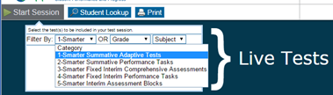

Passwords
On testing day passwords cannot be reset for TAs. Please have your TAs check their log in at least a day prior to testing.
Confirmation Codes
When copying students names and confirmation codes, please verify they are correct. It is easy to get off by one number and everyones SSID is incorrect.
Session ID
Keep a copy of your Session Id number. If you get logged out, there is an issue with a student’s test, the Session Id number is required.
Classroom Activities
Every school is assigned a Classroom Acitivity for ELA and math. Please go to: http://www.scusd.edu/post/classroom-activities-performance-tasks to find your schools activities to download.
Quiet Activity
Students will complete their testing at different times. It is ok to have them do a quiet activity, read, crossward, etc.
Scratch Paper
Scratch or graph paper may be used for ELA and math assessments. If students are using scratch paper for the ELA Performance Task and are taking 2 days to complete, have them write their name on their paper and securely lock it up until the next use. Please securely destroy when completed.
Practice Test
It is critical to use the Practice and or Training tests before taking the Summatives to ensure a smooth first day of testing. Students can go to the secure browser and click on: Click here to go to the Practice and Training Test Site. They can use their log in information then to take the practice tests. TAs should only use the Test Administrator Practice and Training Site to start up a practice session.
Continued on page 2
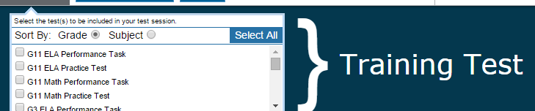
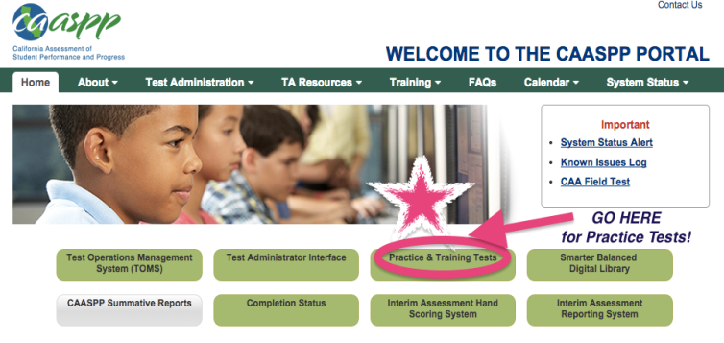
CAASPP.org

iTunes Issues
Please see the attached How to Stop iTunes from Opening During Testing if you are encountering issues with iTunes pop ups

California Alternate Assessment (CAA)
Testing and Version DFAs
The CAA window for testing is now open. Version assignments for the Directions for Administration are available and will be provided when Site Coordinators have reviewed the training.
Coordinator Training
As site Coordinator, you need to be trained on the CAA. There is a self-guided training and quiz you need to view. The training powerpoint and CAA Testing Administration Manual can be found on the U drive at: U:\CAASPP Coordinators. To view the training, open the powerpoint and hit F5 on your keyboard to open fullscreen. When completed, go to the website on the last slide and take the quiz. This will be your completion certification.
Test Administrator Training
Please ensure you receive the CAA Certificate of Completion before your TAs before they can administer the California Alternate Assessment. The CAA Online Training Tutorial can be found at: http://www.brainshark.com/ets/vu?pi=zI1zYUXqyzJ0cZz0

